aAqua: A Database-backended Multilingual, Multimedia Community Forum

Krithi Ramamritham
Dept of Comp. Sc. And Engg
Indian Institute of Technology
Mumbai, India
91-22-25764989
Krithi@cse.iitb.ac.in
Anil Bahuman
Developmental Informatics Lab
Indian Institute of Technology
Mumbai, India
91-22-25764989
abahuman@it.iitb.ac.in
Subhasri Duttagupta
Dept of Comp. Sc. And Engg
Indian Institute of Technology
Mumbai, India
91-22-25764989
subhasri@cse.iitb.ac.in

ABSTRACT
aAQUA is an online multilingual, multimedia Agricultural portal for disseminating information from and to rural communities. It answers farmers’ queries based on the location, season, crop and other information provided by farmers. aAQUA makes use of novel database systems and information retrieval techniques like intelligent caching, offline access with intermittent synchronization, semantic-based search, etc. aAQUA’s large scale deployment provides avenues for researchers to contribute in the areas of knowledge management, cross-lingual information retrieval, and providing accessible content for rural populations. Apart from Agriculture, aAQUA can be configured and customized for Expert advice in Education, Healthcare and other domains of interest to a developing population. This demonstration will showcase the utility of various component DB/IR technologies built into aAQUA to enhance the QoS delivered to rural populations.

MOTIVATION and GOALS
The internet is making a huge impact in bridging traditional geographic barriers and enabling new businesses across towns, regions and countries. If these benefits are to reach the common man in developing countries such as India, the information on the internet needs to be (i) reachable, (ii) accessible and affordable, (iii) relevant (timely and customized) (iv) usable (v) searchable and (vi) up to date. Large sections of the society, particularly the rural folk, do not have access to the huge knowledge base acquired by scientific development through the centuries. While telecenters are beginning to dot the Indian rural landscape, one of the big barriers remains the lack of content that (i) is in the language of the locals (ii) is relevant to their needs and (iii) is delivered in a form that is of immediate use to them.
Keeping these factors and the needs of Indian rural users in mind, a database-backended Question and Answer system and agri-portal has been developed as part of the research activities at the Developmental Informatics Lab, at IIT Bombay. aAQUA-[1] which stands for almost All QUestions Answered- is effectively an online, yet locally archived repository accessible using a web browser, allowing members to create, view and manage content in their mother-tongue (Hindi, Marathi etc). This research artifact aims to continuously incorporate innovations from the perspective of, database query optimization and caching, cross-lingual multimedia information storage and retrieval, human-computer interaction and new ways of providing experts assistance in identifying and addressing farmers’ problems.
Permission to make digital or hard copies of all or part of this work for personal or classroom use is granted without fee provided that copies are not made or distributed for profit or commercial advantage and that copies bear this notice and the full citation on the first page. To copy otherwise, or republish, to post on servers or to redistribute to lists, requires prior specific permission and/or a fee.
SIGMOD 2006, June 27-29, 2006, Chicago, Illinois, USA.
Copyright 2006 ACM 1-59593-256-9/06/0006…$5.00.

aAQUA: A USAGE PERSPECTIVE
aAQUA provides a communication framework for rural users to find and ask solutions to their questions. Solutions get shared by a larger community and solutions are provided by either people having similar experiences or by enrolled experts. aAQUA is available currently on the internet and also through a number of computer operator mediated internet kiosks that are being deployed in India by both commercial and government funded ventures. The kiosk operators help in making the technology usable by users who are unfamiliar to computers and often not literate.
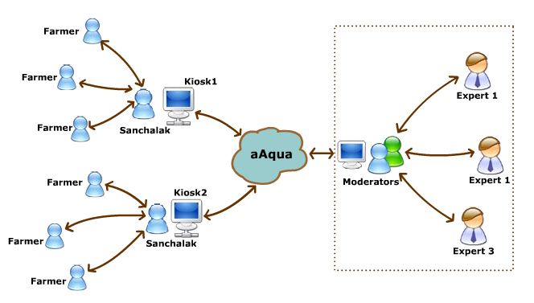
Figure 1: Flow of information in aAQUA system
In this section, we present various stages a typical aAqua question passes through in its life cycle.
An aAqua question is posted either by a registered user directly or through a telecenter/kiosk operator who has an account in aAqua. Usually the question is from a farmer whose profile information provides details such as crop, farm size, pesticides and fertilizers used, dosage etc. This provides an appropriate context for the question. If the question is clear and complete, the Agri-experts provide an answer to the question. Otherwise they ask the original user for further details about the problem. aAQUA Experts response times averaged around 24 hours in the year (Dec 2003 – March 2006). A local help desk operator follows up with the farmer over a phone, a week after the answer has been given, to check if the answer solved the farmer’s problem. It attempts to implement a feedback driven closed-loop system that works even if the farmer was unable to use aAQUA on the computer due to technical (power, connectivity, PC failure) reasons.
From a user perspective, the success of aAqua lies in its incorporation of effective solutions that:
- Provide an interface suitable for novice internet users.
- Allow users to browse content by forum name as well as agricultural keywords and key phrases presented to the user.
- Allow users access to content even over intermittent or low bandwidth connectivity.
- Provide solution to a user in his/her own language independent of the language of the original question.
- Allow experts to recycle knowledge from the continuously growing knowledge base of aAqua for replying to recurring questions.
In the demo, we will show several novel features of aAqua by demonstrating the following: posting a new question, providing a response, navigation + search of archived Q&As as well as related Digital Libraries, off-line operation, synchronization during connection periods.
In the next section, we describe how aAqua has addressed each of the above issues using or adapting research results from the DB/IR communities.

aAQUA: A TECHNICAL PERSPECTIVE
aAQUA employs three tier web architecture consisting of the presentation tier, the web and business logic tier and the data access tier. aAQUA started from an open source discussion forum - mvnforum - built using Java technology (Java Server Pages/Servlets). Based on the standard MVC (Model View Controller) architecture, aAQUA is compatible with any Servlet container which supports JSP1.2 and Servlet2.3. It is currently being deployed within the Servlet container (Catalina) of the Tomcat Web Server. The system uses a Unicode UTF-8 compliant Oracle 9i database which comprises mainly of tables that include attributes for Member, Farmer, Expert, Moderator, Category, Forum, Posts, Thread, Permissions and Attachments.
aAqua’s major technical features are described in the rest of this section.

Enhancing Usability
The users of aAQUA are predominantly non-English speakers, semi-literate and new to the internet. aAQUA provides a simple, yet rich interface suitable for new internet users. A web-based keyboard is also available to assist users. The questions on aAQUA are answered by agricultural experts who provide answers in the local language (or a combination of languages), paying special attention to the language used. Use of technical jargons is generally avoided, for e.g., instead of prescribing quantities measured in parts per million (ppm) or grams, common measures such as the teaspoon are made.
Some agricultural and veterinary problems are better addressed by photographs or audio and video files which provide details to the expert. aAQUA allows attaching images taken by a digital camera or scanner and experts can zoom to specific portions of the images. As shown in Figure 2, users can add images and also attach audio and video files which are automatically played back on viewing. There are many ways of organizing aAQUA content and it remains an open research issue especially when catering to different sets of users- farmers, experts, agri-businesses - both from literacy as well as expertise point of view.
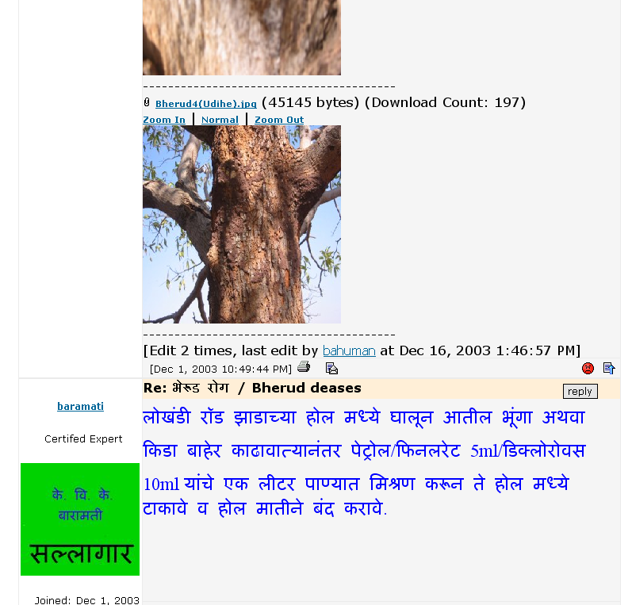
Figure 2: Pictures are worth a thousand words for experts answering questions on aAQUA
The two approaches in use so far are organizing (a) by question category – crops, animals, market price and others and (b) by agricultural keywords (in categories) chosen by experts.

Offline Access, Database Synchronization and Caching
The underlying assumption in almost all web based applications is the availability of a continuous connection to the server over the Internet. However, aAQUA caters to users who connect to the internet on unreliable dial-up connections where the bandwidth is low or intermittent and the user is usually charged by the number of hours online. aAQUA pages are designed to have a lower payload and can also be installed as a standalone application which connects to the internet whenever available. The offline version of aAQUA is created for such users and can be personalized based on individual or group profiles and access patterns. It incorporates a store-and-forward mode, delaying authentication and allowing users to login and ask questions. The application periodically synchronizes with the main server and also receives the latest updates. Google Desktop Search is used for searching the content in the offline version.
In order to improve the response time and robustness in delivery of content, we also have deployed aAQUA mirrors closer to the users.
Web caching and database query-optimization strategies are also being exploited to help improve response. Frequently accessed fragments of pages as well as query responses are cached in the (i) browser (ii) one or more application server tiers.

Language Independent Semantics-driven Retrieval
We are converting the knowledge contained in the Questions and Answers in the forum to a language independent form – Universal Networking Language(UNL) [2] - so that Semantic Based Search techniques can be used for multi-lingual retrieval. This performs better than keyword-based approaches [3]. When a user types a query, the system converts it to a UNL query graph and looks up the UNL document base to find matches. It responds with the answers (also in UNL) and translates them into the language chosen by the user in the original query.
In addition to enhance multi-lingual retrieval, we are currently integrating functionality to (a) automatically pick agricultural keywords and (b) perform a multilingual keyword based search on the database. This is especially useful for users fluent in two or more languages (which is quite common in India). The original search query is expanded with their counterparts in each language. It allows users to search in their own language and retrieve content in other languages.
Since aAQUA serves many novice users, a popular search feature is a categorized list of hyperlinked keywords (also called Virtual fora) that appears on the home page. On clicking these hyperlinks, aAQUA performs a search on the corresponding keyword (e.g. Onion invokes all Onion related threads – independent of language. This feature was an attempt to encourage users to perform search on the database.

Reuse of Knowledge in Previous Answers
A feature has been provided for experts to help them give quick answers while they formulate more detailed answers. The quick answer contains a hyperlink of keywords chosen by the expert allowing the user to click and browse through the results while he is waiting for the answer. Although technically possible, we have avoided giving automated answers. There are a number of reasons for this. A review of the question-answer database has shown that while farmers’ questions are imprecise (short, sometimes erroneous, wrong grammar, spelling, local language typed in English alphabet, question captured as scanned text, as pictures, audio or video), they expect precise, descriptive answers. Another issue is the temporal validity of historical answers in the database. Yet other challenge is the number of variables that makes each farmer’s question unique even though they may be expressed in similar ways on aAQUA. Thus, techniques that assist experts in reviewing past Q&A while answering new questions are more useful and are being incorporated.
In addition, aAQUA has been integrated with other sources of information including government schemes for farmers, monthly forecasts, market price information such as Bhav Puchiye (meaning, "Request for the price", in Hindi) [4].
A Digital Library is associated with the aAQUA repository consists of crop diagnostics, crop recommendations (by browsing by commodity name) and translated aAQUA threads.

CURRENT STATUS and the FUTURE
aAQUA provides a language independent agri-portal and question-answer forum with textual, graphic and audio- visual elements to provide a simple, yet rich interface accommodating novice users. The users can formulate questions in a natural manner often mixing words of two or more languages. Keywords are suggested to guide the user to similar questions asked in addition to answers given by Agricultural Experts (many of whom themselves search the repository.) Keywords are stored in a language independent fashion. This allows multi-lingual users to search content in other languages.
Currently aAQUA is delivered over kiosk networks, cyber centers and PCs via the Internet and also via handheld devices. The key to our success is that aAQUA takes services to people even where they are; leveraging existing skill sets and minimizing the need of a separate expert team. aAQUA is evolving with the needs of the rural users in mind and is a live repository for researchers interested in the areas of knowledge management, cross-lingual information retrieval (in Indic languages, and English using the UNL standard), textual, multimedia and web data mining and data dissemination, web and database caching and prefetching to counter the need for always-on connectivity.
aAQUA content can also be delivered over other media that is more easily accessible to the farmer. We are experimenting with telephony extensions, FM radio broadcasts and mobile Short Messaging Service (SMS) providers. aAQUA is being spread geographically by building strategic partnerships with Kiosk network providers and Agricultural expert organizations. Additional services being considered for aAQUA as part of the scaling up effort include (i) weather reports (ii) disease forecasting by processing data from climate and crop sensors, (iii) online soil test reports (iv) quality standards for exports. Additional features being added are (a) visualization using maps (b) RSS feeds for other portals. Apart from Agriculture, aAQUA can be configured and customized for Expert advice in Education, Healthcare, Counseling, Mentoring and other domains.

REFERENCES

- http://www.aaqua.org
- The Universal Networking Language (UNL) System. UNL center, UNDL Foundation, 2001. http://www.undl.org/unlsys/index.html
- Kagathara, S., Deolalkar, M., Bhattacharyya, P. A Multi Stage Fall-back Search Strategy for Cross-Lingual Information Retrieval. In Proceedings of Symposium on Indian Morphology, Phonology and Language Engineering, Kharagpur, Februrary 2005.

- K Ramamritham, S Duttagupta, A Joshi, G Mathur and T Vilankar, “An Interface-Driven Approach to Information Provision for Wired and Wireless Customers”, Mobile Commerce Proc Int’l Workshop, pp. 102-109, 2003.

This research has been sponsored in part by Media Lab Asia, Developmental Gateway Foundation and PanAsia ICT Grant. Vigyan Ashram and KVK Baramati are partners in running aAQUA deployments. aAQUA content is free for use by academia.

