CTARA Project Sampler

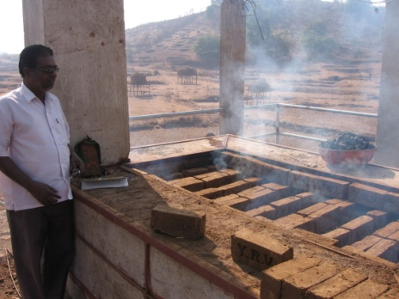
Energy Efficient Brick Making Technology
The Vertical Shaft Brick Kiln (VSBK) technology, introduced in India in 1996, is an energy-efficient environment-friendly means to produce quality bricks.
The Centre for Technology Alternatives in Rural Areas (CTARA, IITB) along with an NGO - Rural Communes, has initiated a project to disseminate VSKB Technology in the Konkan region where no such kilns have been tried before.
The new technology can reduce fuel requirements and has been recognised as a cleaner technology by the Central Pollution Control Board. The project would demonstrate to the local population its technical feasibility and economic viability. The plant has already undergone a test run and is set to operate on full scale in the next season of brick production.

Fighting Severe Acute Malnutrition in India
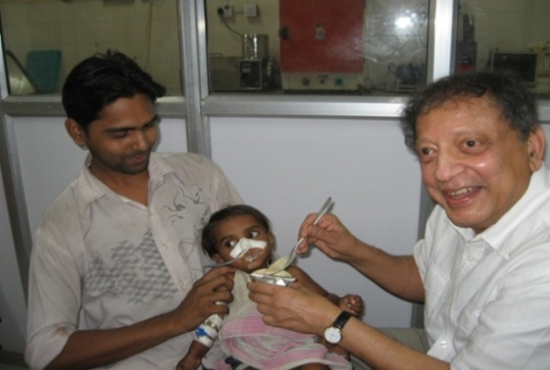
A pilot project has been initiated to prevent malnutrition in children in Mumbai using Medical Nutrition Therapy (MNT).
MNT – components:
- Peanut butter
- Milk powder
- Sugar
Enrolment of children for clinical trials at Sion Hospital, Mumbai
- Soyabean oil
- Micro-nutrient premix
MNT treatment is given for eight months and the children are examined six months after the therapy to measure weight gain. So far 79 % of the children receiving MNT have successfully gained target weights (15% more than the weight at enrolment).
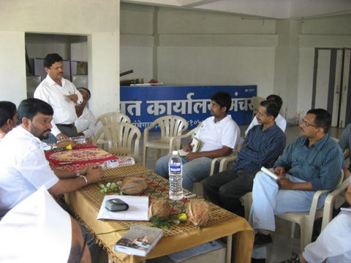
Development Planning for Manchar Village, Ambegaon Block, Pune district
The Centre for Technology Alternatives in Rural Areas (CTARA) IIT Bombay is assisting the Grampanchayat of Manchar to undertake development planning for the village.
CTARA meeting with Grampanchayat
The village which is growing in population and residential space requires planning for roads, public amenities and sanitation systems as the currently available facilities are insufficient to cater to its needs. The villagers are also encountering problems related to water availability and waste disposal.
Work being done by CTARA:
- Analysis of the sanitation system to form a sustainable solid and liquid waste management system
- Technical analysis of the water supply scheme
- Studies on limitations of current policies and regulations for the development of villages

Biogas for Rural Communities
Two successful rural biogas models were studied and compared
- Community Biogas plant established at Bhintbudrak, Gujarat
- Individual biogas plants established by Bhagirath Pratisthan, Maharashtra
The next phase of the project focused on replication of community plants in large number of villages involving GSRDC (Gujarat State Rural Development Corporation) and BOO/BOOT (Build-Own-Operate-Transfer) agencies working on PPPP (Public-Private-People Partnership) basis. Present work in this domain includes interaction with Thane ZP and other stakeholders to facilitate the establishment of an efficient community biogas plant at one of the villages in Thane district.
First successful plant, Bhintbudrak, Gujarat
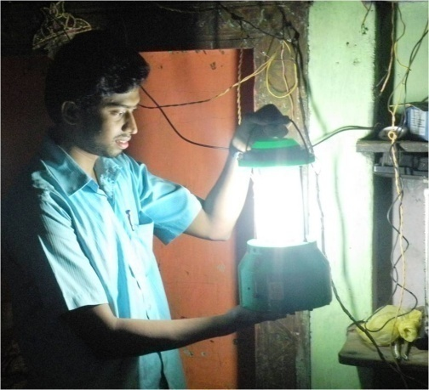
Software to Identify Optimal Solar Photovoltaic Module
A new method has been proposed using Analytical Hierarchy Processing to choose appropriate Solar Photovoltaic module technology for use in different climatic conditions and weather zones.
The performance of different semiconductor technologies and batteries vary under different weather conditions and hence it is very important to choose the appropriate technology for a specific region.

Features of the proposed software:
- Identifies quantitative and qualitative attributes of modules and arranges them hierarchically
- User can make choices based on attributes such as cost, efficiency, operating temperatures, mechanical properties and energy payback.
- Compares available technologies on all available attributes and finally gives a ranked list of available technologies.

Rural Drinking Water Projects
Rural drinking water is an important research area for CTARA, where researchers are engaged with Thane and Raigad district administrations to analyse drinking water scheme failures and design alternatives. Studies include
- Techno-economic feasibility study and design of a piped water supply system for 70+ villages in North Karjat showed that it is economically viable to supply water in pipes from Pej River to the target area. The beneficiary gram panchayats have filed a formal request to implement this scheme (www.cse.iitb.ac.in/~sohoni/karjatshort.pdf)
- Analysis of Sugave piped water scheme for 15 habitations in Karjat block, Raigad district involved field measurements, simulation and stakeholder meetings to identify reasons for scheme failure and make recommendations for revival (www.cse.iitb.ac.in/~sohoni/mvs.pdf)
- Failure analysis of a drinking water scheme in the tribal villages of Tadwadi and Morewadi in Karjat block. Efforts are ongoing to revive the scheme in partnership with Disha Kendra, an NGO active in the area.
The team is also building a planning interface based on Geographic Information Systems (GIS) technology to aid district administrations in their planning and decision making functions (http://www.gise.cse.iitb.ac.in/upload/Thanedb.html) and also a stochastic model to analyse groundwater levels for Maharashtra (http://www.gise.cse.iitb.ac.in/ravisagar/thane/).

