Water resource mapping in Tembhare Gram Panchayat

By:
Anubhav Mangal
Parul Purwar
Shreyendra Garg
Sushant Agrawal
Tushar Jadhav
Guide: Prof Puru S. Kulkarni and Pooja Prasad

Table of Contents
1.Introduction 1
1.1 Location 1
1.2 Demographics 1
1.3 Drinking water scenario in the region………………………………………1
1.4 Major Stakeholders…………………………………………………………………2
1.5 Field Visits……………………………………………………………………………….3

2. A brief Analysis 3
2.1 Shingdol 3
2.2 Tembhare 4

3.Current Scenario 5
3.1 Financial Aspect 5
3.2 Operational Aspect 7
3.3 Health Aspect…………………………………………………………………………8
3.4 Technical Aspect………………………………………………………………….8
4. Problems that the scheme is facing………………………………………..9
5. Features of the Simulation…………………………………………………...9
6. Appendix……………………………………………………………………………..11

1. Introduction

This report presents the analysis of the ongoing Pipe Water supply Scheme (PWSS) implemented in Shingdol and Tembhare village s in Karjat Taluka, Raigad district of Maharashtra. The focus of this study is the Scheme that was started in 2010 covering the two villages. The motivation for the study was to look at the challenges involving in implementing and sustaining the multi village scheme. The objective of this study was to understand the history of the scheme and the present problems that are faced in implementing the scheme. The aim was to look at the financial, Social, organisational and operational issues being faced by the scheme and also suggests ways for ensuring smoother functioning of the scheme.
This work analysis was performed by 5 students of IIT Bombay , Anubhav Mangal, Parul Purwar, Shrey Garg , Sushant Agarawal and Tushar Jadhav.
The first chapter of this report is an introduction to the beneficiary villages if the pipe water schemes. The second describes the water sources , water situation and the problems plaguing the scheme. Chapter 3 looks into the scheme in detail while Chapter 4 looks into the problems regarding it.
The procedure for getting the scheme implemented in the village starts with the villagers submitting a request for the same. Every December a survey is conducted, all the water resources are looked at and evaluated. So if that village is listed under water scare village then that village is eligible to apply for the scheme. On the basis of that the Gram Sabha takes a decision on whether to apply for the scheme or not. The proposal is passed in the gram Sabha in front of at least 25% villagers. The Sabha is held around 6 times in a year. The above Tembhare Pipe water scheme was started 2 years back in 2010, under the Rashtriya Pey Jal Scheme . 90% of the funding for this scheme is done by the government. The rest 10% was funded by the people
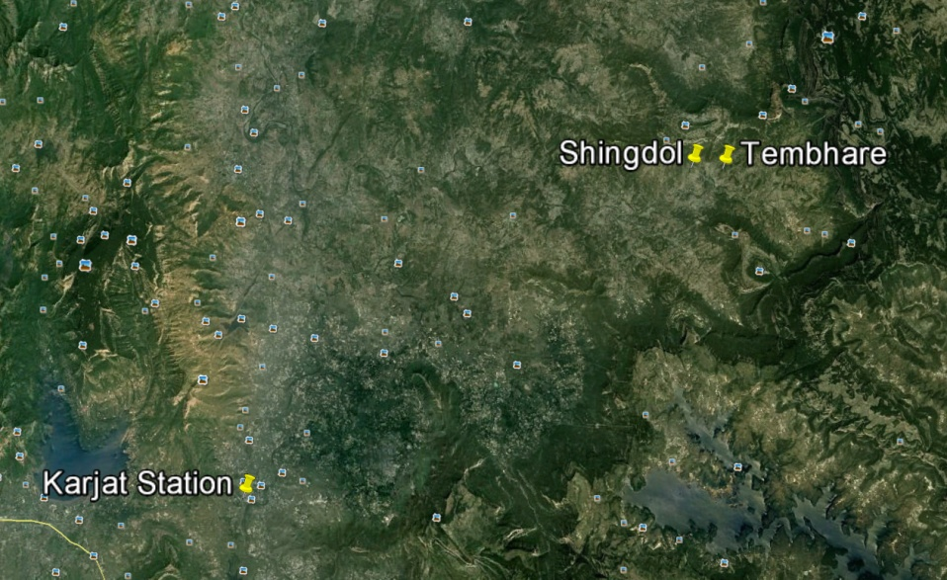
Before this scheme there was an MJP scheme which existed in 5 villages. Those villages were Pinglas, Bhaktachiwadi, Ambivali , Tembhare and Shingdol. The earlier scheme failed as there was a mismatch in the source strength and the demand by these 5 villages.
1.1 Locations
Shingdol and Tembhare are located in the Karjat Taluka of Raigad district at about 35 Km from Karjat Town. The nearest railway station is Karjat station. The two villages are separated by around 2 kilometres .

1.2 Demographics
The scheme was started for 630 (as per the 2001 people census) and targeted for 1125 people by the year 2030. The current population for Shingdhol village currently is 429.While that for Tembhare is around 600.
The main occupation of the people there is agriculture. Paddy crops and vegetables are grown during the monsoon season. In dry months a lot of people especially those belonging to the Katkarwadi (the adivasi ) community leave to work as labourers . A lot of houses are kaccha. But the basic amenities like electricity are present.
1.3 Drinking water scenario in the region
In Shingdol, the wells are situated near water that runs from the mountains. This water stream lasts till end monsoon . The wells contain water till the month of April. People use these wells for drinking and washing clothes. Many people prefer getting drinking water from the wells in spite of the scheme. The problems with these wells are that they dry out in April and very limited amount of water is available for each family. The main well is the source for people in Tembhare.
1.4 Major Stakeholders
A. The villagers
- The primary stakeholders and beneficiaries of this scheme are villagers of Shingdhol and Tembhare.
- CTARA’s team visited the beneficiary hamlets multiple times to interview the villagers.
- As both the villages share the same source well, hence villagers of both parts are important players in the functioning of the scheme in the other part.
B. Minor Irrigation department, Karjat
- The scheme is implemented by Minor Irrigation (MI) department, Karjat. It is located in Karjat town and is responsible for all Minor Irrigation schemes in Karjat tehsil.
- The Detailed Project Report (DPR) along with the cost estimation for the scheme was done by MI.
- Contractor : Shri Ramdas (9028343128, 9222144197)
E. Disha Kendra
- Disha Kendra is an active NGO working in the Karjat block for many years.
- Kunda Tai who is a part of Disha Kendra and has an in depth knowledge of the scheme and the problems faced by the people.
D. Elected representatives and policy makers( gram sevaks, Panchayat)
- Sustainable implementation of MVS schemes, reasons for their failures and recommendations for reviving these schemes are of particular interest to elected representatives at the state and central level. Through this report, our hope is to communicate the lessons learned from this rural pipeline scheme and create an impact in policy and decision making.
E. MSEB: Maharashtra state Electricity Distribution Co. Ltd- Billing :
- They provide the electrical supply for theses schemes. In Tembhare and Shingdol, they have a major role to play as the electrical bill was very high which resulted in the temporary shutdown of the scheme

1.5. Field Visits:
S.No. | Visited On | Met | Output
1 | 29th July 2012 | 1.Kunda Tai  2.Sapan Sapan Bhaliwade -9270114396  3.Suman aunty (Santosh Gharat-922082011) -Collects money  4.Kailash (9260531589)-Operator | Got an initial understanding of the Shingdol and Tembhare PWS.
2. | 9th August | Kailash (9260531589)-Operator  Kunda Tai | Looked deeper into the Scheme
3 | 12th August | Kailash | Went to verify the Pump and the Motor
4. | 15th August | Kunda Tai  Ramdas (contractor) | Marked the stand posts in both villages
5. | 27th August | Mr. Jambrukar. | Went to collect the file from the MI office. Did not get it though.

2. A brief Analysis

2.1 Shingdol

Communities | Houses | Males | Females | Total
Baudhhwad | 19 | 61 | 61 | 125
Maratha | 29 | 114 | 110 | 224
Katkarwadi | 30 | 40 | 40 | 80
Total | 84 |  |  | 429

It has 2 wells and a private well between Tembhare and Shingdol. The wells are situated only 25 m apart and had the same water quality. But some villagers preferred to use one for drinking and the other for washing clothes and other things.
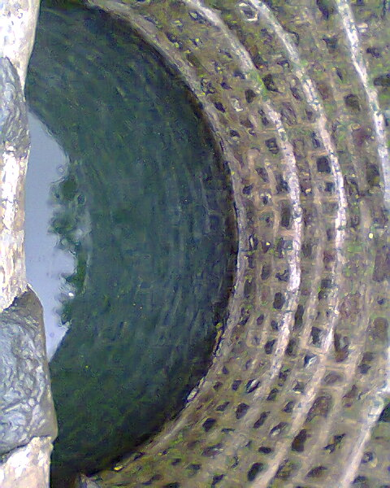
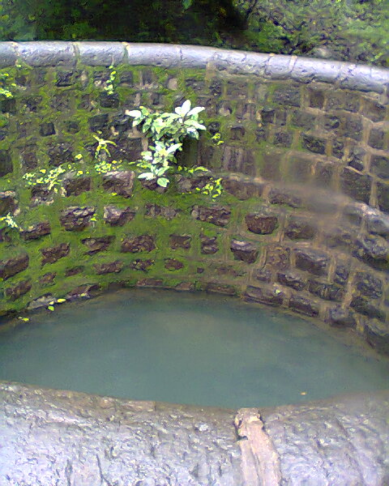
The village has water tank. The tank was built in 2009-10 and its dimensions are 3mx3.25mx3.2 m .It is bypassed currently since the water is directly pumped to each household. Shinghdol has 8 public stand posts, each of which sees a demand of about 40 – 65 handas. The water is delivered for 2 hours.
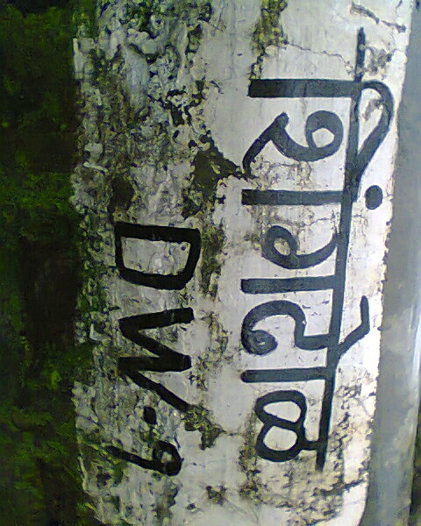
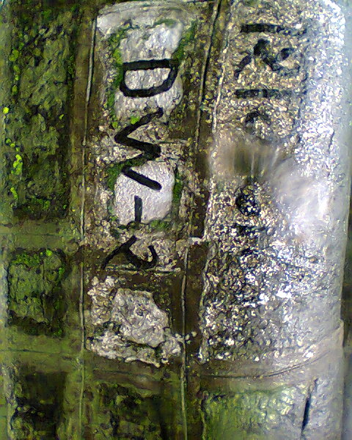

Well | Latitude | Longitude | Water level At | Depth | Elevation | Inner Diameter
DW1 | 19 01.750’ | 73 29.214’ | 3.15m | 6.5m | 144m | 4.3m
DW2 | 19 01.449’ | 73 29.2128’ | 2.5m | 5.1m | 146m | 4.5 m

We talked to Kunda Tai , from Disha Kendra and Suman aunty who collects the money for the scheme. Currently there is no Pani Samiti, so the task is assigned to suman Aunty. Amount of money that needs to pay per house is not fixed as Marathi community pays Rs 50, some people pay around Rs 30 and some can’t afford to pay. Nevertheless the collection is around 2000. 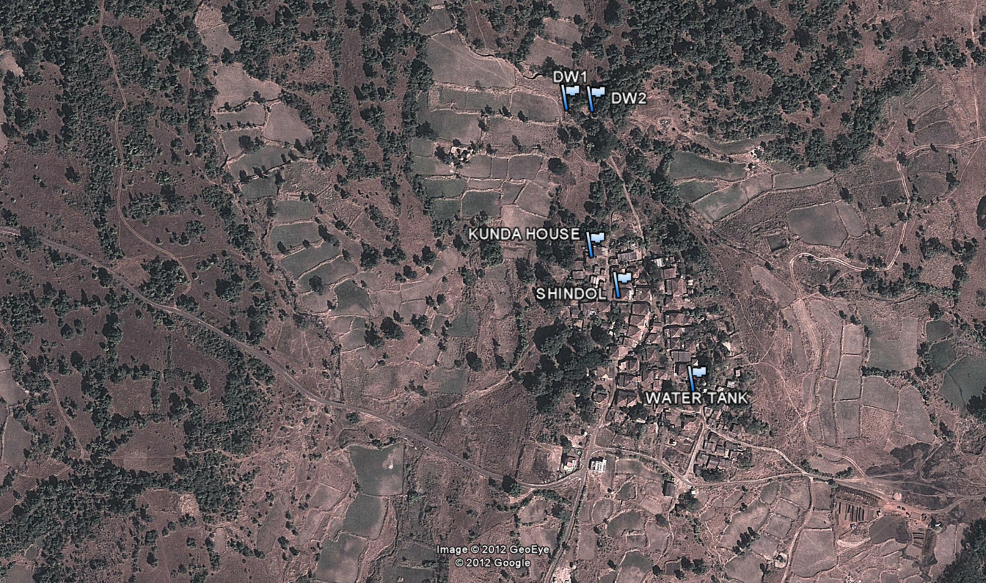

2.2 Tembhare
Tembhare has a population of around 600. The total number of households is 70. The main source well is from the well located between Shingdol and Tembhare, there is one other water tank in Tembhare. The pump house for the scheme is located in Tembhare. It was situated nest to a running scheme.
 | Latitude | Longitude | Elevation | Water Depth | Water Level | Diameter
Water Tank in Tembhare | 19 1.780’ | 73 29.689’ | 142m
Main tank | 19 1.443’ | 73 20.706’ |  | 6.9m | 2.7m | 6.9m,

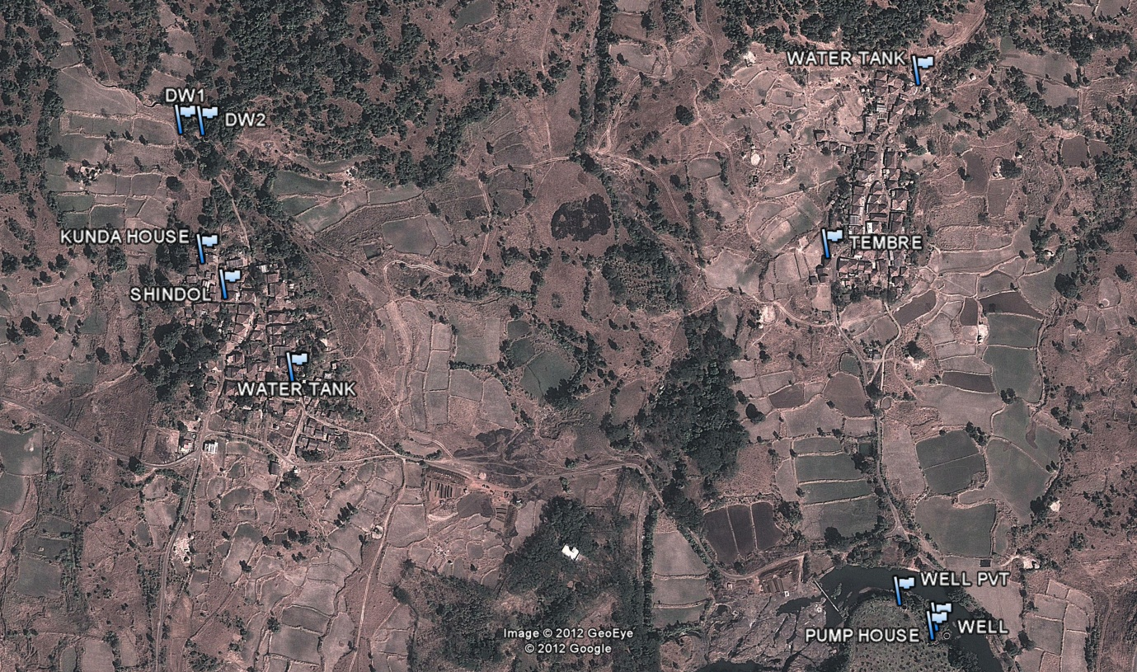

3. Current scenario:

3.1 Financial Aspect:
.
. Estimated Cost Initial) | 25,99,943 ,
per capita Cost | : 231
OPERATIONAL COST AND REVENUE
Revenue Collected (per village ) | About 2000-2500
Operators Salary | 2400
Pump Repairing in Summers (2012) | 14-15,000
Monthly Average Electricity bill | ~ 1500

Since this is a 2 village scheme m the water tax is collected independently by both the villages and the expenses are shared equally. On an average the money collected is around 2500/-.the amount of money taken from each individual should ideally have been rs.50 per connection, but due to financial problems many could pay only Rs. 30 and below. We also felt that there was a general lack of motivation amongst the villagers to pay and that they felt that the Gram Panchayat would handle it. The Gram Panchayat also holds a record of what all villagers paid and how much they paid. The electricity bill comes to the Gram Panchayat.
3.2 Operational Aspect:
The pumps are operated by Shri Kailash. Originally the contract was awarded to his father, who had been the operator of the earlier water scheme running in Tembhare. The scheme runs for 2 hours from 7 am to 9 am. The water scheme runs throughout the entire year though the ground water level goes down considerably in the summers. After allowing water to fill up the Tembhare tank, the valve operator would close the valve, bypassing the Tembhare tank and sending the water directly to the houses in Shingdol. The tank in Shingdol was bypassed as it was on a similar altitude to some of the houses; hence water did not get delivered there at a proper pressure.
The following two figures shows the relative heights of the standposts and the private connections with respect to the main tanks. As we can see some connections in Shingdol are higher or at almost the same level as the Tank height which would cause problems in maintaining the water pressure or even supplying the water to theses connections.. Hence the Operator bypasses the Shingdol tank and sends the water directly to the households.

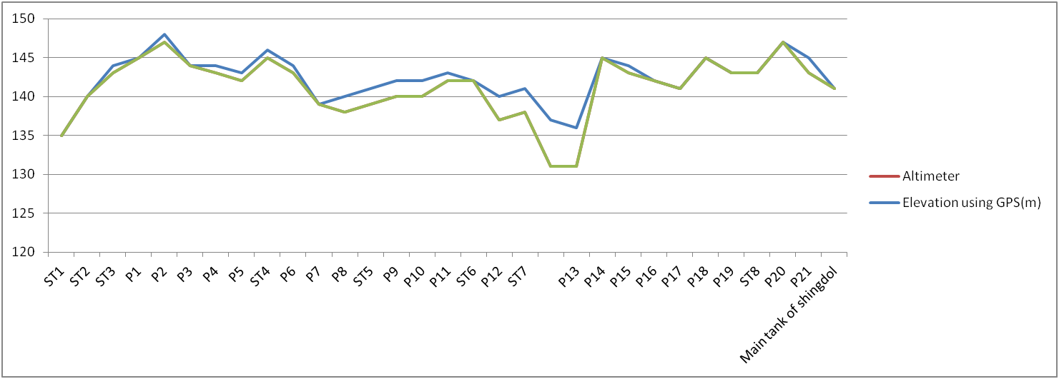

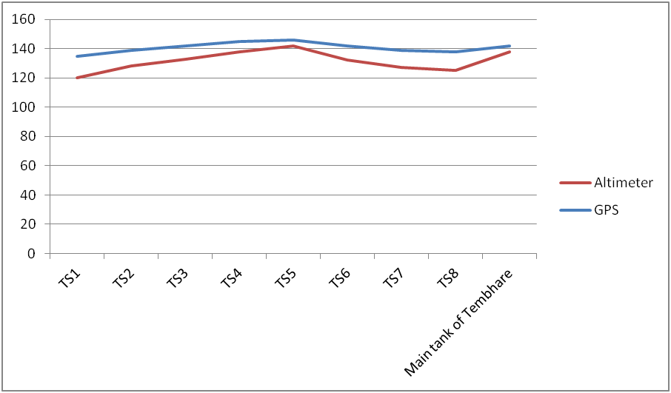
3.3 Health Aspect
Gram Panchayat trains its members for putting adequate amount of chemicals (medicine) in the wells to maintain the quality of water. A trained person visits the village if any complaints regarding the water quality are made. TCL is regularly added to the water to ensure it’s safe for drinking.
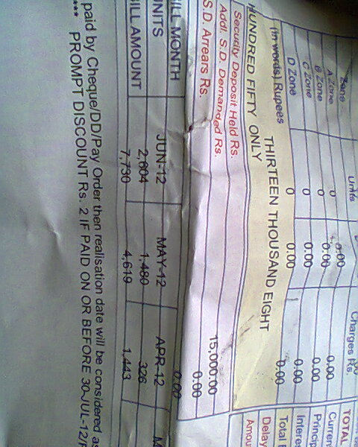
3.4 Technical Aspect
There is a 7.5 HP motor which is currently operational. But maybe due to low ground water level the motor had burned out in May and was taken to Karjat Township for repairing. They spent a large amount of money for its maintenance. Also during the Month of May the electricity bill reached had 1480. In June it was even more. Since the bill had not been paid from March the total became a staggering 13,800.
To verify the pump and the meter, the folloeing things were done :
- The Power analyser was used to measure the load voltage (Vll), load current (I_{ll}) and the Kilo Watt hour (KWh).
- This was done for different postions of the valve.initially the wall was open for Tembhare ( Position 1) and then it was open for Shingdol (position 2)
- The readings were every half and hour.
- The number of units consumed was verified against the meter.

  - 4. Problems with the Scheme
- According to operator all the equipments are old and fails quite often
- Tank in the Shingdol village is below average land height so no use of tank as there is no electric pump
- Electricity bill is unrealistic for last 2 months even though pump was not working for most of the period
- People are not willing to pay for extra expenses like maintenance cost etc
- MSEB person does not care to take reading and contact responsible person at the time of taking reading.

The electricity bill in the previous five months
Month | June | May | April | March | Feb
Units | 1664 | 1480 | 326 | 234 | 418
Amt. | 7730 | 4619 | 1443 | 1181 | 1371

The pump and meter were checks a part of the project. The objective was to figure out the reason for the high electricity bill. We measured the power consumed by the motor and estimated it to be 300 units per month. This estimation differed greatly from the bills in May and June. They checked the meter and found it to be working correctly. They then came up with two hypotheses for the sudden increase in the bill.
- The ground water level had decreased during the summers thus the motor was drawing more power to work effectively and in the process it got burnt
- Since there were festivities in these two months, the motor was kept running for 8 hours each day. This would explain the increase in the meter readings.

  - 5. Features of the Simulation
Designed for a total of 630 souls with a final expected population in 2030 for 1125 souls.
- The terrain is hilly, with a slope from south east to west. However, there are no sudden large changes in elevation
- Source is a main percolation well located in the river.
- Features – The well has to provide a total of 40 litres per capita per day. With an average total demand (including 20% losses) of 0.07 Millions of litres per day
- Source is 1.85 KM from the main GSR for Tembhare and Shingdol. Water is disinfected here
- The well is fitted with two 4 horsepower Submersible pumps (one is backup)
- Features –
  - Main pump pumps for 8 hours
- Discharge capacity of 8127 L/H against a head of 62.66M
  - Static head: 36M
  - Pipes –
    - Length of rising main = 1850M
    - 4 kinds of pipes were considered, 50mm, 65mm, 80mm, and 100mm. By optimizing requirement and cost, the 65mm pipes were used
    - Dia: 65mm
    - CS area: 0.003319 m2
  - Tanks –
    - Something about calculated GSR for Tembhare = 21000L, finally says 25000L
    - For Shingdol = 13000L, finally says 1500L
    - The diagram shows some kind of pipe system where the pump pumps to 450M, then an arrow says rising main for 1850M, and then 700M for both Shingdol and Tembhare

- Appendix
Table : Standpoints and connections in Tembahre abd Shingdol
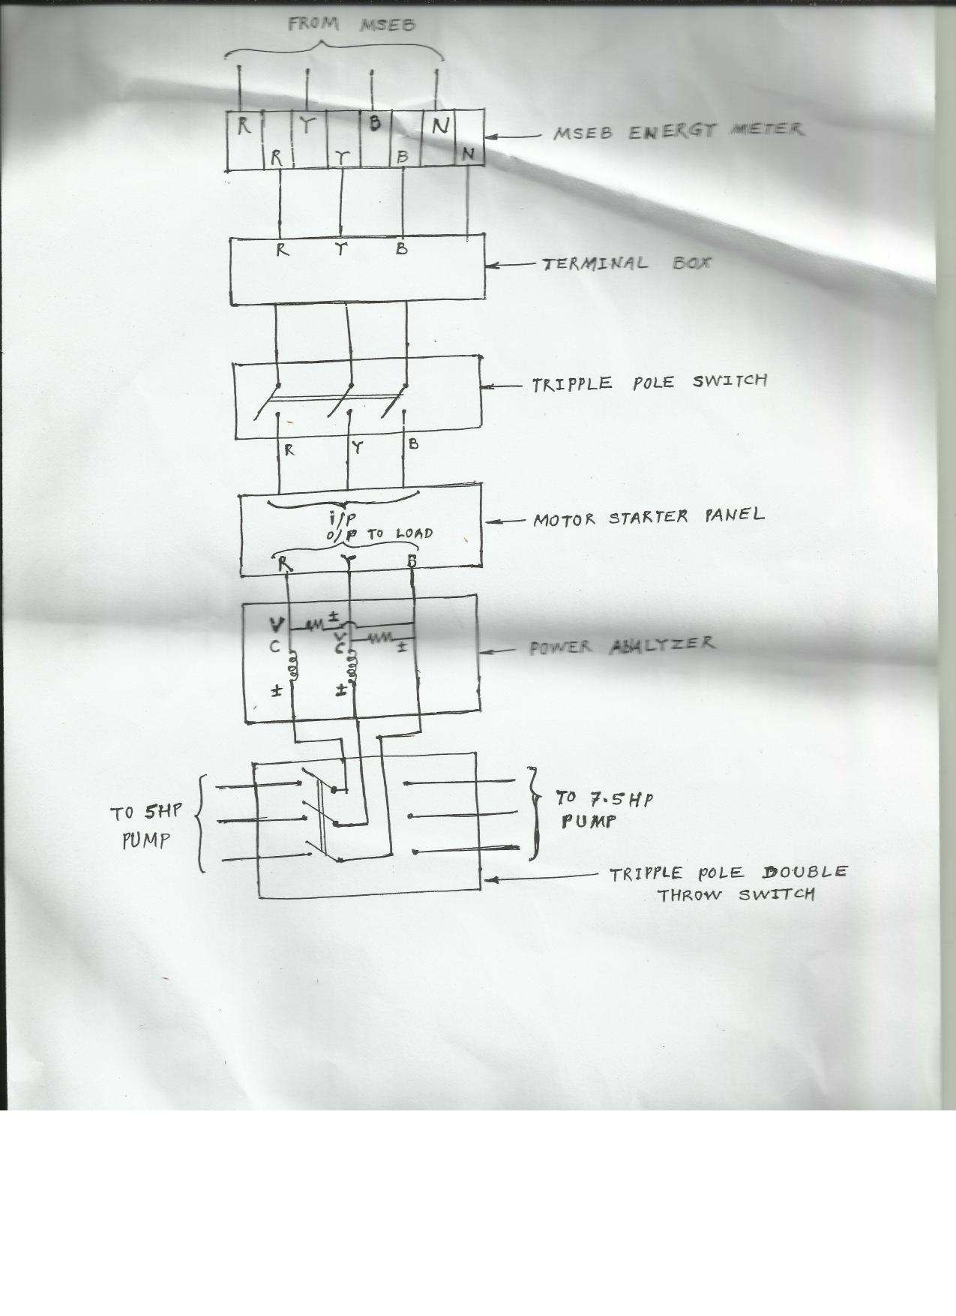
Figure : the Circuit Diagram for the Meter.
It’s a 3 phase connection, Denoted by R, Y, D and N denotes Neutral.

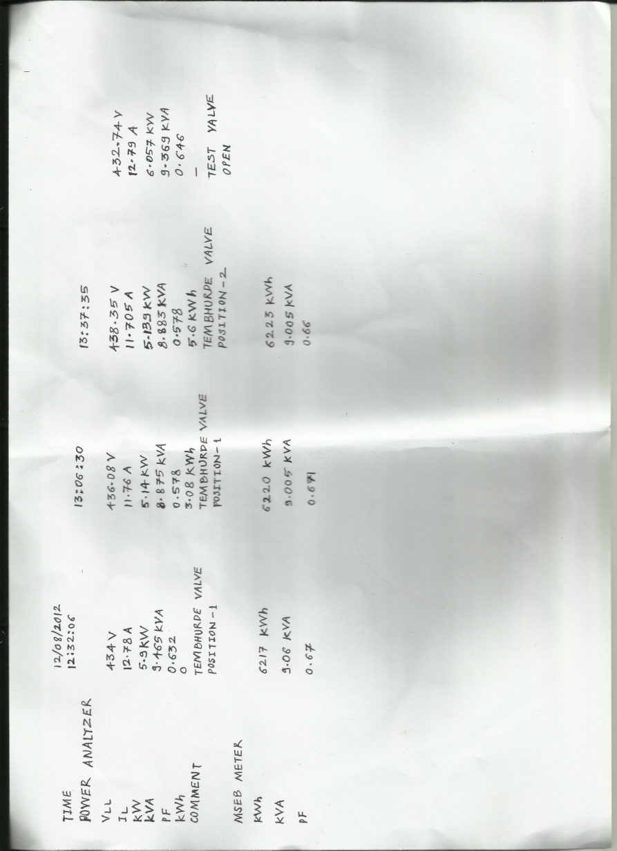
The readings taken by Vishal.
It shows the load current, Load voltage, Timings, units consumed and the corresponding values in the meter.

