chapter 6: broadband for rural india
This chapter discusses the key issues involved with broadband enabling rural India. The chapter has been structured as follows:
- Need for broadband and its role in addressing rural developmental concerns
- Review of international initiatives to provide universal services in broadband
- Indian experience in providing rural connectivity and the business model
- Recommendations on business, revenue, cost and service mix model for viable rural broadband service
- Framework for structuring partnership between different stakeholders in rural broadband
- Crucial role of the Government, the primary guiding principle being to promote private investment and limiting Government's direct funding to essential areas
- Key learning

Need for Broadband
  - The Indian rural population is expected to change over the next two decades as shown in exhibit below.
- Indian Rural Population – 2001-2020
Population Statistics | 1991 | 2001 | 2011 (Estimated) | 2021 (Estimated)
All India (Mn) | 846 | 1027 | 1175 | 1331
15-59 population- All India (Mn) | NA | 604 | 747 | 882
Rural population (India) | 75% | 72% | NA | 60%
Agricultural employment | 67% | 58% | NA | 45%
Rural unemployment | 5.6%  (93-94) | 7.2%  (99-00) | NA | NA
Source: Planning Commission, Center for Policy Research, Institute for Economic Growth

  - By the year 2020-2021, the total employable population (15-59 age group) will rise by 280 million. Of this the rural portion would amount to 168 million. Assuming that the labour force participation rate in villages continues at the current levels, the net new employable population in rural India will be 102 million.
  - Of the projected addition to the population of around 330 million by 2020 over 2001, the increase in rural population will amount to 240 million. Of the total rural originated population, 120 million will migrate to urban centers during this period. Regardless, the bulk of this 240 million people will undergo schooling, gain skills, receive health services and enter into employment primarily in the villages.
  - The ability of agriculture to provide employment opportunity has been reducing over time and is expected to reach as low as 40% of the total labour workforce by 2020 (refer exhibit below).
- Dependence on traditional agriculture for work
Year | Cultivation | Agricultural labour | Total  (Cultivation + Labour)
Proportion to main workers (%)
1978 | 42.9% | 26.9% | 69.8%
1981 | 41.5% | 25.1% | 66.6%
1991 | 38.4% | 26.4% | 64.8%
Proportion to main & marginal workers (%)
1991 | 39.7% | 27.4% | 67.1%
2001 | 31.7% | 26.7% | 58.4%
2021 | NA | NA | ~40%
Source: Vision 2020, Planning Commission

  - The report of special group on targeting 10 million employment opportunities a year in Tenth Plan, Planning Commission (2002) also indicates a sequential year on year drop of between 0.12% per annum to 0.34% per annum in employment growth rates in the agricultural sector. The absolute number of people employed in agriculture also appears to have dropped in some states as well. All these raises three key concerns:
- There will be a huge net addition to the employable population (15-59 age group) in the next two decades, especially in the rural areas (approx. 5-6 million new jobs per annum).
- The traditional agriculture sector will be unable to provide additional jobs
- In addition the migrant labour to the cities will be adding another 20 million employables (at current urban LFPR) or 25 million (at current rural LFPR), who will enter the job market (i.e. 2 to 2.5 million per annum)
  - Even to maintain current employment levels in rural India, so that the 7.5 million rural employables entering the job market each year may be able to obtain a job outside the traditional agricultural sector, there is a need to create more rural non-farm jobs . This would require:
- Creation of non-farm jobs in commercial agriculture, rural industry, food processing forestry etc.
- Vocational training and skill building so that people are employable in these sectors
- Creation of appropriate skill sets in rural population, that will enable them to migrate to urban areas where they can obtain value-adding employment
  - In this regard, it is instructive to note the following in terms of primary and middle school education levels and vocational skill levels among rural employed.
- Worker composition in the 15 years+ age group
 | Up to primary enrolled | Up to the middle and higher enrolled | Possession of vocational skills | Illiterate | Share in total workforce
Rural male | 27.3% | 33.1% | 10.1% | 39.6% | 49.7%
Rural female | 15.5% | 10.5% | 6.3% | 74% | 25.8%

  - As envisaged in Vision 2020, the larger need to shift rural employment from traditional to alternate and agri-based employment such as commercial agriculture (such as horticulture, floriculture, diary, livestock etc.), food processing and forestry (including commercial forestry) will require significant amount of training, skilling and support for traditional farmers to take up such new opportunities.
  - The entire agriculture industry may also need to see significant liberalisation with greater degree of micro financing, extensive corporate-farmer commerce, intra-rural and rural-urban commercial trade to enable these industries to grow.
  - Given the lack of infrastructure and funds/ budgets to set up the additional education/ training/ agricultural extensions etc, there is a need for innovative solutions including alternate media/ communication channels that can enable a range of interactions and interfaces including:
- Education and information
- Vocational training and skills development
- Agricultural extension support especially in propagation of commercial agriculture
- Micro-financing & technology transfer and entrepreneurship enhancement
- E-commerce and trade along the agriculture supply chain, leading to organised aggregation of supply and demand
- Improvement in quality of life indices in the rural areas to reduce the pressure to migrate, including improvements in health services, governance etc.
  - In this regard, Broadband can provide the most comprehensive set of capabilities to address all these needs at a rural level.

International Initiatives for Universal Provisioning of broadband services
  - Given the potential benefits of broadband to the underserved population segments including reduction of the digital divide, many countries have made specific and proactive policies for ensuring universal provisioning of broadband-based services. The exhibit below illustrates the extent to which many of the countries have even moved to support through direct financial support to ensure such provisioning.
- Country initiatives for universal provisioning

  - Various other countries such as Malaysia (USO policy), UK (USO policy) and US (Interconnect mandated for CLECs) etc. also have policies focused towards ensuring that universal broadband access is available and to bridge the digital divide between the uneconomic rural markets and profitable urban centres.

Review of Existing Rural Initiatives in India
  - As part of the study, a quick review of some of the rural data connectivity initiatives by Government, corporates and NGOs in India has been carried out. This is based primarily on secondary research and discussions with the promoters of these initiatives.
  - The initiatives studied include:
- Aksh Broadband
- ITC e-Choupal
- N-Logue
- Akshaya (Tulip)
- CIC (NIC / Department of IT)
Aksh Broadband
  - Aksh broadband consists of a fiber based broadband network solution connecting 400 village kiosks in the district of Jaipur in Rajasthan. The exhibit below gives an overview of the technology solution adopted.
- Aksh Network

  - This is the only “true” broadband network operating in the rural areas, providing 2 to 6 Mbps connectivity services scalable upto 10 Mbps. The key applications/ services provided include:
- Cable TV at homes
- Telephone services/ Web conference/ STD booths – at home and at kiosk
- E-services – horoscope, photoshop, games, internet access, movie projection etc.
- Computer education (limited implementation as on date)
- Agro-inputs commerce (under discussions)
- E-governance including land records querying and transaction initiation
  - The primary revenue earner for the network is the cable TV services. With household penetration of TVs estimated at over 25% (with 25 million TVs) in the rural segment, this is likely to be a fairly strong and stable revenue earner in most of the larger villages. However the penetration of cable TV services in this district, that is the state capital, may not be replicable entirely in the more remote /smaller rural markets.
  - New initiatives such as education and e-commerce for sale of agricultural inputs to farmers are being planned or have been implemented in a very limited way. Although there is potential for higher education, especially ICT oriented education, given the high level of educated unemployed youth, it is yet to become a significant revenue generator for Aksh.
  - Although the network is planned to support 400 village kiosks, less than 120 kiosks are currently operational and about 30 to 40 kiosks have been shutdown for various administrative/ business problems.
  - Most of the kiosks are currently unviable with revenues ranging from Rs 4000 per kiosk per month to Rs 10,000 per kiosk per month. Compared to the capital cost of over Rs 200 million (USD 4.3 Million) and the operating costs in excess of Rs 2.1 million (USD 45650) per month, the business is not viable in its current form.
  - However it appears that Aksh’s cost structures could be significantly reduced and the same network today could cost less than 60% of the original investments. With improvements to the revenue model and services, it could be made self-sustainable, at least in higher income villages that are close to cities / large towns.
  - Currently, most of Aksh’s kiosks are manned by company employees. The change in revenue model will need to be supported by a shift to a franchisee model, which will improve revenue generation and resolve administration issues.
ITC e-Choupal
  - The ITC e-Choupal network (largely operating in the states of Madhya Pradesh and Andhra Pradesh) is essentially an e-commerce network and involves very different business, revenue, services and technology models. The ITC network is the largest network of kiosks in the country with over 2100 kiosks in operation. Technologically the network is designed for low bandwidth web connectivity and operates an extranet for the purpose of direct procurement from villages by the ITC group for specific commercial crops. While 60% of the village kiosks are connected using 512 kbps Ku band V-sat connection, the balance 40% are on the POTS based dial-up connection (1-6kbps operating speeds).
  - The primary service provided by these kiosks is in terms of information on product prices and direct procurement. The kiosks are tied into agro-processing and logistics / supply chain network operated by ITC. To that extent the location of the kiosk is not based on a district or state based coverage but on crops and available tradable surplus.
  - e-Choupal is currently experimenting with two-way commerce and is having discussions with potential alliance partners for providing a range of agro and non-agro products for sales to the rural markets. The same logistics and supply chain manages both lines of business (i.e. procurement & sales) with the kiosk operator being the point person in the village.
  - As of today, the network does not have a real revenue model for the e-procurement activity. The benefits are essentially on account of the savings made by the parent organisation through the disintermediation of the info-mediaries in the traditional procurement channels. Since ITC owns all parts of the infrastructure and supports 100% of the network operating costs, it looks at the return on investments in the form of savings in material costs, improved infrastructure, quality of products, and procurement costs. ITC estimates that the total cost savings through the e-Choupals is around 2-3% of the total costs of material at their end with a further 2-3% savings being passed on to the farmer through better purchase prices.
  - On the e-sales portal, the bulk of the commissions earned do not currently accrue to ITC, with the wholesaler and distribution commissions being earned by the supply chain members. However, to the extent that the revenues provide income to the kiosk operator/ distributor, ITC looks at it as a source of revenue to the total network and therefore can reduce the burden of funding the network operations as well as enhance the attractiveness to Sanchalaks (kiosk operators) and the Sanyojaks (distributors/aggregators).
  - Although ITC is evaluating optional services, currently they are not providing any services such as education, e-health, e-governance, telecommunication/ VoIP services, micro credit/ micro financing or agricultural extension through videoconferencing/ radio/ etc. Due to the low bandwidth availability in many of their kiosks, there will be a technological problem in providing such services in the future on an as-is basis.
  - Thus, although ITC e-Choupal is the only viable/ self-sustaining business model that is currently operational, the current technology and service mix does not permit provision of many of the societal/developmental services.
  - Organisationally, the service is a 2-tier agent model, with all infrastructure investments being made by the company (ITC) and full ownership, being vested with the ITC group. However, since agents / dealers are handling the kiosks and supply chain operations on “share of earnings” principle, there is a strong motivation for them to build the business and increase usage of the kiosk services in and around the villages in their catchment area.
n-Logue
  - The n-Logue operation is based on a leased fiber backbone and kiosks with wireless-based last mile solution. Unlike others, the n-Logue kiosks do not form part of a single network but are part of multiple regional networks operating in Tamil Nadu, Andhra Pradesh, Maharashtra, Madhya Pradesh etc. The largest network of kiosks has about 200 operational kiosks. It is estimated that they have set up around 800 kiosks, with 500-600 kiosks understood to be currently operational.
  - n-Logue has leased bandwidth from a state level / regional level telecom player. At large towns / cities along the backbone, CorDECT wireless base stations (with bandwidth of 2 Mbps each) have been set up. Each of this wireless base stations is used to connect 10-15 village kiosks within a 20-30 km radius. Each kiosk has a 70 kbps dedicated bandwidth (equally split between upstream and downstream) per connection, although a kiosk could purchase multiple connections.
- n-Logue Network
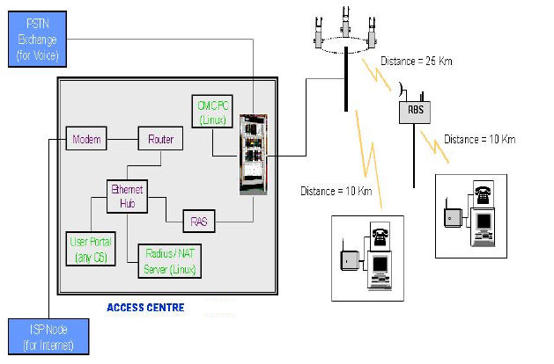

  - The kiosks are owned and operated by franchisee operators, while n-Logue operates the network and charges a connection fee per month from the franchisee. n-Logue firmly follows the principles of affordability in designing the network and kiosk facilities and is focused on generating a payback for the kiosk operators within 1.5 years. To this end, the n-Logue network kiosk capital cost structure is among the lowest across the rural models that have been studied.
  - The range of services that are provided by n-Logue include:
- Internet access with local language content
- Videophony / Voice Telephony
- Video – e-governance
- Medicine and tele-veterinary services
- Agricultural – extension advisory services
- Data entry and data communication services etc.
- Educational services
  - To provide these, n-Logue has a number of strategic alliances in place. In Tamil Nadu, for instance, the alliances include:
- Local language software: Chennai Kaviggal
- Local language content: Webduniya.com
- Mandi rates (local market prices): Local Government bodies and webduniya.com
- Contest-based advertising: C2W, Hungama.com
- School education augmentation: NIIT Netvarsity , PacSoft
- Agri-services: TAFE, Mahindra Shublabh & National Institute of Agricultural
- Extension Management (Manage), Industry and Agriculture, India Agriline (EID Parry)
- Animal husbandry: Tamil Nadu Veterinary and Animal Science University
- Financial services: HDFC Bank, Western Union, ICICI Bank, Royal Sundaram, Bajaj Allianz
- Sales of financial products: HDFC Bank
- E-governance applications: Drishtee
  - Given the bandwidth limitations of n-Logue’s technology model, it does not appear feasible to provide full screen video display capability and this could limit its ability to provide realistic e-education (with full screen video) and entertainment services. Also given the low bandwidth per connection, it is unlikely that the technology solution currently in use can provide services outside the kiosk (such as in-home, telephony connectivity services or in-home entertainment services). However the service does provide for real time video conferencing/ chat/ interaction at the kiosk and can replace all face-to-face communication needs in the areas of e-governance, financial services etc.
  - The focus of the network is currently on communication and data connectivity based revenues. Hence this service is not very strong in terms of its revenue model. However with one of the lowest cost models among the set of business models studied (. Rs 10000 to 12000 per month breakeven revenue), it may be very effective in providing a wide range of basic services and be viable even in smaller / remote locations such as the sub 2000 population villages.
  - The addition of village commerce and e-governance (non-video) services would considerably strengthen its revenue model and may enable additional investments to increase bandwidth availability to the kiosks. This could help in enabling improved education, entertainment and other high bandwidth services.
Akshaya (Tulip)
  - The Akshaya initiative is a multi-phased initiative undertaken by the Government of Kerala through KSITM in the district of Mallappuram. The project covers 560 villages/ locations spread over a 3600 sq. km area. The initiative started with a vision to ensure that every family (urban and rural) in the district should have at least one member who is computer literate. With this purpose the Government set up a number of computer training centers (CTCs) with both capital funding (part and full funding) and revenue guarantee to enable such kiosks/ training centers to be set up in each and every village in the district. In the next phase, they hired the services of a solution provider to setup and operate a connectivity solution, interlinking all the CTCs and providing select e-governance services at low bandwidth through the kiosks to the general population. The contract for provisioning and servicing is for a period of three years on a combination of fixed fee and monthly tariff plan that can be extended on mutually acceptable terms. It does not however specify whether the network would be subsequently taken over by a Government agency or not.
  - The terms of the tender allowed the parties to choose their technologies, and provide a combination of one time fixed fee and monthly per CTC connectivity fees over the three year period. Tulip was selected from among the competitors to provide the connectivity service, on a competitive bidding basis.
  - The service has to be structured in such a manner so as to be able to enhance the bandwidth, beginning from an initial minimum of 16 Kbps, to be scaled up to 4 Mbps per Akshaya center (CTC). The technology architecture for Akshaya as finalized by Tulip is shown in the exhibits below.
- Akshaya Technology Architecture
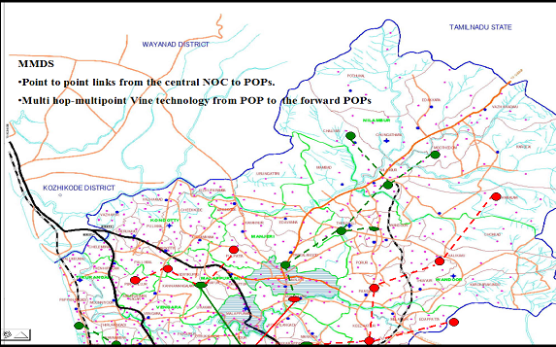

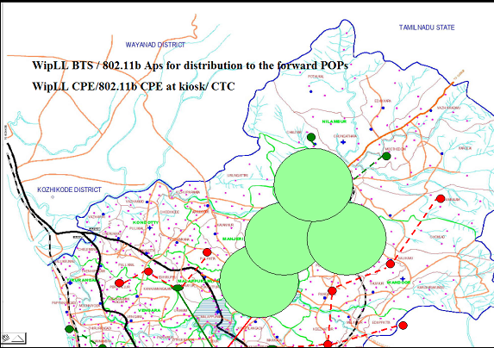

  - Franchisee/ investors who pay Tulip for connectivity services are running the Akshaya centres. The program also provides for the computer training center owner, i.e. the operator, to invest in base transmission stations, that can provide connectivity to multiple kiosks and sharing revenues with Tulip for the networking component of services.
  - Key services proposed to be provided currently by Tulip on the Akshaya network in phase one of their rollout of services include:
- Voice telephony enablement
- Streaming video – e-learning programs
- Internet access
- E-governance
  - While detailed cost structure and revenue models were not provided, it has been stated by Tulip that their operations would be viable.
  - It is understand that Tulip has nearly completed the first phase of its connectivity program and is currently providing, NOC, Super PoP-PoP connectivity and 16kbps connectivity at the CTC. They now plan to move to the next stage of consolidation and rollout of services.
  - In the next, TULIP may additionally provide connectivity to all Government organisations, schools, colleges and NGO initiatives and provide them with all forms of communications, education and information transmission.
  - A few key points to be noted here are:
- Separation of the program owner, kiosk owner/ operator and the network operator. Kerala State IT Mission as the program owner has shouldered the burden of initial training and program management and also the responsibility for all legal approvals/ spectrum availability etc. The CTCs (which are also part funded by local entrepreneurs) are either owner-operated or manager/ agent operated. In Akshaya, the network is currently owned and operated by Tulip.
- Although currently providing 16 kbps (committed information rate) connectivity, it is understood that as part of the Akshaya contract, Tulip needs to scale the network with the same technology to provide 4 Mbps connectivity per kiosk.
- Another innovative approach in this case has been that the entire program commenced as Government-funded program for ensuring computer literacy of at least 1 person in each family. This has facilitated the usage of services by all families in the district. Unlike the other three models that have been studied, this model stresses on personal usage and hence provides a richer and more flexible experience to the rural user. The likelihood of usage and higher popularity of the service is therefore much stronger here.

Community Information Center Project – North East
  - The CIC project is an initiative of the Department of Information Technology to provide block level connectivity through 487 kiosks in the North Eastern States at a cost of Rs 2.2 bn (among the highest on a cost per kiosk basis). It involves setting up a Community Information Center (CIC) in each of the blocks and subsequently in connecting up local schools, colleges or Government buildings to these CICs. Each center has computers and printers and is connected to NIC through a VSAT based network. The exhibit below shows the network architecture used by CIC.
- Network Architecture CICs
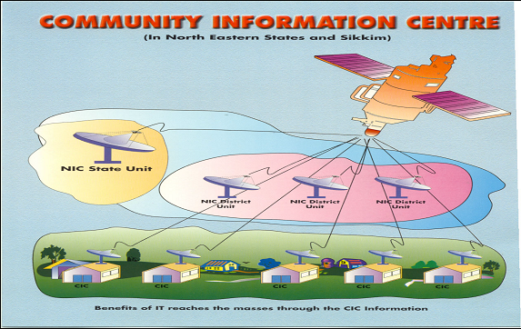

  - The objectives of CIC are to create computer awareness and literacy among Government workers, provide connectivity for educational institutions, e-governance services, distance learning programmes and information services for the public in the North Eastern States. The initiative is also expected to help in creating a database of information on drinking water, education, health and population statistics. Given the location of the kiosks (at block / taluk level rather than the village level), this project is less of a rural connectivity model and more of a semi-urban network.
  - NIC/ NICSI has designed the project and is responsible for setting up the CICs. However the State Government is responsible for operation and maintenance of the CICs and providing e-governance services through the centers. NIC/ NICSI has also trained 2 operators for each CIC for operating it on a day-to-day basis.
  - Many of the CICs are understood to have good utilisation with an average of 20 visitors per day who use email, web and word processing facilities and attend IT training programmes. The CICs are run by State Government employees and are open during the Government working hours.
  - Unlike the franchisee/ agent run model, which provides real connectivity and formatted services to the rural public, the nature and organisation of the CIC operations and services is not very public friendly and they are not located in rural areas. They are typically located in a Government office premises next to the NIC operations center, operate during Government office hours (compared to real rural networks which see demand for services in the evenings and early mornings) and are planned for use by Government employees as well as the general public.
  - Given the Governments’ involvement, there are also issues in pricing / publicising / marketing these services as compared to a private sector player. Since Government employees operate these CICs, there is inadequate focus on enhancement of revenues and making the operations self-sustainable for the CICs.

Analysis of business models
  - It is instructive to consider some of the following key issues while analysing the specific need for a rural broadband policy:
- Business, revenue and cost models for rural broadband connectivity
- Self sustaining / viable models for rural broadband services
- Proposed role of the Government as ‘user’, ‘anchor tenant’, ‘service provider' and ‘investor’
  - A review of the current status of the three full-fledged network owner / service provider business models for which data has been collected (i.e. Aksh, ITC, e-Choupal, n-Logue) is presented below.
- Business models of rural initiatives

- Revenue / cost model of rural initiatives (current costs – Nov 2003)

  - Although none of the models appear to be currently viable, it is likely that a model that combines the best practices on cost and revenue models will enable creation of self sustaining business models, which will also be capable of providing developmental services on a “true” or “near-true” broadband network.

Best practices based rural business model
  - A list of potential services/ applications possible on the broadband network and the likely revenue potential of each of these (based on preliminary inputs from existing service providers) is given in exhibit below.
- Broadband services and applications
Sl. No. | Service/ Application |  | Revenue potential per kiosk  (Rs / month/ kiosk)
Sl. No. |  |  | 5000 pop. | 2000 pop. | 1000 pop
1. | Agricultural Procurement |  | 25,000+ | 10,000+ | 2,500+
2. | 2- way commerce |  | 20,000+ | 8000+ | 2000+
3. | Cable TV |  | 7000+ | 2000+ | 240+
4. | Voice telephony/ videophony/ videoconferencing |  | 1500+ | 300+ | 100+
5. | e-Governance services |  | 1000+ | 400+ | 200+
6. | Education | Online | 500+ | 200+ | 100+
6. | Education | Computer education | 500+ | 200+ | 100+
7. | Telemedicine/ e-health |  | 200+ | 100+ | 50+
8. | Internet access/ usage. Data services/ kiosk assistance |  | 200+ | 100+ | 25+
9 | e-Agri extension including tele-veterinary services |  | 200+ | 100+ | 50+
Total |  |  | 49,000+ | 21,400+ | 5,400+

  - Best practices indicate that it is possible to establish a fiber-based or a wireless-based high bandwidth solution at an approximate network cost of Rs 100000 – 150000 per kiosk. The kiosk cost could range between Rs 50,000 to Rs 100,000. The total cost of rural connectivity solution per kiosk, at current cost structures, is therefore in the range of Rs 150000 to 250000.
- Assuming a 24-month payback, the monthly costs work out to be Rs 7,000 to 10,000.
- Network Operating Centre (NOC) and POP costs could range from Rs 500 to 1,000 per kiosk per month
- Operating costs of kiosks could be in the range of Rs 8,000 to 10,000 per month, including costs to kiosk operation from any fees for bandwidth consumables, power costs etc.
- Total kiosk costs per month would, therefore, range between Rs 16,000 and Rs 21,000 per month.
- On this basis, a fully operational network should breakeven at any village of population size greater than 2000 based on the best practices revenue model.
- For villages with population less than 2000 (i.e. less than 400 households), there will be a need for direct financial support unless they can be clustered together or tied into a larger village kiosk.
  - It should be noted that the costs indicated above are based on duty structure prevalent as on November 2003. As indicated in Chapter 3 on Technology and Business Models, customs duties have a significant effect on the capex and hence the viability of the business model. For instance, all communication and IT equipment (forming between 60 to 70% of the total rural network) that could be imported were subject to effective duty (including CD, CVD and special additional duties, in November 2003) ranging between 38.9% and 50.9%. A total elimination of these duties for the rural business model would lead to a reduction in total capex by 24% to 35% and in that case, enable viable business models even for a village (or a cluster of villages) that can provide monthly revenues of Rs. 13,000 to 17,000. Thus even villages of smaller size with less than 2000 population or even a cluster of villages of total cluster population of 1500 to 1800 could look at having a kiosk to support them, thereby enabling private sector investment to reach to even smaller (or so-called less remunerative) villages.
  - It should also be noted that the business model has assumed no taxes being applicable to rural networks / kiosks and the commerce done through them. These include waiver from Income Tax, Sales Tax, Entertainment Tax, Service Tax, etc., that would otherwise raise the cost of provisioning and operating to a level that does not allow for viable business models for kiosks even at the 2000 population villages.
Private/ public participation in Rural Broadband
  - Given that average inter-village distance range from less than 1 km (in states such as Kerala) to 10-12 km (in states such as Rajasthan/ Madhya Pradesh), a case-to-case evaluation may be needed to decide whether financing support for a standalone kiosk is required for a village or not. For villages with less than 2000 population, capital infusion could be provided from the USO fund or similar source, so that the kiosk can operate on a marginal operating cost breakeven basis.
  - Conversely the Government could consider classifying districts / blocks based on their economic potential (village income based) and geographical / logistical status (remoteness, difficult terrain, etc.) to identify whether such regions require any support.
  - The Indian census and NRS data on villages indicates that nearly 55% of the rural population lives in villages with population over 2000 and another 20% population lives in villages with1000-2000 population.

- Rural Market Segments
Village Category - by Population size  (# of people) | Number of Villages  (# '000s) | Population  (# Million) | Average Income per village  (Rs. Mn pa) | Cum number of villages  # | Cum % of rural population  % | Cum %age of Rural economy  %
Greater than 5000 | 14 | 124 | 28.8 | 14 | 18% | 22%
2000 – 5000 | 67 | 203 | 9.7 | 81 | 48% | 56%
1000 – 2000 | 122 | 175 | 2.6 | 203 | 74% | 73%
Less than 1000 | 417 | 178 | 1.2 | 620 | 100% | 100%
Source: Census 1991, 2001 and NRS 2001 and projections

  - In essence, a self sustainable village broadband network could be set up by private entrepreneurs in the richer districts or in all villages with population greater than 2000. A lower bandwidth solution such as n-Logue/ Tulip may be viable even in smaller villages, those with population of about 1000. Therefore, the Government does not need to get into capital funding or putting up such rural networks by themselves. Rather they should ‘enable’ and promote private enterprises and operators/ service providers focused on rural services to enter and grow this area and remove all policy / regulatory restrictions. The Government may end up having to directly fund connectivity solutions only for the last 25% of the rural population.
Rural Broadband networks - Investments required
  - The costs per village kiosk, as already seen, could vary between Rs. 120000 to 180000 (with no duties / taxes) including costs of network. This means that the total cost of the entire rural network (covering all the villages) would amount to between USD 1.5 bn to 2.4 bn (i.e. Rs. 70 to 110 bn).
  - The kiosks that could be funded through entrepreneurs or by USO fund or by banks for the most part amount to 35% to 40% of the total estimated possible kiosks, depending on business and service model and technology used. The balance 60% to 65% of the investment coming from the corporate / private sector amounts to USD 1 bn to 1.4 bn (Rs. 45 bn to 70 bn); this is a sizeable sum – approximately half the estimated value of investments required for the urban market.
  - As seen from the financial analysis of the best practices business model, below the 2000-5000 population villages, there is no possibility of a return on investment. Rather it is being designed to be self-sustaining, i.e. sustenance model for rural broadband.
  - Clearly there will be no one party or even a few parties who could or would contribute to such sustenance models (rather than profitability and ROI focused models) for provisioning rural broadband services. Rather these networks would be of interest and direct use to the corporates that deal in agricultural / veterinary (food chain) commodities as they would approach this from the point of view of saving in buying costs and gains from direct access to the farmers in that area. However such corporates would be commerce focused and would not look to providing development services.
  - The Central and State Governments have, therefore, a key role to play in promoting the concept of providing public services on broadband to these agri-commodity corporates.

Government’s Role in promoting Rural Broadband
  - The Government can do three things to ensure the success of the village broadband initiative:
- E-Governance facilities to be extended over the rural broadband network services for direct interface by the rural Indian citizens
- Government to act as anchor tenant by using the rural broadband networks for its internal communication for district administration, village and taluka level training services, etc.
- Government to ensure / promote the provision of education, health and agriculture / veterinary extension services over the rural broadband networks in the vernacular medium and through audio-visual as well as text based solutions
  - The provision of e-Governance facilities requires that the rural networks have to directly access all relevant Government IT databases for querying and transaction proposal inputs. The actual transaction may continue (for the purposes of control and procedural correctness for the time being) to be approved and updated in the system by a Government person at the village / taluk / district level, as may be required. The use of e-Governance services would be a key driver for use of the rural kiosks by the villagers due to the criticality of citizen – Government interaction in the rural economy covering agriculture, rural trade, land sale and transfers, certification of ownership, BPIP programs, etc.
  - The second area where the Government can play a critical role is that of using the rural networks as an anchor tenant. The Government has large volume of its own internal communication needs which is maintained through a combination of post, telegraph, telephone, fax and radio networks primarily due to the paucity of communication services below the district level in the past. Given the presence of a rural network interconnected to the national networks, the Government could commit to transfer all but the most sensitive / confidential information to the public networks, where secure IP VPNs can be set up for the Government traffic. As a service user, the Government could practically guarantee a large revenue stream for the rural network which can enhance the sustainability of such networks without any additional spend on the Government’s part.
  - The third major contribution of the Government to ensure the usage and uptake of broadband services from the kiosks is to support and provide e-Education and e-Agriculture / e-Veterinary extension services on the rural networks.
  - A number of States (e.g. Rajasthan, Uttaranchal) already have programs for installation of PCs in rural schools for a subsidised fee collected from the students. The addition of broadband connectivity can help to deliver the e-Education services (refer Chapter 5 on Broadband in Public Services for details) in a much bigger way. Education will be a key driver in the villages for mass use and acceptance of broadband services. Kerala’s Akshaya program indicates that it is possible to achieve, over the next 15 years, kiosks in each village as well an ICT trained broadband / PC / internet user in each home in the village. This will also be a critical revenue stream that can grow over time for the rural networks. The Government needs to fund creation of vernacular educational content for school children, adult education, vocational training and distance education. The Government will also need to review the possibility of mandating a 5 to 7 year program to connect all schools atleast in those villages with over 2000 people population as and when a broadband kiosk is set up in that village.
Problems /issues faced by rural connectivity services
  - Based on the discussions with rural service providers and the analysis of the best practices business models, the critical barriers / hindrances to roll-out of rural connectivity/ broadband networks are as follows:
- Lack of legal convergence of ICT & broadcasting: The multiple service streams indicate a strong need for convergence of voice, video and data regardless of the media used.
- Licensing rules do not appear to differentiate between the need for stable and financially secure players required for the urban market and the much lower costs involved in rural networks. For e.g. under the current licensing norms a basic service provider needs to have assets of USD 50 million. This is clearly not a requirement from the rural market perspective.
- Spectrum allocation for rural networks needs to be eased considerably in the 2 GHz to 6 GHz frequency range for rollout of wireless based networks; the timeliness in release of spectrum, spectrum availability and pricing of spectrum could affect the rate of investments in rural connectivity.
- Lack of quality power supply is a significant constraint in providing always-on connectivity services and has an impact on operating and capital costs. The additional cost involved in setting up back-up power supply or alternate energy sources (such as solar panels) is significant. Currently only home installations of solar panels are provided with a subsidy element which needs to be extended to the solar panels being used by rural infrastructure facilities such as the rural broadband kiosks as well.
- Deregulation of agri-commerce is essential; given the role of agri-procurement in enabling a viable revenue model and benefits, this is likely to be critical to the users of the rural network. The existing APMC system needs to be studied and modified to enable agri-commerce in the rural areas.
- Enterprises investing in rural connectivity (such as ITC for agri-commerce; Aksh for entertainment, Tulip for connectivity) need to be guided through appropriate policy to put in place a broadband (high bandwidth) network wherever possible and viable, so that the full range of developmental/ governance services could be rolled out. The low bandwidth systems could be promoted for the smaller villages (<2000 population) where operators may find it unviable to establish and operate true broadband services.

Proposed rural broadband value chain/ partnership framework
  - To summarise, the monetisation of benefits of information dis-intermediation / e-commerce in agricultural produce is an important element for a viable rural model. This is possible only when the corporate that is doing the procurement also owns the network. Otherwise the network itself becomes the infomediary / intermediary and the revenue potential for the network would fall drastically.
  - This means that the network investment would come primarily from an agro-industry / agro-commerce oriented corporate/ player. However as has been seen in the ITC e-Choupal case, such a player may not be interested in investing in providing all the other services related to education, health and e-governance, or to invest in bandwidth to enable full screen quality video as may be required for e-education/ entertainment services at the villages.
  - Many of the corporates, that may still be willing to invest in creating such a network, would not wish to get involved in managing the activities related to product/ service development, marketing, provisioning, operating, servicing, maintaining, upgrading, billing, collection and customer care services.
  - It therefore makes sense to look at a separate role of a rural network operator cum service provider. Such a service provider need not necessarily be a solution provider, but would definitely need to have enough knowledge to roll out the network and operate and maintain services. Currently operators like Aksh, Tulip and n-Logue are a combination of solution provider and service operator and the Government may in the short term promote smaller players.
  - Although the actual services may be created and operated by private players there may be a need to subsidise the operators or reimburse the costs to them to enable subsidised charging for the services in the rural markets.
  - The Government has a very significant role to play in the provisioning of content/ application services since the rural market is currently dependent on Government for provisioning of services such as Government schools, primary health centers (PHC) and Government hospitals, agriculture extension services etc. The Government will need to support the provision of e-Education, e-Health, e-governance services by designing and owning content for these services in the short and the medium term.
  - Lastly across the board, a model with franchisee/ agent/ entrepreneurial kiosk operator is a must to ensure focus and motivation to develop the business in a rural setting. The two employee-based models, Aksh and CIC, do not appear to be administered effectively and both suffer from the lack of proactive local marketing and business development. However, the typical rural investor may not be the best choice for being the kiosk operator since the operator needs to be a full time person (not an absolute owner) and should be technically trained and computer literate. There are a large number of educated youth in villages who would fit these criteria, but who may not be capable of investing in such a kiosk. Therefore, it is necessary to frame policies which will ensure that people who are selected as kiosk operators could avail of zero / low interest loans to the extent of the cost of setting up the kiosk (Rs 70,000 to 100,000) which will enable such people to participate in the rural broadband revolution and gain employment.
  - The vision for a likely rural broadband alliance framework is provided in the exhibits below.
- Rural broadband partnership framework
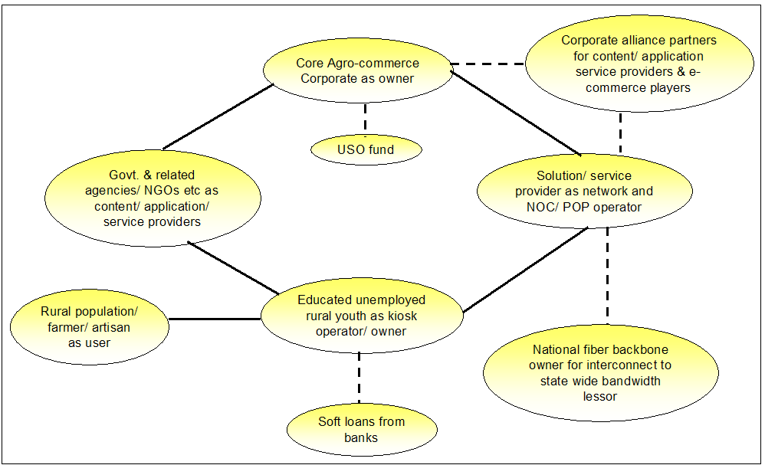

Relative roles of Corporates and Governments in Investments in Rural Broadband
S No | Village Category – by Population size | Cumulative # villages*  '000s | Cumulative %age rural population | Viability of Rural Broadband | Role of Corporates | Role of Govt.
1 | >5000 | 14 | 18% | Profitable | Investor | Financing of kiosk
2 | 2000 – 5000 | 81 | 48% | Sustainable | Investor | Financing of kiosk
3 | 1000 – 2000 | 203 | 74% | Requires capex subsidy | Investor | Financing of network / kiosk
4 | < 1000 | 619 | 100% | Requires capex and opex subsidy | User / tenant | Investor

  - There are however some problems in creating such a complex partnership framework. The issues that would arise include:
- How to select network and program owners?
- Who decides the selection criteria and the geographical coverage policy for proposed network investments?
- Who will play incubator to all the parties together?
- How will the service providers/ network operation be selected and by whom?
- Who will set the requirements and specification for the kiosk operation and who selects and enrolls them?
  - Industry associations/ State Governments have a critical role to play as incubators for such alliances/ partnerships. Since the prime movers in this initiative are the Agro-Commerce corporate players who has to mobilise the core investment and chart out the geographical area of interest (based on cropping patterns/ local economy, products for procurement, State Government policies etc.), they need to be selected first and an agreement on overall coverage/ services that would be provided needs to be put in place between the corporate and the State Government agency. Once this agreement is in place the rest of the details are best left to the corporate owners to plan and execute.
  - The State Governments would continue to be responsible for ensuring minimum coverage and that service mix including developmental content as well as services and pricing levels in the rural areas is in line with agreement terms.

Key learning
  - It is possible to create a self-sustaining rural broadband network based on private investments in India, subject to liberalisation/ Government supporting policies in the following areas:
- Total convergence of all forms of communication and broadcasting is a must for rural broadband
- Total deregulation of licensing requirements for rural broadband and connectivity services
- Deregulation of at least commercial agriculture products and livestock/ dairy business from current regulations under APMC and waiver of the ‘mandi’ tax for all direct procurements from farmer using rural connectivity/ broadband solutions
- Capital costs are a critical factor affecting viability of the business models. The Government can support the reduction of capital costs without any direct funding requirements through the following measures:
  - Waiver of all taxes and duties on all rural broadband network capital investments and waiver of any income tax for a period of 8-10 years from date of start of operations
  - Ensuring power availability and quality and provide subsidy to rural broadband kiosks which invest in renewable power sources (such as solar panels)
  - Low cost bank investment / financing to village based educated youth for establishing kiosks
- State and central Governments have a critical role in setting out the standards and service mix requirements for a rural broadband network and taking on a supporting role in de-bottlenecking the Government interfaces required for establishing and operating such networks
- Industry associations / Governments need to incubate the initial agreements and partnerships to enable rollout of services within the States.
  - Finally regardless of all these incentives, private investors would only be willing / able to provide broadband services in villages which have greater than 2000 population or in villages where it is commercially viable. For the remaining smaller villages, direct Government funding / subsidies may be required for capital investments.

Source : WRI Report

