Dear Krithi,

Following here is your edited article. As you’ll see, the edit was straightforward -- I basically focused on changing passive voice to active and simplifying sentence structure to enhance readability. I also did some minor reorganizing, as noted below.

I’ve included queries to you throughout, indicated by //Krithi: ....//, or simply //okay?// if I’ve reworded something but wasn’t sure I got it right. Please respond to all queries.

Note: It’s possible that I might have inadvertently changed your meaning or introduced errors during the editing process; this is not ideal, but it does happen. Please correct any such mistakes you find.

Finally, as you review the edit, use track changes/highlight changes mode so that I can clearly distinguish your comments from the existing text.

If possible, I’d like your revision by

Monday, 4 February.

If you think you’ll need more time, let me know. Also, if you have any questions or concerns, please contact me and I’ll get back to you right away.

Thanks,
Keri

Spotlight

The aAQUA Approach: Innovative Web 2.0 Tools for Developing Countries //okay?//
Krithi Ramamritham, Saurabh Sahni, Malathy Baru, Chaitra Bahuman, Arun Chandran, and Manjiri Joshi
IIT Bombay
Anil Bahuman
Agrocom, India
As in many regions of the world, people in rural India often lack access to knowledge that’s more readily available to people in urban areas. Although rural telecenters are becoming more common, developing content that’s presented in local languages, relevant to users, and delivered in an immediately useable form is a challenge here and in rural areas across the globe. To address this, an agricultural portal for rural farmers in India uses innovative database systems and information retrieval techniques. In so doing, it both improves service and addresses connection costs and constraints. //okay?// Yes
The Internet is making a huge impact by bridging traditional geographic barriers and enabling new businesses across towns, regions, and countries. If such benefits are to reach people throughout the world, from small town Arkansas to rural India, Internet information must be accessible, affordable, relevant, usable, searchable, and up-to-date.
//Krithi: Please add 2-3 sentences here that offers an overview of the current situation in terms of existing approaches to content development/distribution in rural areas, along with their problems/shortcomings etc.//
Currently, a rural user in India depends on web content developed mostly for the western world, and hence in a language he or she is not familiar with. Even assuming that the content is relevant and usable, delivering the usually rich content demands high bandwidth and persistent connectivity.

In India, many people in rural areas lack access to the huge knowledge base acquired by scientific development through the centuries. Although telecenters are beginning to dot India’s rural landscape, a major barrier remains in terms of developing content that is translated into local languages, relevant to users’ needs, and delivered in a form they can immediately use. //okay?// Yes
With these factors—and the specific needs of Indian farmers in mind—we developed a database-backended question-and-answer system and agri-portal as part of the research activities at IIT Bombay’s Developmental Informatics Lab. Our system, Almost All Questions Answered (aAQUA; www.aaqua.org), is an online, locally archived repository. Users can access aAQUA using a Web browser or Java-compatible mobile phone to create, view, and manage content in three languages (Hindi, Marathi, and English). Our research goal is to incorporate innovations in
- database query optimization and caching,
- cross-lingual multimedia information storage and retrieval, and
- Human-computer interaction.

We also seek novel ways of providing expert assistance to identify and address farmers’ problems and facilitate farmer-to-farmer interactions. //okay?// Yes .Although we developed it for agriculture, researchers can configure and customize aAQUA to provide expert advice in education, healthcare, and other key domains for developing populations.

The aAQUA system
aAQUA is a discussion forum that provides answers to questions related to agriculture and animal husbandry. Launched as a collaborative effort by IIT Bombay, Krishi Vigyan Kendra (Agricultural Sciences Outreach Centre) in Baramati, and Vigyan Ashram in Pabal, the effort attempts to build a bridge between knowledgeable agriculturists and knowledge-seeking users. To accomplish this, we had to address several challenges specific to the rural context (see the “Domain Requirements” sidebar). //okay?// Yes
In a typical aAQUA thread, a farmer submits a problem, and agriculture experts or other farmers provide solutions (see Figure 1). Currently, users can post a question on the aAQUA site through the Web site, via email, or via mobile texting. //okay?// As of early February, the aAQUA portal has received 12,052 posts and 626,015 views. To date, 3,925 people have sent new questions; they include a mix of individual farmers, as well as users from farmer organizations, small and medium-sized agribusinesses, and larger companies. As Figure 2 //formerly Figure 9// shows, questions have come in from 290 of India’s more than 600 districts. Any noncommercial user can browse the forums for free, though users must register on the site before posting a question. Typically, questions come from either farmers or from agri-professionals seeking industrial, financial, or legal advice. The user’s profile includes details such as location and weather forecast to offer an appropriate context for the question. Assuming the question is clear and complete, agri-experts provide a detailed answer and attach images or documents if necessary. If the question is incomplete, /the agri-expert? site administrator?// the agri-expert asks the user to clarify the problem.
Figure 1. A question on aAQUA portal. The user asks //Krithi: Please give readers a brief translation of the question and answer, and describe what the figure’s images/interface show.//
The entire question can be viewed at the following URL: http://aaqua.persistent.co.in/aaqua/forum/viewthread?thread=80

The original question is in Marathi Language .
The question translated to English: The picture shows a Mango tree with a disease called “Bherud”. As a result the tree which is only 20 years old is drying up completely. Please give a solution to this problem.

The post has four images as attachments to show the details of the disease. The user’s image and profile can also be seen in the interface.

The figure depicting the question along with four images .

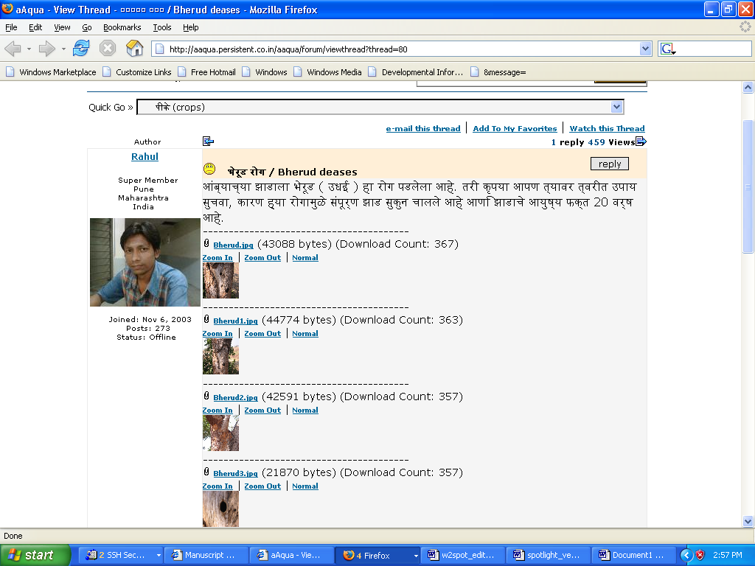

The expert’s answer is shown in Marathi in the figure.
The answer translated to English: Make a hole in the tree and insert an iron rod through it. The insects inside the tree will come out of the rod. Remove the rod . Add 5ml of Petrol and 10 ml of Dichlorovus to 1 litre of Water. Pour this solution through the hole in the tree. Close the hole now with mud .

The interface shows the green image on which the expert’s institute , “KVK Baramati” is written in Marathi.
Below the answer, a reply box along with the Marathi soft keyboard is provided.

The figure with the answer from the expert.:

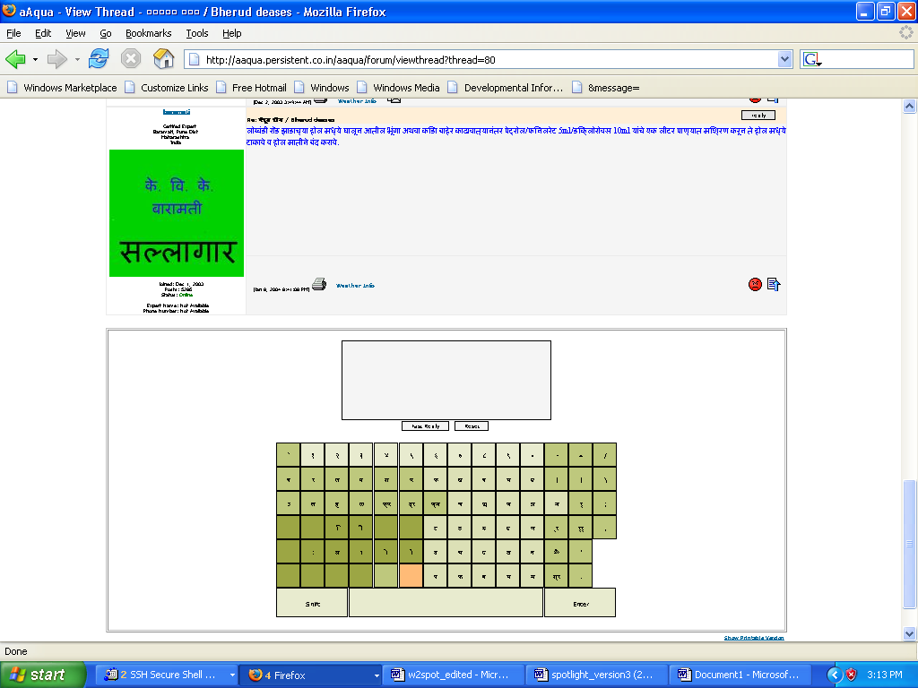

Figure 2. //Krithi: please provide a short label for this figure//. Questions for aAQUA come from farmers and agribusiness workers across India. Farmers and agriculturual consultants : Users of aaqua system
Our service is similar to Google Answers and its variants (GA was discontinued in November 2006; for an overview, see http://en.wikipedia.org/wiki/Google_Answers). aAQUA differs from GA in several key respects. First, GA was a paid service, and experts answered only if they accepted the offered bid. Also, there was no guarantee on how long the questioner would have to wait for an answer, though most questions were answered quickly. In addition, GA //experts derived their answers from Web search results?//.[ Delete the above red line ] In contrast, aAQUA experts must reply within 48 hours and compose their answers on the basis of their own acquired knowledge or reference to standard crop- and animal-management practices.
//Krithi: I did some minor reorganizing here, moving the user access info to the end of this next section to better introduce the material on offline aAQUA -- okay?// Yes

Basic Technology and Interface
aAQUA uses a three-tier Web architecture with Java Server Pages/Servlets, Oracle, and MySQL databases. We based this on the standard model-view-controller architecture, and run it on a Tomcat Web server. The system uses Unicode UTF-8 compliant databases and Lucene, a Unicode-compliant search and indexing tool.
The aAQUA database comprises mainly tables with attributes for Member, Farmer, Expert, Moderator, Category, Forum, Posts, Thread, Permissions, and Attachments. Our target users are predominantly semi-literate non-English speakers who are unfamiliar with the Internet. Our tools provide a simple yet rich interface suitable for new Internet users. We also offer users a Web-based soft keyboard. Experts provide answers to users’ questions in the local language (or a combination of languages), paying special attention to the terminology used and avoiding technical jargon. For example, rather than prescribe quantities measured in parts per million (ppm) or grams, experts use common measures, such as the teaspoon.
Users typically access our portal through Internet kiosks and cybercafes that commercial enterprises and the Indian government are funding throughout the country.//okay?// Yes Kiosk operators help semiliterate and illiterate users as well as those unfamiliar with computers. Users at these rural Internet kiosks connect to the Internet on unreliable dial-up connections with low or intermittent bandwidth. Further, they’re typically charged by the number of minutes //should this be minutes?// online. To reduce these access costs, we developed a delay-tolerant application, offline aAQUA.

Offline aAQUA Architecture
Offline aAQUA lets users browse and search all aAQUA threads, forums, and other pages without being connected to the site. Because the content is stored on users’ computers—and thereby avoids network delays—users can search and browse quickly. Offline aAQUA’s local cache or repository also updates whenever users connect to the Internet. The site sends users incremental updates; only the delta is transferred between the clients and the server. If connectivity breaks between thread downloads, users can resume the download later. Users can also post updates to an aAQUA forum in offline mode. The system saves the update on the user’s machine and sends it to aAQUA server whenever the client node connects.
Figure 3 //formerly Figure 4// shows the offline aAQUA architecture, which is based on heterogeneous database synchronization. The system stores a subset of the server’s database on the offline client. The aAQUA portal mainly consists of a threads collection. On the server, our database stores the complete post, metadata, and all other required information for each thread. On the clients, we store only thread metadata — such as thread id, thread subject, author name, last author, last modified date, and number of replies — in a lightweight database. This lets the system operate efficiently on low-end machines.
Figure 3. Offline aAQUA architecture. The server database has the complete post, metadata, and all other required information, whereas the databases on the client systems store only thread metadata. //okay?//
We store complete posts separately in a repository (local cache) on the client system, thus reducing the database load. We also index metadata and posts separately to achieve advanced content search capabilities. Users can perform a keyword-based search in all aAQUA threads, as well as do an advanced search on specific attributes such as author or last post date. During synchronization, the client first fetches all the server threads that were updated after the client’s last update timestamp and then transfers any pending questions, posts, or form submissions to the server.

aAQUA Performance
To measure offline aAQUA’s efficacy, we conducted a study to determine the amount of network bandwidth reduction users achieved. We also compared the connectivity time required for online and offline aAQUA. We collected data from the online aAQUA Web site, analyzing 594 visits over a five-day period using both server and client logs. When we see several hits from a single IP address in one session, we consider that part of one visit. Our estimated data transfer duration is for dial-up connections, with an average download or upload speed of 2.89 Kbytes per second (23.12 kbps) and bandwidth of 56 kbps. Figure 4 //formerly Figure 5// offers an overview of how our data transfer rates compare to other systems that offer offline access. //okay?//
Figure 4. Data transfer rates. How on- and offline aAQUA connectivity times compare to other systems. //Krithi: Please provide another complete sentence to further describe this figure for readers just skimming the article//[ Label for this figure ]

Online Data Transfer
Most of the aAQUA Web site’s users view threads, or search or browse forums and other Web site pages. Some users also create posts to ask the experts questions. The average aAQUA visitor session’s data transfer is about 351 Kbytes. To create a new post, users typically open the following pages: the homepage, login page, create a new post page, and the post submission page, and are then redirected to the created thread page. On average, these five pages incur a data transfer of 500.25 Kbytes.
Apart from time spent in data transfer, users spend a significant amount of time viewing pages or typing posts. This elapsed time can be costly—particularly with dial-up users who are charged by the hour. Because our users can do most of their work offline, we’ve reduced this elapsed time to zero and thus helped them significantly reduce internet access costs.

Offline Data Transfer
Offline aAQUA stores all aAQUA pages and the search index locally, so the data transfer involved in browsing is also zero. //As Figure 5 //formerly Figure 6// shows,?// transferring a post submitted in disconnected mode to the server incurs an average data transfer of 12.63 Kbytes. The network connectivity duration required for sending a post is 4.37 seconds. We also have to synchronize all online aAQUA updates with offline aAQUA, so it downloads the new and updated threads and stores them locally. Downloading one thread requires an average of 14.3 Kbytes of data transfer, which requires 4.94 seconds of network connectivity.
Figure 5. Comparing online and offline aAQUA visits. //Krithi: please provide another sentence describing what’s occurring in the figure for readers just skimming the article// [ Label for this figure ]

Offline Browsing
We’ve explored various possible strategies for offline browsing. A naive method might be to cache a Web site using wget (www.gnu.org/software/wget). However, this requires that users repeatedly download the whole Web site, which is very inefficient. In our current connectivity scenario, even a single such download might not complete at all. Another simple way to realize offline browsing is to use Internet Explorer’s synchronization option to cache a Web site locally and then use Google Desktop Search to search the content offline.
However, interactive Web sites such as aAQUA require that end users post forms, send messages, and so on. Both of these simpler approaches let end users statically browse the data, but not send completed forms to the servers. Also, neither approach lets users fetch only new updates; rather, they must download the entire content each time. Fetching pages from a frequently updated Web site and keeping those pages current would be quite costly using either of these approaches. As we now describe, researchers have proposed models that are more sophisticated. Although they’re better and more efficient than the simple models, these approaches nonetheless fail to meet our requirements.

Fish-search-based caching. Researchers have based most of the existing offline browsing techniques on caching pages by fish search.1 In this approach, when users request a Web site download, the system first downloads the starting page and then recursively retrieves links from the downloaded page. //okay?// The complete Web site downloads only once; a crawler later identifies and fetches new or updated pages. The method specifies the downloaded page set using well-defined boundary conditions and rules, which might be based on parameters such as crawling depth, repository size, and number of pages.

//Krithi: The magazine’s guidelines on figures is that they add significant value beyond what the text provides. Because Figures 7 & 8 don’t add much beyond your thorough description of these approaches, I’d like to cut them -- okay?// Yes

//This approach uses?// a breadth-first search crawl. While pages download, the method incrementally builds a search index to allow offline search. Users can also submit forms and post messages in offline mode by storing posts in XML files, which the system sends to the server when connectivity is established. Fish-search-based caching’s advantage over wget and Internet Explorer’s synchronization is that it can download only updated pages at a cost of a slightly more complex system. It’s a good approach for implementing a generic offline browsing solution for Web sites with frequently updated pages. Also, the source Web site can’t modify //what? the caching method?// Delete the above red line However, the approach does limit the depth to which you can download a Web site’s embedded pages. The method also fails to identify fragments common to different pages and thus redownloads them with every page.

Digital-library software. Greenstone (www.greenstone.org) is an open-source digital-library software that organizes Web pages and documents in various ways. Once they’ve added files to Greenstone, users can browse them online as well as offline. When files are added or updated at the server, //Greenstone?// Yes rebuilds its index and transfers it — and the related files — to the local machine. The index transfer’s high payload means that sending small updates is quite expensive. It’s thus preferable to use Greenstone when you can represent a Web site’s content in digital-library form and create large batch updates. //okay?// Yes Because aAQUA updates are small and quite frequent, this approach is unsuitable for our system.

Homogeneous database replication. In this approach, developers port Web site and database mirrors on a machine closer to end users. The system synchronizes the replicated databases and other files at regular intervals, or whenever Internet connectivity is available. During synchronization, it resolves conflicts and query logs (stored at either end); after synchronization, both databases contain same set of information.
Homogeneous database replication can provide an excellent offline experience with local-server connectivity. It also has a small synchronization payload and improves response time and robustness in content delivery. The method’s disadvantage is that deploying it requires the client to have dedicated, high-performance databases, which in turn requires administrators to manage them. This approach is useful when a Web site has many users in a local region, such as within a LAN.

//Krithi: The magazine doesn’t permit summary in the conclusion, so I’ve revised this accordingly. Okay?// Yes
Table 1 shows our outcomes in relation to our initial goals. The many-fold reduction in bandwidth that we achieve using offline aAQUA makes it well suited to the requirements of developing regions. Our approach is also useful for caching other delay-tolerant dynamic Web sites for browsing and searching in disconnected mode. //To achieve this?//, Yes Web site administrators must identify the dynamic and static content to make them available offline. The site’s offline installer can ship static pages and fragments, whereas dynamic content can be updated during synchronization. Developers can design schema for the offline database by analyzing the dynamic fragments and pages. The synchronization process and changes required at the Web site server are similar to those of offline aAQUA.
Table 1. aAQUA goals and outcomes.
aAQUA goals | Current status
Reachable | Deployed across 290 out of more than 600 districts of India
Accessible | Users can access it via PCs and mobile devices, including those with limited or intermittent Internet access //okay?// Yes
Affordable | Kiosk operators charge less than 10 Rupees per question (approximately 25 cents) //okay?// Yes
Relevant | Content is customized to users’ specific questions
Usable | Most users and extension staff find it easy to use
Searchable | Users can search by keyword selection or keyword search
Up-to-date | Experts provide answers within 36 hours; archives are not updated

As for future work, there are many avenues ahead. First, we’d like to experiment with using the Vector Space Model2 to generate profile and context information in aAQUA with minimum user intervention. //okay?// YesBy understanding usage patterns, the system could prefetch pages that match a profile. For example, the system might prefetch all updated threads related to the onion crop for users interested in onions.
Second, we’re planning to develop mechanisms that let users easily collaborate with peers and share information. The clients must be highly interactive, offering data and services to their peers, while at the same time remaining autonomous so the local cache can serve most requests and facilitate successful collaboration.2,3 //okay?// Yes In offline aAQUA, one user might cache all threads related to “onion” and “potato,” while another peer caches those related to “onion” and “cucumber.” Collaboration would let both users browse threads related to all three topics. Also, only one user would need to receive onion-thread updates to make them available for both to download. //okay?// A server’s data coherency is always higher compared to that of a peer.//okay?// Yes Deciding whether to download from a peer or the Internet would rest on several parameters, such as download time, the target page’s lifetime characteristics, how long the peer had had the page, and fidelity requirements. //okay?// Yes
We have several other research possibilities, including
- using the benefits of novelty detection and automatic fragmentation to further reduce the data transfer payload and provide users even better performance;
- exploring how to use offline aAQUA on palmtops and other mobile devices; and
- examining when an offline aAQUA client should synchronize to provide optimal user responsiveness using any one of several existing techniques.4,5
Currently, Agrocom, a spin-off startup company based at IIT Bombay, is helping us replicate aAQUA within the Indian Agri-University and Agri-Extension System. Specifically, Agrocom is increasing the number of experts on the panel and creating partnerships with organizations that serve numerous farmers. We currently have the ambitious goal of reaching 1 million farmers by 2011.

References

1. P.M.E. De Bra and R.D.J. Post, “Searching for Arbitrary Information on the WWW: The Fish-Search for Mosaic,” Proc. 2nd Int’l Conf. on WWW, //ACM Press?// 1994, //page numbers?//.
2. F. Perich et al., “Collaborative Joins in a Pervasive Computing Environment,” Very Large Databases J., vol. 14, no. 2, 2005, pp. 182–196.
3. F. Perich et al., “On Data Management in Pervasive Computing Environments,” IEEE Trans. Knowledge and Data Eng. vol. 16, no. 5, 2004, pp. 621–634.
4. S. Garg, K. Ramamritham, and S. Chakrabarti, “Web-CAM: Monitoring the Dynamic Web to Respond to Continual Queries,” Proc. Int’l Conf. Management of Data, ACM Press, 2004, pp. 927–992.
5. S. Pandey, K. Dhamdhere, and C. Olston, “WIC: A General Purpose Algorithm for Monitoring Web Information Sources,” Proc. 30th Int’l Conf. Very Large Databases, VLDB Endowment, 2004, pp. 360–371.
//Krithi: I couldn’t find a reference to the following. Please add to text or cut this reference.// Cut the reference
16. Self-adaptive user profiles for large-scale data delivery, October 02, 2000, U Cetintemel, MJ Franklin, CL Giles.

Krithi Ramamritham is a professor of computer science and engineering and the Dean of Research and Development at IIT-Bombay, as well as the Principal Investigator of the Developmental Informatics Lab. His interests include database systems, real-time systems, and Internet computing. Ramamritham has a PhD in computer science from the University of Utah. He is a Fellow of the IEEE, ACM, and Indian National Academy of Engineering.//any relevant memberships?//, Contact him at krithi@iitb.ac.in .

Anil Bahuman is a social entrepreneur who recently co-founded Agrocom along with Krithi Ramamritham and Bishnu Pradhan at the SINE Business Incubator at IIT-Bombay. His research interests include Wireless networks, Developmental Informatics.//research interests?//. Bahuman has a bachelor's degree in electrical engineering from NIT-Surathkal and an MS in artificial intelligence from University of Georgia //institution?//. He serves as a member of the board at Vigyan Ashram, Nikshepa Technologies and is the Chairman of the Weather Insurance Guidelines and Standards Forum (WIGS). Contact him at abahuman@it.iitb.ac.in //email?//.

Saurabh Sahni is a senior software engineer with Yahoo! India Research & Development, Bangalore. His research interests include dynamic data dissemination mobile environments, algorithms, Internet technologies, and network security. Sahni has a BS in electronics engineering from IET-DAVV, Indore. Contact him at saurabh.sahni@gmail.com //email?//

Chaitra Bahuman is a senior developer at the Developmental Informatics Lab, IIT-Bombay and currently heads a team working in the area of content delivery over mobile phones for agriculturists in rural Maharashtra. Her research interests include emerging technologies, mobile computing , //please list//. Bahuman has an MS in computer applications from Visweswariah Technological University, Karnataka. Contact her at //email?//.

Malathy Baru is a project manager at the Developmental Informatics Lab, IIT-Bombay. Her research interests include Information and communication technologies, Human Computer Interface Design , //please list//.Baru has a BS in electronics engineering from Osmania University, Hyderabad. Contact her at malati@it.iitb.ac.in.

Arun Chandran is a senior developer at the Developmental Informatics Lab (DIL), IIT-Bombay. His research interests include database systems and Internet Technologies .//research interests?//. Chandran has an MS in computer applications from Amrita University, Kerala. Contact him at arunc@it.iitb.ac.in //email?//.

Manjiri Joshi is a research assistant at the Developmental Informatics Lab, IIT-Bombay. Her research interests include Internet computing and Mobile computing.//research interests// Joshi has a BS in computer science and engineering from Nanded University, Maharashtra. Contact her at manijirij@it.iitb.ac.in //email?//

Domain Requirements //okay?// [ Add intro ]
//Krithi: Please add a 2-3 sentence introduction to the following requirements, focusing on the general challenges of developing a solution for this domain.//

First, we must capture questions in a natural way. A review of our question-answer database shows that farmers’ questions are typically brief and sometimes contain spelling or grammar errors. //One reason for this is that?// farmers must use the English alphabet to type words from their local language. In addition, our users sometimes post questions as scanned documents with text or uploaded questions as pictures or in audio or video format.
Second, aAQUA must retrieve content in our three target languages—Marathi, Hindi, and English—and let users search and select database keywords in all three languages as well. //okay?// yes Multilingual categorization is useful for users fluent in two or more languages, which is quite common in India. Because users can expand a single search query into its counterparts in all three languages, they can search in their own language and also retrieve content in the other two.
Third, unlike most online discussion forums and Web portals, a review of our search query logs indicates that our users infrequently employ the search feature. Upon noting this, we added the “Browse by Agricultural keywords” feature. When users ask a question, the experts use this tool to find previous answers they can reuse. An expert searching for a powdery mildew disease on tomatoes might first look under “Crops” and then refine the search with “powdery mildew” (see Figure A).
Figure A. Refining a search by crop and disease name. The expert searches for “tomato” and refines the search further with “powdery mildew” in response to a user’s question.
Fourth, we put all agricultural keywords in the noun form and tag them so that our agri-experts can classify them. Our tagging method is similar to Google Mail’s labels. To improve document retrieval, we’re also incorporating stemmers and spell-checkers (measured by precision and recall). However, precision can be compromised — when, for example, “powdery” is stemmed to “powder,” we see a reduction in precision and a considerable increase in recall.
Fifth, we must tailor aAQUA in specific ways to cater to users with limited Internet access. Currently, users can
- post and receive answers to questions via email and mobile phone text; and
- search aAQUA’s documents via mobile phone, either by providing keywords in a standard search interface (see Figure B //formerly Figure 3//) or using an organized list of English and Marathi tags in the keyword browser (as in Figure A //formerly figure 2//).
Figure B. Keyword search on aAQUA. This standard search interface is available to all users, whether they access the Web site through a PC or a mobile phone. //okay?// Yes
We’re also looking at the possibilities of providing rich multimedia applications over mobile phones. We might, for example, use a combination of photos taken with a mobile phone and GPS information to spatially record images of crop infestation. Another example might be to send real-time alerts — such as weather forecasts — to a large number of farmers.
Finally, as the “Offline aAQUA architecture” section in the main text describes, we addressed users’ often slow and discontinuous Internet access by incorporating an offline client that mimics the online user experience.

Related Work in Offline Browsing
Many researchers have used various techniques for browsing in disconnected mode. Sean Rhea and colleagues proposed value-based caching,1 which eliminates redundant data transfer by breaking a page’s contents into blocks. The system serves repetitive requests for the same blocks by sending a hash of those blocks. This technique uses low bandwidth efficiently, but requires a proxy to store soft state for each client. All block hashes with each client must be stored at the proxy.
Henry Chang and colleagues proposed and implemented a request-queuing system for disconnected and asynchronous browsing.2 Whenever a browser sends a request and receives a response, the system caches static pages. Users can then browse and send requests to the cache in disconnected mode. Then, when users establish connectivity, the system serves the queued requests. This approach doesn’t let users prefetch a complete Web site for future offline usage; after cache expiry, users must redownload the complete page from the Internet. //okay?// Also, this approach doesn’t work for caching dynamic pages.
Webaroo (www.webaroo.com), a free software service, lets users download any Web site pages that they can access or search without a connection. It also regularly fetches updates for the pages. This approach faces problems similar to content-based caching.
Another model, Web Intelligent Query, implements a proxy server system to minimize bandwidth usage.3 With WebIQ, users register queries for online search. The system disconnects itself and later reconnects and fetches search results for users to browse offline.//okay?// However, users can’t download complete Web sites for offline access. Users can create an offline forum using an email or RSS or news reader. All new forum posts arrive as emails; by replying to those emails, users post messages to the forum.
With WebIQ, both email and RSS require users to include all page requisites — such as header, footer, and common images — with every email, thereby increasing the payload. Also, although a news reader can receive new forum posts, it can’t facilitate offline browsing for other aAQUA portal pages, such as polls, aAQUA keyword browser, and the crop doctor. Moreover, we designed aAQUA’s Web-based interface with simple, yet rich textual, graphic, and audio-visual elements for non-English speakers, semi-literate users, and those new to the Internet. Such users would find a news reader’s interface quite unfriendly and difficult to use.
Apart from these systems, there are several commercially available offline browsers, including offline explorer (www.metaproducts.com/OE.html), WebCopier (www.maximumsoft.com), WebZip (www.spidersoft.com), BackStreet Browser (www.spadixbd.com/backstreet), WebStripper (www.webstripper.net), and Grab-a-Site (www.bluesquirrel.com/products/grabasite). To keep the local cache and server content synchronized, all of these products must repeatedly download the entire Web site, which is highly inefficient. //okay?// Bandwidth limits the depth to which users can download a Web site’s pages. Because the system will repeatedly download and store common fragments of different pages, it wastes both network resources and disk space. With this approach, only small, rarely updated Web sites can be cached efficiently.
No existing solution effectively addresses the problem of bandwidth waste due to a system repeatedly downloading and storing common fragments. In a forum like aAQUA, an addition or update to a single thread changes several pages — when a new thread is added, for example, it changes all pages that list recent threads in reverse chronological order. As Figure 4 //formerly figure 5// //Krithi: I don’t see how the following refers to that figure. Please clarify.

This is the figure

Before addition of a new thread After addition of a new thread

// in the main text shows, one added thread (circled in Figure above) moves the last thread from the first thread-listing page (circled thread in above figure) to the second thread-listing page. This movement repeats across all thread-listing pages, updating them all. Here, even techniques that permit downloading only updated pages will prove a failure. We therefore need a solution that can optimize network and disk storage usage, transfer only the “delta” of updates, and yet also present consistent results to the user. To achieve this, the offline system must take on a certain amount of page construction. //okay?//

References
1. S.C. Rhea, K. Liang, and E. Brewer, “Value Based Web Caching,” Proc. 12th Int’l Conf. World Wide Web, ACM Press, 2003, pp. 619–628.
2. H. Chang et al., “Web Browsing in a Wireless Environment: Disconnected and Asynchronous Operation in Artour Web Express,” Proc. 3rd Int’l Conf. Mobile Computing and Networking (MobiCom 97), ACM Press, 1997, pp. 260–269.
3. R. Kavasseri et al., “Web Intelligent Query-Disconnected Web Browsing Using Cooperative Techniques,” Proc. 1st IFCIS Int’l Conf. Cooperative Information Systems (COOPIS 96), //publisher?// 1996, pp. 167–174.

//Krithi: The following extended abstract will appear in the digital library. Please review it, amend as needed, and add keywords as indicated.//

“The aAQUA Approach: Innovative Web 2.0 Tools for Developing Countries”
Krithi Ramamritham, Anil Bahuman, Saurabh Sahni, Malathy Baru, Chaitra Bahuman, Arun Chandran, and Manjiri Joshi
aAQUA is a multilingual, multimedia agricultural portal that lets rural farmers and agribusiness employees ask and answer questions online. The system incorporates novel database systems and information retrieval techniques, including intelligent caching and offline access with intermittent synchronization. aAQUA’s large-scale deployment provides avenues for researchers to contribute in the areas of unstructured information and knowledge management, cross-lingual information retrieval, delay-tolerant Web application design and content provision for rural populations. Apart from agriculture, aAQUA can be configured and customized to provide expert advice in education, healthcare, and other key domains for developing populations.
Index terms—//Krithi: Please provide keywords.//
Web Portal, Online question answering system, multilingual information retrieval, offline access with Updates, ICT for Agriculture, Delay tolerant application.

