Report on the Summer School on Universal Networking Language
IIT Bombay, June 5-13, 2003

The Universal networking language (UNL) has emerged as a viable medium for information exchange on the internet in the natural languages of the world. This is a knowledge representation system that can be used for various text information processing tasks. About 8 research groups across the world- under the co-ordination of the Universal Networking Digital Language (UNDL) Foundation, Geneva- are working on the development of the UNL System (vide http://www.unl.ias.unu.edu).
To acquaint the research community of the UNL system and of the nitty gritties of the technology, a summer school devoted to UNL was held at the Department of Computer Science and Engineering, Indian Institute of Technology Bombay from 5th to 13th June, 2003. The faculty were from the UNDL Foundation, Geneva and IIT Bombay. The objective of the school was to train the trainers and the developers of the UNL System. The advisory committee of the school consisted of Prof. M.G.K. Menon, ex-chairman IIT Bombay and member UNDL foundation, Prof. Ashok Mishra, director IIT Bombay and Prof. Tarcisio Dellasenta, President UNDL Foundation. The co-ordination was done by Prof. Pushpak Bhattacharyya of IIT Bombay in consultation with Dr. Hiroshi Uchida of the UNDL Foundation, the architect of the UNL system. Ms. Meying Zhu and Dr. Ronaldo Martins of the UNDL foundation were the other faculty members teaching in the school.

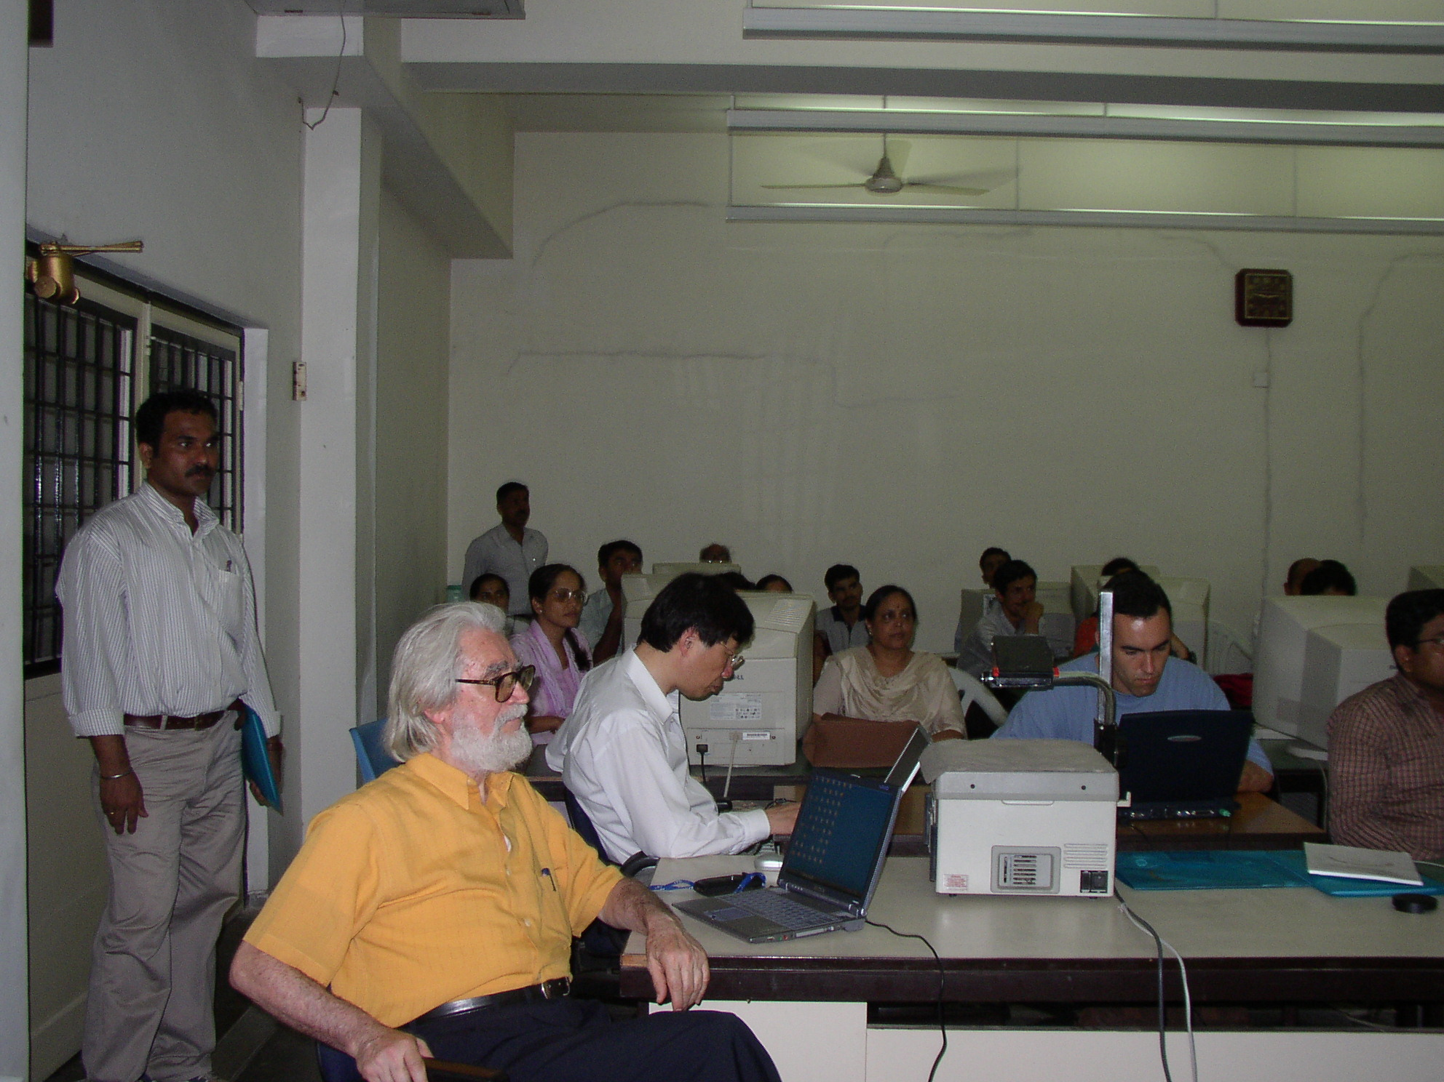

The school at work
The school was inaugurated by Prof. S.C. Lakkad, Deputy Director, IIT Bombay in presence of Prof. Della Denta, Prof. S. Biswas, Head, Computer Science and Engineering Department, IIT Bombay, Dr. Hiroshi Uchida and Prof. Pushpak Bhattacharyya. Prof. Lakkad mentioned the relevance of language research in a country like India. Prof. Biswas acquinted the participants with the activities of the CSE department and mentioned the support given to the UNL research in the department under the supervision of Prof. Bhattacharyya. Subsequently Prof. Della Senta described the phillosphical and societal foundations of the UNL framework and tackled question answers pertaining to this.
Following this began the actual exposition of the UNL technology. The lecture sessions consisted of:
Universal Words (UWs) and the Knowledge Base (KB).
Universal Parser.
Deconverter.
All these were accompanied by elaborate hands-on exercises. The participants downloaded documents from the site http://whc.unesco.org/nwhc/pages/sites/main.htm regarding the heritage sites of India. These were brief descriptions of the sites which were annotated by the participants with UNL tags. These tagged documents were converted into UNL expressions by using the Universal Parser. The UNL expressions then were deconverted to natural language sentences.
The languages represented in the school were:
Assamese, Bengali, Gujarati, Hindi, Kannada. Khasi, Konkani, Marathi,
Oriya, Sanskrit, Sindhi, Tamil, Telegu,
This means almost 2/3rd of the major languages of India, and represents a population of about 200 million people. The participants numbered 34. They were from prestigious academic institutions like the IITs and the Central Institute of Indian languages (CIIL) and industries of repute like the Centre for Development of Advanced computing (CDAC).
Prof. M.G.K. Menon, member UNDL Foundation and ex-chairman, Board of Governors, IIT Bombay addressed the participants of the school on the 10th of June. He underlined the importance of multilingual information processing in current times. Describing the importance of the UNL framework, he mentioned the role of IIT Bombay in India in spreading this technology. The last day of the school was devoted to question answering and feedback from the participants. These were mainly handled by Dr. Uchida and Prof. Bhattacharyya. The participants were given certificates by Prof. Dellasenta and Dr. Uchida.

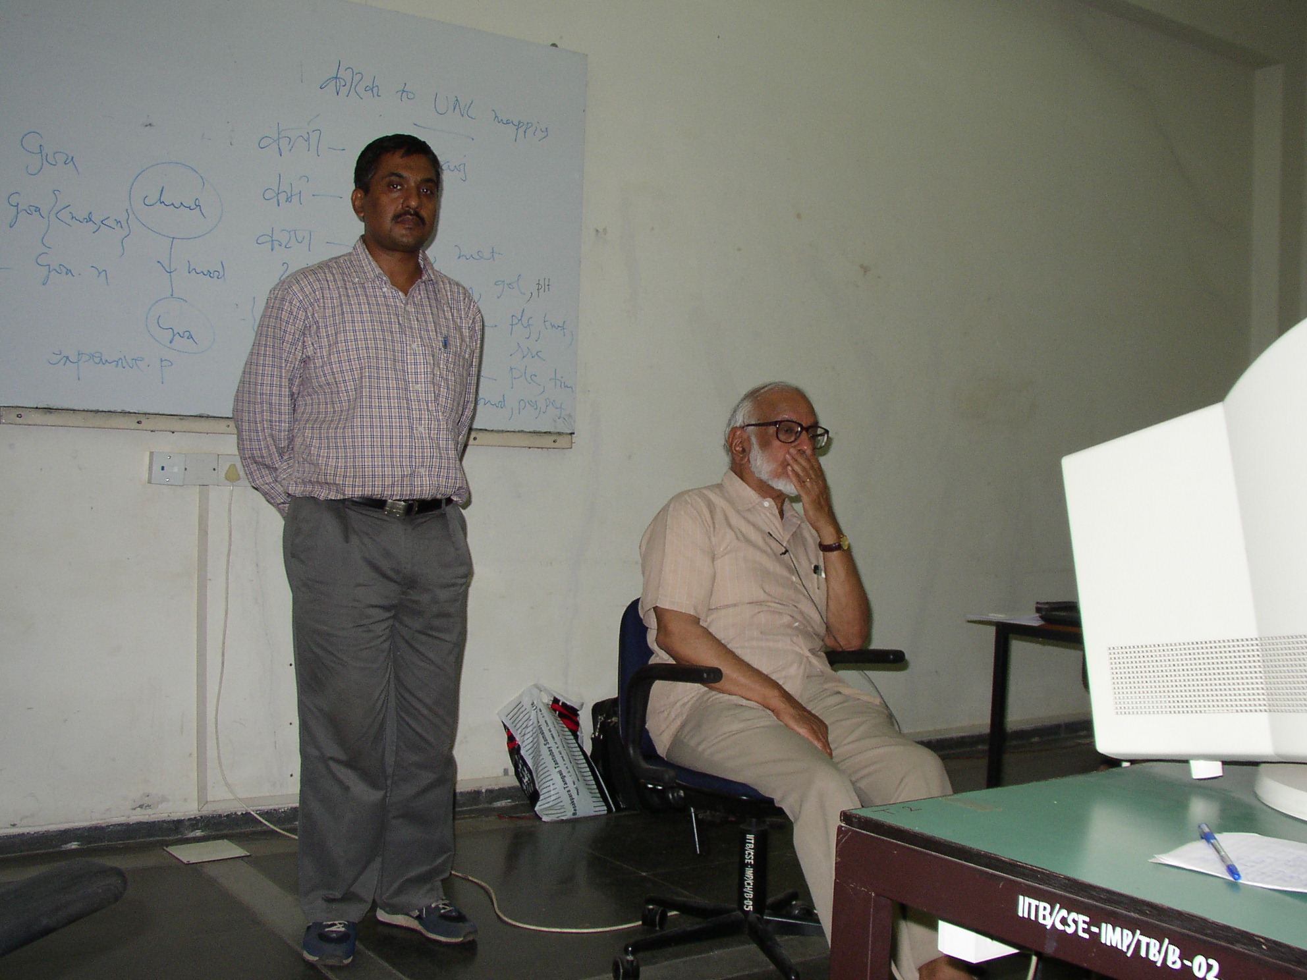

Prof. M.G.K. Menon addressing the participants

The UNL research group from IIT Bombay presented their work on English analysis, Hindi and Marathi analysis and generation, application of UNL to text mining and generation of UNL expressions from syntactic representations of the input sentences.

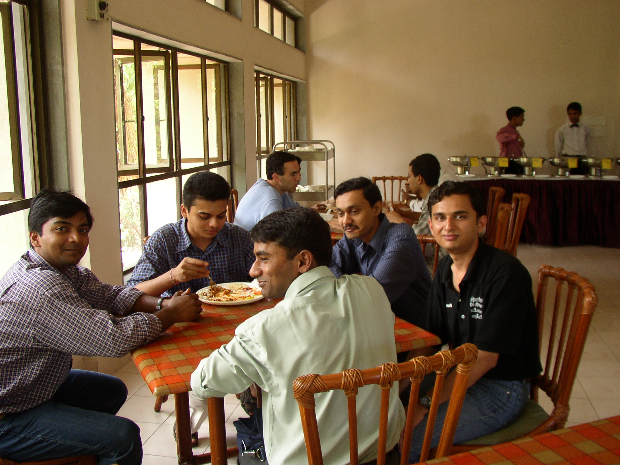

UNL Research Team, IIT Bombay, during lunch.

In the concluding part of the school, Dr. Uchida mentioned that a consortium has been created in Japan devoted to the field of Semantic Computing which will use the UNL technology. Efforts are also on to build the UNL Encyclopedia that will store all the human knowledge in UNL form. A national center for UNL research will be set up in IIT Bombay. This will plan- in consultation with UNDL- Regional schools on UNL in different parts of India.

