A WordNet for Hindi



Prof. Pushpak Bhattacharya,

Centre for Indian Language Solutions,
Computer Science & Eng. Department,
Indian Institute of Technology,
Bombay.

Introduction

An On-line Lexical Database

Organization of a traditional Dictionary

Need for a Lexical Database

Synchronic properties of the mental lexicon

Searching dictionaries conceptually

Division of Wordnet in four categories

- Nouns
- Verbs
- Adjectives
- Adverbs

Organization using synonyms sets

An On-line Lexical Database

Organization

Synonym Sets removes the ambiguity in cases where a single word has multiple meaning or senses.

e.g.
- {Gara, KAMcA},

- {Gara, saMgrahAlaya}

Hindi Wordnet is organized by semantic relationship. Since a

semantic relation is a relation between meanings and since

meanings can be represented by synsets it is natural to think of

semantic relations as links between synsets.

Preparation of Database

Division of task

- Words, Its Polysemy, Homograph, and Synsets Data Entry
- Data entry of other semantic relations
- Re-Organization of the Database
- Generation of a display for user

Use of Hindi Thesaurus

- Part 1 : Anukrama KaMda

- Part 2 : saMxarBa KaMda

Step 1: User Interface for Data Entry

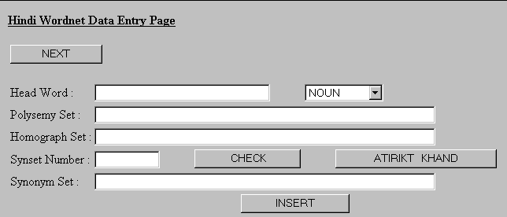

To add an entry in the database for example “aMka”, we look up this word in the “anukrama KaMda” in which words are arranged in alphabetical order .

Sub-headings under the heading “aMka” in given as follows….
aMka
akRara, 410.2
aparAXa,861.1
eka,948.17
kati,147.7
goxI,721.7
GumAvaxAra reKA,968.14
cinha,407.1
etc………

Data Entry Step 1

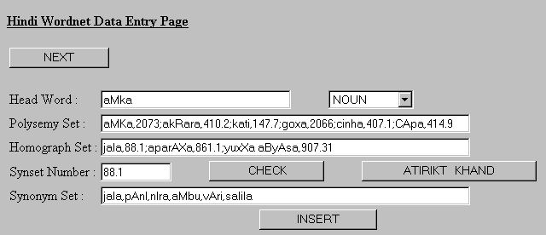

- Put the word “aMka” in the Head Word text box.
- List up the entries from the sub-heading of closely related senses in the Polysemy text box.
- List up entries in the Homograph text box if any.
- Each word is followed by an Index number.
- Each Index number points to an entry in saMxarBa KaMda.
- Preparation of Synonym Sets (Synsets)
- “Check” button enables us to see all the information fed into the database.
- “Atirikt Khand” button gives the details of the synset_ids entered by the linguists, which are not present in the saMxarBa KaMda.

Step 2: User Interface for Data Entry

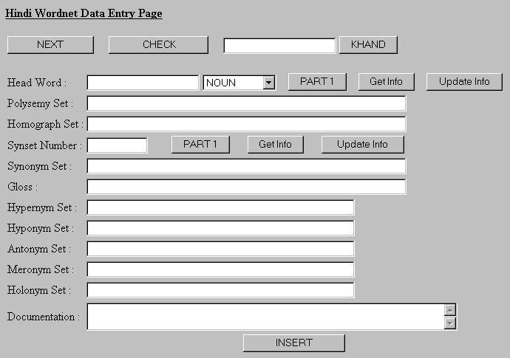

This form is used to retrieve the information entered in Step 1 and complete the entries for other semantic relations.

Data Entry Step 2

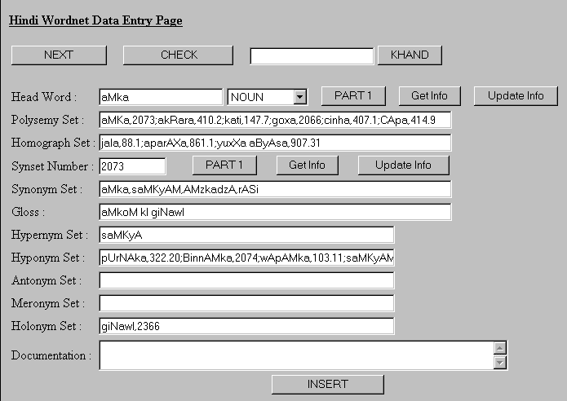
- “Part 1” retrieves the information from the database entered in Step 1.
- “Next” button is used to get to the new headword.
- “Check” button enables us to see all the data in the database.
- “Get Info” is used to view the data previously entered.
- “Update” button is used to modify the entry, which is present in the database.

- Retrieve data till “Synset” text box from the database.
- Enter “Gloss” that describes the concept of the “Synset”.
- Enter Hypernym and Hyponym of the concept implied by the “Synset”.
- Enter Meronym and Holonym, and Antonym for the “Synset”.
- An Index Value follows each word. This value is looked-up from “saMxarBa KaMda”. If the word is not found it is entered in “Atirikt KaMda” and new Index value is assigned.

Step 3: Re-Organization of data

Data Entered in Step 1 & 2 are stored in tables as shown below –

tbl_word_store
Fields | Datatype
word | Char
polysemy_grp | Char
homograph_grp | Char
word_type | Char

tbl_data_store
Fields | Datatype
synset_id | Char
synonym_grp | Char
gloss | Char
hyponym_grp | Char
hypernym_grp | Char
meronym_grp | Char
holonym_grp | Char
antonym_grp | Char

Format of Data stored in columns named as *_grp
<word>,<synset_id>;<word>,<synset_id>;
e.g.
aMKa,2073;akRara,410.2;kati,147.7;goxa,2066;cinha,407.1

Example Data

Tbl_word_store
Fields | Value
Word | Gara
Polysemy_grp | kamarA,614.1;AlA,671.18;koRTaka cinha,425.43; KAMzcA, 970.10;KAnA,671.20;gaMwaya sWAna,1100.2;gQha,601.1; Cixra,271.6;janma kuMdali sWAna,261.8; parivAra jana,726.9; BaMdAra,670.3; vAMSa,727.1; saMgrahAlaya,669.8;svaxeSa, 34.12
Homograph_grp
Word_type | N

Tbl_data_store
Fields | Datatype
Synset_id | 727.1
Synonym_grp | vaMSa,anuvaMSa,kula,KAnaxAna,vaMSaja
Gloss | UMzcA vaMASa
Hyponym_grp | sUrya vaMSa,731.23;yaxu vaMSa,2015.00; ikRvAku vaMSa, 2016.00
Hypernym_grp
Meronym_grp | GarAnA,2014.00;gowra,729.10;upAXi,856.10
Holonym_grp
Antonym_grp

- Organizer Utility is used to parse the data stored and put it in the tables defined below.

tbl_all_words
Fields | Datatype
Synset_id | Char
Word | Char
Word_type | Char

tbl_all_synsets
Fields | Datatype
Synset_id | Char
Synonym_grp | Char
Category | Char
Gloss | Char

tbl_hypernyms
Fields | Datatype
Synset_id | Char
Hyper_synset_id | Char
Hyper_word | Char

tbl_hyponyms
Fields | Datatype
Synset_id | Char
Hypo_synset_id | Char
Hypo_word | Char

tbl_meronyms
Fields | Datatype
Synset_id | Char
Mero_synset_id | Char
Mero_word | Char

tbl_holonyms
Fields | Datatype
Synset_id | Char
Holo_synset_id | Char
Holo_word | Char

tbl_antonyms
Fields | Datatype
Synset_id | Char
Anto_synset_id | Char
Anto_word | Char

tbl_polysemy
Fields | Datatype
Word | Char
Polysemy_word | Char
Polysemy_synset_id | Char
Word_type | Char

Step 4: Generation of Display for the users

- Use of Java JDBC to connect to MySQL server and retrieve the relevant values.
- Use of Java JFC/Swing to create GUI.
- Procedure to search for a given word
  - Tables’ tbl_polysemy and tbl_homograph is searched to get the different senses of the word.
  - Get the synset_id for each sense.
  - Look-up the relative table to retrieve the synset_id of the required relation.
  - Get the Synset for each synset_id and display the formatted result.

References

- [Miller et. al., 1993]
Miller, G. A., Beckwith, R., Fellbaum, C., Gross, D., Miller, K., Introduction to WordNet: An On-line Lexical Database, 1993. Available at URL: http://clarity.princeton.edu:80/~wn/.
- [Miller, 1993]
Miller, G. A., Nouns in WordNet: A Lexical Inheritance System, 1993. Available at URL: http://clarity.princeton.edu:80/~wn/.
- [Fellbaum et. al., 1993]
Fellbaum, C., Gross, D., Miller, K., Adjectives in WordNet, 1993. Available at URL: http://clarity.princeton.edu:80/~wn/.
- [Fellbaum, 1993]
Fellbaum, C., English Verb as a Semantic Net, 1993. Available at URL: http://clarity.princeton.edu:80/~wn/.
- [Beckwith et. al., 1993]
Beckwith, B., Miller, G. A., Tengi, R., Design and Implementation of the WordNet Lexical Database and Searching Software, 1993. Available at URL: http://clarity.princeton.edu:80/~wn/.
- [Frank Parker]
Parker F., “Linguistics for Non-Linguists”.
- [Howard Jackson]
Jackson H., “Words and Their Meaning”.

