CONTENTS

- ABSTRACT

2. INTRODUCTION
  - INTRODUCTION TO PROJECT
  - INTRODUCTION TO ASP.NET
  - INTRODUCTION TO ORACLE 8i

3. SOFTWARE REQUIREMENT SPECIFICATION
  - PURPOSE AND SCOPE
  - GENERAL DESCRIPTION
  - SOFTWARE SPRCIFICATION
  - HARDWARE SPECIFICAION
3.5 FUNCTIONAL REQUIREMENTS

- SYSTEM DESIGN
  - IMPLEMENTATION
  - DESIGN METHODOLOGY
  - DATA BASE DESIGN
  - NORMALIZATION THEORY
  - TABLE DESCRIPTION
  - DATAFLOW DIAGRAMS
  - E.R. STRUCTURE
- CODING

- TESTING
  - TEST PLAN
  - TESTING STRATEGY
  - TEST CASE DESIGN
  - TEST CASE ANALYSIS
- FORMS

- FUTURE ENHANCEMENTS

- CONCLUSION

- BIBILOGRAPHY

ABSTRACT

TITLE: ONLINE ISSUE MANAGEMENT

It’s an intranet application. The main concept for developing the project is conference on the net. We can compare the net Conference with the telephone conference. Only the allowed employees can login, and have conference with other allowed employees and individual conclusion is made.

It is having mainly two modules. One is at Administration Level and other one is of Employees. It maintains authentication in order to access the application. Administrator task includes Employee Registration i.e., new employee recruitment will take place. News and information about company can access employee.

The complaints which are given by employees will be referred by authorities. Issues will put in front of related employees to get proper solutions. For selecting higher posts Elections will be conducted.

The user modules include reading and checking notice and displayed issues. Employees can register complaint against management. Every employee can participate in the elections. Nominees can put their promise on net through canvas module. Results will be displayed for every issue. On an issue an employee can vote only for once. It generates all the related validations.

INTRODUCTION TO PROJECT

Online Issue Management project is mainly divided into two modules. There are
- Administrative Module
- Employee Module

DESCRIPTION:
ADMINISTRATIVE MODULE:
Administrator will have the full authorities on this site. Administrator can do any thing like he can
- Register a New Employee
- Adding a New Branch
This module is further divided into 6 sub modules.
- Notices
- Issues
- Complaints
- Branch
- Nominations
- Set Election Date
Notices:
In this notices module the Administrator will give Branch wise notices. So that every Employee in that concerned branch will know about that notice in time. The notices may be anything like it may be regarding inspection of branches or any general notices etc., at the same time the Administrator can update the notice information and he can delete the notices. Like this notices module further divided into 3 modules.
- Add Notice
- Modify Notice
- Delete Notice

Complaints:
In this Complaints module the administrator can view the complaints of the employees. So that he can know the problems of the employees branch wise. After watching and solving the complaints he can delete the complaints. This module is further divided into two more sub modules.
- View Complaints
- Delete Complaints
Issues:
Issues are the third module of Online Issue Management. In this module the administrator will give any issue or problem and he requests the suggestions on that particular issue. For that he will give some schedules like Issue Date, Closing Date and Result Date. The Administrator can edit, add and delete the issues.
- Add Issue
- Edit Issue
- Delete Issue
Branch:
This module deals with branch details exists in that organization. The Administrator can add or delete a branch. He can update the existing branch details.
Nominations:
In this nominations module the Administrator can view all the Nominations of the Employees for a particular Designation. After viewing all the nominations of a particular election the administrator can accept the nomination or he can reject the nomination. So this module also divided into two sub modules.
- Accept Nomination
- Reject Nomination

Election Schedule:
This module is divided into two sub modules.
- Set
- Alert
In the Set module the administrator will set the Election Date., result displayed date and the nomination closing date. The Administrator will prepare the entire election schedule in this module
In Alert module Administrator can modify the election schedules.
EMPLOYEE MODULE:
In this module the Employee does not have any authority or authentication on the website. He can simply view the information regarding notices. He can give any complaints, he can poll his vote etc., this module is further divided into 8 sub-modules.
- Notices
- Issues (View)
- Complaints
- Election
- Voting
- Nomination
- Result
- Canvas
Notices:
In Notices sub module the employee can watch/view the notice send by the higher authority to his branch.
Issue:
In this issue module he can wanted the issue details like issue topic, issue closing date, result date etc., He can vote for the issue topic.
Complaints:
In this sub module if the employee has any problems he can give the complaints to the higher authorities. These complaints will be stored branch wise.
Election:
In this election module the employee can watch the election details like election date, nomination closing date, result displayed date given by the authorities. According to the he can put nomination or he can utilize his vote.
Voting:
Through this employees can express this opinion. He can vote for right candidate and employee can vote only once. All validations includes in this module.
Nomination:
Incase Employee wants to participate in the election as a member then he can nominate through this module.
Result:
This is divided into two more sub modules.
- Issue result
- Election result
In this issue result employee can view a particular issue result. In election result he can view who has won in the election.
Canvas:
The nominated candidates can put all his views and promises in this canvas. So that the employees who are going to participate in the elections can know the views of the nominees.

INTRODUCTION TO ASP.NET

ASP.NET is a programming framework built on the common language runtime that can be used on a server to build powerful Web applications. ASP.NET offers several important advantages over previous Web development models:
- Enhanced Performance. ASP.NET is compiled common language runtime code running on the server. Unlike its interpreted predecessors, ASP.NET can take advantage of early binding, just-in-time compilation, native optimization, and caching services right out of the box. This amounts to dramatically better performance before you ever write a line of code.
- World-Class Tool Support. The ASP.NET framework is complemented by a rich toolbox and designer in the Visual Studio integrated development environment. WYSIWYG editing, drag-and-drop server controls, and automatic deployment are just a few of the features this powerful tool provides.
- Power and Flexibility. Because ASP.NET is based on the common language runtime, the power and flexibility of that entire platform is available to Web application developers. The .NET Framework class library, Messaging, and Data Access solutions are all seamlessly accessible from the Web. ASP.NET is also language-independent, so you can choose the language that best applies to your application or partition your application across many languages. Further, common language runtime interoperability guarantees that your existing investment in COM-based development is preserved when migrating to ASP.NET.
- Simplicity. ASP.NET makes it easy to perform common tasks, from simple form submission and client authentication to deployment and site configuration. For example, the ASP.NET page framework allows you to build user interfaces that cleanly separate application logic from presentation code and to handle events in a simple, Visual Basic - like forms processing model. Additionally, the common language runtime simplifies development, with managed code services such as automatic reference counting and garbage collection.
- Manageability. ASP.NET employs a text-based, hierarchical configuration system, which simplifies applying settings to your server environment and Web applications. Because configuration information is stored as plain text, new settings may be applied without the aid of local administration tools. This "zero local administration" philosophy extends to deploying ASP.NET Framework applications as well. An ASP.NET Framework application is deployed to a server simply by copying the necessary files to the server. No server restart is required, even to deploy or replace running compiled code.
- Scalability and Availability. ASP.NET has been designed with scalability in mind, with features specifically tailored to improve performance in clustered and multiprocessor environments. Further, processes are closely monitored and managed by the ASP.NET runtime, so that if one misbehaves (leaks, deadlocks), a new process can be created in its place, which helps keep your application constantly available to handle requests.
- Customizability and Extensibility. ASP.NET delivers a well-factored architecture that allows developers to "plug-in" their code at the appropriate level. In fact, it is possible to extend or replace any subcomponent of the ASP.NET runtime with your own custom-written component. Implementing custom authentication or state services has never been easier.
- Security. With built in Windows authentication and per-application configuration, you can be assured that your applications are secure.

Language Support
The Microsoft .NET Platform currently offers built-in support for three languages: C#, Visual Basic, and JScript.

INTRODUCTION TO ORACLE

Oracle 8i is an Object Relational Database Management system .It offers capabilities of both relational and object-oriented database systems. In general, objects can be defined as reusable software codes which are location independent and perform a specific task on any application environment with little or no change to the code.
Oracle products are based on the concept known as the ‘client/server Technology’. This concept involves segregating the processing of an application between two systems. One performs all activities related to the database (server) and the other performs activities that help user to interact with the application (client).
A client or front end database application also interacts with the data base by requesting and receiving information from the ‘database server’. It acts as an interface between the user and the database. Further it also checks for validation against the data entered by the user.
SQL * PLUS
SQL AND PL/SQL
Among the many application development and end user products available with in the Oracle family there is a common ability to access the database. Whether directly or in directly this is achieved through the Structured Query Language (SQL). This query language has been useful in developing the software in an efficient way. The Query language has Data Definition Language (DDL), Data Manipulation Language (DML) and Data Control Language (DCL).
Data definition language helps in defining various database objects such as Tables and views. This has been useful in defining all the relational tables of the project. It has also been used in creating many views providing for information hiding and data security. Alteration of the existing tables is also supported by Data Definition Language(DDL).
Data Manipulation Language(DML) is the most important of the query Language. This has features for inserting records into the tables, Deleting the existing records from the tables, Updating the existing records in the tables and retrieving the data from one or more tables as and when required. This has been used to fulfill the objectives of the organization. Other packages like Foxpro and Dbase do not have such features and hence make the job of querying more complex.
Data Control Language(DCL) is used for controlling data and having access to the databases. This part of the language provides extensive security features in order to safe guard the users information from both unauthorized access and intentional damage. Security is provided by granting and revoking privileges. Oracle uses have names and passwords and own tables, views and other database objects.
PL/SQL :
This is a procedural extension to the non procedural SQL. It combines the data manipulation power of SQL and procedural power of standard procedural languages. It supports sub-programming features such as procedures and functions, triggers, packages, exceptions and integrates well with SQL* PLUS and other application development products of ORACLE.
These facilities have eased the job of developing the software to meet the organizational requirements. Many similar programming logic have been coded as functions and procedures and have been used in many areas. For Example retrieving the records, Calculation of various parameters of Pay etc. This has been a big advantage in developing the package.
The facility of triggers has been used to generate actions based on some database events. For example the software, on insertion of records generates an error message if the record already exists. For deletion of records the software generates an error message if the record with the given primary key value does not exist. Similarly for selection of records the software generates error messages if the record is not present.
The facility of exceptions also helped in developing a user friendly package. Exceptions are raised and a suitable actions are taken when errors occur such as ‘when no data found’, ‘Too many rows’ etc. The facility of Cursors where used in retrieving records one bye one in an orderly way. This helps in management in viewing the records one after other to get the required information about each employee. This usage of Cursors eliminates many errors such as ‘Too many rows’ etc. Each record can be retrieved and studied for any amount OD time before retrieving the next record. Cursors retrieve the records in ascending order of the values of the primary Key.
Reasons for Choosing Oracle
Direct SQL interface to the database through SQL Plus lets developers and users interact with the database and manipulate it directly. The interactive Developer 2000 FORMS 4.5 helps us to produce prototype applications quickly. These prototypes can be used as basic units for the real application. Additional changes to these applications can be done in a very short time .There are three types of modules one can create with FORMS. They are:
FORMS : Allows creation deletion and updation of data
MENUS : Helps to define a set of main menus for the application and also the various submenus associated with the main menu.
Library : A repository of centralized PL/SQL code accessed by other form modules.
3. The portability of the applications developed using SQL Forms to any platform like Mainframes or Mini Computers can be achieved.
4. Oracle has the capability top interface with a wide variety of third generation languages such as C COBOL PASCAL.
5. Oracle is the most popularly used RDBMS in the recent because it satisfies most of the twelve CODD’s rules for an RDBMS package like
- View Updation
- High level insert delete update
- Physical data independence
- Systematic treatment of NULL values
- Integrity Independence
- Non subversion
- Distributed Independence
- Comprehensive data sub language
- Guaranteed access
- Logical Data Independence
- Information Representation
- Dynamic on-line catalog based relational model

6. Oracle has its own CASE tools designed to help business requirements and to generate data entry and reporting modules.

The components are
- CASE Designer
- CASE Dictionary
- Oracle forms generator
- Oracle reports generator
MODULARITY:
Software architecture embodies modularity i.e. software is dividing into separately named and addressable components called modules that are integrated to satisfy problem requirements. Modularity is the single attribute software that allows a program to be intellectually manageable. It is easier to solve a complex problem when it is divided or broken down into manageable pieces using the divide and conquer principle. ORACLE allows us to embed this principle while developing applications. ORACLE allows us to implement individual modules thus enhancing the modularity.

SOFTWARE REQUIREMENT SPECIFICATION

PURPOSE: The main concept for developing the project “ONLINE ISSUE MANAGEMENT” is conference on the net. We can compare the net conference with the telephone conference. Only the allowed employees can login, and have conference with other allowed employees and individual conclusion is made.
SCOPE: This document is only one that describes the requirements of the system. It is meant of the use by the developers and will be the basis for validating the final delivered system. Any changes made to the requirements in the feature will have of through a formal changes approval process. The developer is responsible for clarification, where necessary, and will not make any alternation without the permission of the client.

GENERAL DESCRIPTION:
User Characteristics:
In this system the main user is the Administrator. Administrator task includes Employee Registration i.e., new employee recruitment will take place. News and information about company can access employee. The complaints which are given by employees will be referred by authorities. Issues will put in front of related employees to get proper solutions. For selecting higher posts Elections will be conducted.

Developers Responsibilities Overview:
The developer is responsible for the following

Developing the system
Installing software on the client’s hardware
For conducting any user training that might be needed for using the system.
Software Specification:

Operating system: Windows 2000 Server
Front - End : ASP.NET
Back - End : Oracle 8i
Hardware Specification:
Processor : Pentium 3
Ram : 128 MB
Hard disk : 20 GB
Functional Requirements:
Inputs:
Various inputs to the system are through the following files or forms:

ADMIN : adminid, password
BRANCH: branchcode,branchname,address,city, state, country, phoneno
ISSUE : issueno, issuedate, issue,issuelosingdate,branchcode, yes,no,neutral
NOTICE : noticeno, noticedate, notice, branchcode
NOMINATION : empid, brachcode, message
COMPLAINT : complaintno, complaintdate, complaint, branchcode
NETVOTEEMP : empid, name, department, designation, address, password, branchcode
ELECTION : electioncode, empid, votes, branchcode
VOTE : empid, branchcode,votedate
ELECTIONDATE : branchcode, eletiondate, electionresultdate,electionclosingdate
outputs :
Outputs produced by the System are :
Report on Issue Results
Report on Election Results
Report on Candidates Canvasing

SYSTEM DESIGN
The primary activity during data design is to select logical representations of data objects identified during requirement analysis and software analysis. A data dictionary explicitly represents the relationships among data objects and the constrains on the elements of the data structure. A data dictionary should be established and used to define both data and program design.
Design of software involves conceiving planning out and specifying the externally observable characteristics of the software product. We have data design, architectural design and user interface design in the design process. These are explained in the following section. The goal of design process is to provide a blue print for implementation, testing and maintenance activities.
IMPLEMENTATION:
Implementation is the stage where the theoretical design is turned into a working system. The most crucial stage in achieving a new successful system and in giving confidence on the new system for the users that it will work efficiently and effectively.
The system can be implemented only after thorough testing is done and if it is found to work according to the specification.
It involves careful planning, investigation of the current system and its constraints on implementation, design of methods to achieve the change over and an evaluation of change over methods a part from planning. Two major tasks of preparing the implementation are education and training of the users and testing of the system.
The more complex the system being implemented, the more involved will be the systems, analysis and design effort required just for implementation.
The implementation phase comprises of several activities. The required hardware software acquisition is carried out. The system may require some software to be developed. For this, programs are written and tested. The user then changes over to his new fully tested system and the old system is discontinued.
Design Methodology:
The design process for software system has two levels.
- System Design or Top level design
- Detailed Design or Logical Design
System Design:
In the system design the focus on the deciding which modules are needed for the system, the specification of these modules and how these modules should be interconnected.
Detailed Design
In detailed design the interconnection of the modules or how the specifications of the modules can be satisfied is decided. Some properties for a software system design are
- Verifiability
- Completeness
- Consistency
- Traceability
- Simplicity / Understandability

DATABASE DESIGN:
The data base structure is a model of the enterprise and should represent accurately and support its needs. The design process must have the support of all the functional areas need to describe and define the data elements from management and ensure view points. The data pertaining to proposed system is voluminous that a careful design of the database must proceed before storing the data in the database.
A database management system provides flexibility in the storage and retrieval of data bad production of information. The DBMS is a bridge between the application program, which determines what data are needed and how they are processed, and the operating system of the computer, which is responsible for placing data on the magnetic storage devices. A schema defines the database and a subschema defines the portion of the database that a specific program will use.
Data Model:
The organization of the data is represented by a data model and identifies the logical organization of data. In a model of real world similar things are usually grouped into classes of object called object types.
A data model is a pattern according to which data are logically organized. It consists of the named logical units of data and expresses the relationships among the data as determined by the interpretation of the model of real world.
The relational data model is a formal model for representing relationships among attributes of an entity set and the association between entity sets.
In the relational data model all attribute relationships and all associations are represented as relations. There is no distinction even at the model level, between the different kinds or relations. Syntactically all the relations are the same. The data model does not produce the introduction of additional semantic information to distinguish different relations according to their properties of models namely:
Network Model
Hierarchical data model
Relational Data model
The design of the database will be only as good as the definitions as the data elements and their relationships. Infect the design process is definition of the organization in terms of its input entities and intrinsic relations.
ENTITY:
An entity is an object, which exists and is distinguishable from other objects. An entity set is of the same type. The various entities in our system are unit codes, section codes, product codes, division-section codes, store code, etc.
ATTRIBUTE:
An attribute is a function, which maps the entity set into a domain. An entity has a various attributes, which we may wish to record such as monetary value or name. Each and every entity is defined by a set of attributes.
DATA ITEM:
The smallest unit of data that has meaning to its users is called a DATA ITEM. It is also called a field or data element. Data items are the modules of the database. These are groups together to form records.
A normal group of data items with in a record is referred to as a data aggregate or segment.
RELATIONSHIP:
A relationship is an association among two or more entities. A relationship is a set of relationships of the same data type.
MAPPING CONSTRAINTS:
This expresses the number of entities to which another entity can be associated via relationship. In our system we have the following mapping constraints:
ONE TO MANY:
An entity in A is associated with any number of entities in B, how ever, can be associated with at most one entity in A. For example each Employee will have one Department number but the same Department number may be there for more Employees. Hence one to many relation is established.

IDENTIFIERS:
The primary key denotes a candidate key to identify a particular entity from other entities. A weak entity does not have a primary key.
NORMALIZATION THEORY:
Relations are to be normalized to avoid anomalies. In insert, update and delete operations. Normalization theory is built around the concept of normal forms. A relation is said to be in a particular form if it satisfies a certain specified set if constraints. To decide a suitable logical structure for given database design the concept of normalization, which are briefly described below.
- 1st Normal Form (1NF): A relation is said to be in 1 NF is and only if all unaligned domains contain values only. That is the fields of an n-set should have no group items and no repeating groups.
- 2nd Normal Form (2NF): A relation is said to be in 2 NF is and only if it is in 1 NF and every non key attribute is fully dependent on primary key. This normal takes care of functional dependencies on non-key attributes.
- 3rd Normal Form (3NF) : A relation is said to be in 3 NF is and only if it is in 2 NF and every non key attribute is non transitively dependent on the primary key.
This normal form avoids the transitive dependencies on the primary key.
- Boyce/code Normal Form (BCNF): This is a stronger definition than that of NF. A relation is said to be in BCNF if and only if every determinant is a Candidate key.
- 4th Normal Form (4NF) : A relation is said to be in 4 NF if and only if whenever there exists a multi valued dependency in a relation say A->->B then all of the relation are also functionally dependent on A(i.e. A->X for all attributes x of the relation.).
- 5th Normal Form (5NF) OR Projection Join Normal Form (PJNF): A relation R is in 5 NF if and only if every join dependency in R is implied by the candidate key on R. A relation can’t be non-loss split into two tables but can be split into three tables. This is called Join Dependency.
TABLE DESCRIPTION:

1. TABLE : ADMIN

NAME | NULL ? | TYPE
ADMINID |  | VARCHAR2(8)
PASSWORD |  | VARCHAR2(8)

2. TABLE : BRANCH

NAME | NULL ? | TYPE | CONSTRAINT
BRANCHCODE | NOT NULL | VARCHAR2(8) | PRIMARY KEY
BRANCHNAME | NOT NULL | VARCHAR2(25)
ADDRESS | NOT NULL | VARCHAR2(35)
CITY | NOT NULL | VARCHAR2(20)
STATE | NOT NULL | VARCHAR2(50)
COUNTRY | NOT NULL | VARCHAR2(20
PHONENO |  | NUMBER(8)
3. TABLE : ISSUE

NAME | NULL ? | TYPE | CONSTRAINT
ISSUENO | NOT NULL | NUMBER(5) | PRIMARY KEY
ISSUEDATE | NOT NULL | DATE
ISSUE | NOT NULL | VARCHAR2(100)
ISSUELOSINGDATE | NOT NULL | DATE
BRANCHCODE | NOT NULL | VARCHAR2(5) | FOREIGN KEY
YES |  | NUMBER(5)
NO |  | NUMBER(5)
NEUTRAL |  | NUMBER(5)

4. TABLE : NOTICE

NAME | NULL ? | TYPE | CONSTRAINT
NOTICENO | NOT NULL | NUMBER(18) | PRIMARY KEY
NOTICEDATE | NOT NULL | DATE
NOTICE | NOT NULL | VARCHAR2(100)
BRANCHCODE | NOT NULL | VARCHAR2(5) | FOREIGN KEY

5.. TABLE : NOMINATION

NAME | NULL ? | TYPE | CONSTRAINT
EMPID | NOT NULL | VARCHAR2(8) | FOREIGN KEY
BRANCHCODE | NOT NULL | VARCHAR2(8) | FOREIGN KEY
MESSAGE | NOT NULL | VARCHAR2(100)

6. TABLE : COMPLAINT

NAME | NULL ? | TYPE | CONSTRAINT
COMPLAINTNO | NOT NULL | NUMBER(18) | PRIMARY KEY
COMPLAINTDATE | NOT NULL | DATE
COMPLAINT | NOT NULL | CHAR(200)
BRANCHCODE | NOT NULL | VARCHAR2(8) | FOREIGN KEY

7. TABLE : NETVOTEEMP

NAME | NULL ? | TYPE | CONSTRAINT
EMPID | NOT NULL | VARCHAR2(8) | PRIMARY KEY
NAME | NOT NULL | VARCHAR2(18)
DEPARTMENT | NOT NULL | VARCHAR2(18)
DESIGNATION | NOT NULL | VARCHAR2(18)
ADDRESS |  | NUMBER(15)
PASSWORD | NOT NULL | VARCHAR2(8)
BRANCHCODE | NOT NULL | VARCHAR2(8) | FOREIGN KEY

8. TABLE : ELECTION

NAME | NULL ? | TYPE | CONSTRAINT
ELECTIONCODE | NOT NULL | NUMBER(18) | PRIMARY KEY
EMPID | NOT NULL | VARCHAR2(8) | FOREIGN KEY
VOTES | NOT NULL | NUMBER(18)
BRANCHCODE | NOT NULL | VARCHAR2(8) | FOREIGN KEY

9. TABLE : VOTE

NAME | NULL ? | TYPE | CONSTRAINT
EMPID | NOT NULL | VARCHAR2(8) | FOREIGN KEY
BRANCHCODE | NOT NULL | VARCHAR2(8) | FOREIGN KEY
VOTEDATE | NOT NULL | DATE
10. TABLE : ELECTIONDATE

NAME | NULL ? | TYPE | CONSTRAINT
BRANCHCODE | NOT NULL | VARCHAR2(8) | FOREIGN KEY
ELECTIONDATE | NOT NULL | DATE
ELECTIONRESULTDATE | NOT NULL | DATE
ELECTIONCLOSINGDATE | NOT NULL | DATE
DATA FLOW DIAGRAMS

It is one of the most important modeling tools used by system analysts. It is used to illustrate how data flows in a system. DFD’s use a number of symbols to represent systems. There are four kinds of symbols. These are used to represent four kinds of system components. Processes, data stores, data flows and external entities
Components of a DFD :

a) Process : Process show what systems do. Each process has one or more data inputs and produces one or more data outputs. Processes are represented by circles in a DFD.

→ PROCESS

b) Data Store : A Component of a DFD that describes the repository of data in a system.

- DATASTORE

c) External Entity : An object outside the scope of the system. It is represented in a box.

- External Entity

d) Data flow : It shows how data flows between process, data stores and external entities. They model the passage of data in the system and are represented by lines joining system components.

- data flow
We have no control of flows between external entities. So we do not model them.

Context Level

UID, PWD RESULT

Net voting
1.0

Administrator

Employee

Admin home page

Emp home page

UID, PWD RESULT

Password Checking

Valid Option

Login

Menu
Admin
Notice

Issues

Not valid

Complaints

Branch

Nominations

Reg emp

Election

Notices
Branch db

Notice

Add

Update

Delete
Notice db

Issues
Branch db

Issues

Add

Delete

Issue db

Modify

Nomination accepting or Rejecting

Nominations

Accept

Reject
Nomination db

View Notices

View

Notice

View

Issues

Screen

Notice db

Screen

Issues db

View Issues

Add complaints

Add

Complaints

Complaints db

View Election Schedule

View

Election

Screen

Employee Nomination

Nomination
add

Voting

Nomination DB

Issue result

Result

Election
result

Issue db

Election db
screen

Results

Candidates
view

Canvas

Nomination db

Election db

Screen

Canvas

E.R. Structure

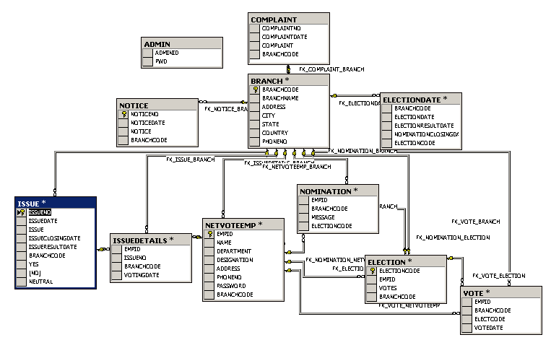

CODING

LOGIN FORM:
Imports System.Data.OleDb
Dim CON As OleDbConnection
Private Sub Page_Load(ByVal sender As System.Object, ByVal e As System.EventArgs) Handles MyBase.Load
'Put user code to initialize the page here
CON = Application("CON")
If Not Page.IsPostBack Then
If Application("CON").STATE = 1 Then Application("CON").CLOSE()
Application("CON").OPEN()
End If

End Sub

Private Sub Button1_Click(ByVal sender As System.Object, ByVal e As System.EventArgs) Handles Button1.Click
Dim SCMD As OleDbCommand
SCMD = New OleDbCommand("SELECT LOGIN,PWD FROM ADMIN WHERE LOGIN='" & TextBox1.Text & "' AND PWD='" & TextBox2.Text & "'", CON)
Dim DR As OleDbDataReader
DR = SCMD.ExecuteReader()
If Not DR.Read() Then
Label4.Visible = True
Else
Response.Redirect("webform5.aspx")
End If
DR.Close()
End Sub

Private Sub Button2_Click(ByVal sender As System.Object, ByVal e As System.EventArgs) Handles Button2.Click
Response.Redirect("webform4.aspx")
End Sub
End Class

REGISTRATION OF AN EMPLOYEE:
Imports System.Data.OleDb
Dim CON As OleDbConnection
Private Sub Page_Load(ByVal sender As System.Object, ByVal e As System.EventArgs) Handles MyBase.Load
CON = Application("CON")

'Put user code to initialize the page here
If Not Page.IsPostBack Then
If Application("con").stATE = 1 Then Application("CON").CLOSE()
Application("CON").OPEN()
End If
End Sub

Private Sub Button1_Click(ByVal sender As System.Object, ByVal e As System.EventArgs) Handles Button1.Click
Dim ICMD As OleDbCommand
Dim SCMD As OleDbCommand
'Dim STR ="SELECT LOGIN,PWD FROM ADMIN WHERE LOGIN='" & TextBox1.Text & "' AND PWD='" & TextBox2.Text & "'"
'RESPONSE.WRITE(STR)
SCMD = New OleDbCommand("SELECT LOGIN,PWD FROM ADMIN WHERE LOGIN='" & TextBox1.Text & "' AND PWD='" & TextBox2.Text & "'", CON)
Dim DR As OleDbDataReader
DR = SCMD.ExecuteReader()
If Not DR.Read() Then
DR.Close()
ICMD = New OleDbCommand("INSERT INTO ADMIN VALUES('" & TextBox1.Text & "','" & TextBox2.Text & "','" & TextBox3.Text & "','" & TEXTAREA1.Value & "'," & CInt(TextBox4.Text) & ",'" & TextBox5.Text & "')", Application("CON"))
Dim R As Integer
R = ICMD.ExecuteNonQuery()
Label9.Visible = True
Response.Redirect("WEBFORM3.ASPX")
'Response.Redirect("HTTP://LOCALHOST/ONLINE/WEBFORM39.ASPX")
Else
DR.Close()
Label8.Visible = True
End If
DR.Close()

End Sub
End Class

DELETING OR MODIFYING BRANCH:

Imports System.Data.OleDb
Dim con As OleDbConnection
Dim l As ListItem
Dim adp As OleDbDataAdapter
Dim ds As New DataSet()
Dim dt As DataTable
Dim i
Private Sub Page_Load(ByVal sender As System.Object, ByVal e As System.EventArgs) Handles MyBase.Load
'Put user code to initialize the page here
If Not Page.IsPostBack Then
If Application("con").state = 1 Then Application("con").close()
Application("con").open()
con = Application("con")

Dim scmd As OleDbCommand

scmd = New OleDbCommand("select bcode from branch", Application("con"))

adp = New OleDbDataAdapter("select bcode from branch", con)
adp.Fill(ds, "branch")
Dim i As Integer
dt = ds.Tables("branch")
For i = 0 To dt.Rows.Count - 1
dl.Items.Add(dt.Rows(i)(0))
Next

End If

End Sub

Private Sub dl_SelectedIndexChanged(ByVal sender As System.Object, ByVal e As System.EventArgs) Handles dl.SelectedIndexChanged
Dim cmd1 As OleDbCommand
l = dl.SelectedItem()
i = l.ToString
cmd1 = New OleDbCommand("select * from branch where bcode=" & CInt(i), Application("con"))
Dim dr1 As OleDbDataReader
dr1 = cmd1.ExecuteReader()
dr1.Read()
TextBox2.Text = dr1(1)
TextBox3.Text = dr1(2)
TextBox4.Text = dr1(3)
TextBox5.Text = dr1(4)
TextBox6.Text = dr1(5)
TextBox7.Text = dr1(6)
dr1.Close()
End Sub

Dim i As Integer
Dim l2 As ListItem
l2 = dl.SelectedItem
i = l2.ToString
Dim dcmd As OleDbCommand
dcmd = New OleDbCommand("delete from branch where bcode=" & CInt(i), Application("con"))
Dim r As Integer
r = dcmd.ExecuteNonQuery

End Sub

Private Sub Button2_Click(ByVal sender As System.Object, ByVal e As System.EventArgs) Handles Button2.Click
Dim j As Integer
Dim ll As ListItem
ll = dl.SelectedItem
j = ll.ToString
Dim ucmd As OleDbCommand
Dim str
str = "update branch set bname='" & TextBox2.Text & "',address='" & TextBox3.Text & "',city='" & TextBox4.Text & "',country='" & TextBox5.Text & "',state='" & TextBox6.Text & "',phno=" & CInt(TextBox7.Text) & " where bcode=" & CInt(j)
ucmd = New OleDbCommand(str, Application("con"))
Dim rr As Integer
rr = ucmd.ExecuteNonQuery

End Sub
End Class

SET ELECTION DATE:

Imports System.Data.OleDb
Dim con As OleDbConnection
Dim adp As OleDbDataAdapter
Dim ds As New DataSet()
Dim dt As DataTable
Dim l As ListItem
Dim k
Private Sub Page_Load(ByVal sender As System.Object, ByVal e As System.EventArgs) Handles MyBase.Load
If Not Page.IsPostBack Then
If Application("con").state = 1 Then Application("con").close()
Application("con").open()

End If
con = Application("con")
adp = New OleDbDataAdapter("select bcode from branch", con)
adp.Fill(ds, "branch")
Dim i As Integer
dt = ds.Tables("branch")
For i = 0 To dt.Rows.Count - 1
dl.Items.Add(dt.Rows(i)(0))
Next
'Put user code to initialize the page here

End Sub

Private Sub Button1_Click(ByVal sender As System.Object, ByVal e As System.EventArgs) Handles Button1.Click
l = dl.SelectedItem
k = l.ToString
Dim icmd As OleDbCommand
' Dim str = "insert into election values(" & CInt(k) & ",to_date(" & CDate(TextBox1.Text) & ",'mm-dd-yyyy'),to_date(" & CDate(TextBox2.Text) & ",'mm-dd-yyyy'),to_date(" & CDate(TextBox3.Text) & ",'mm-dd-yyyy'))"
' Response.Write(str)
icmd = New OleDbCommand("insert into election values(" & CInt(k) & ",'" & TextBox1.Text & "','" & TextBox2.Text & "','" & TextBox3.Text & "')", Application("con"))
Dim r As Integer
r = icmd.ExecuteNonQuery
End Sub
End Class

VOTING BY EMPLOYEE:
Imports System.Data.OleDb
Dim con As OleDbConnection
Dim adp1, adp2 As OleDbDataAdapter
Dim dt1 As DataTable
Dim ds1 As New DataSet()
Dim l1, l2 As ListItem
Dim i, j
Private Sub Page_Load(ByVal sender As System.Object, ByVal e As System.EventArgs) Handles MyBase.Load

If Not Page.IsPostBack Then
If Application("con").state = 1 Then Application("con").close()
Application("con").open()
con = Application("con")
adp1 = New OleDbDataAdapter("select distinct bcode from nomination",con)
adp1.Fill(ds1, "nomination")
dt1 = ds1.Tables("nomination")
Dim r As Integer
For r = 0 To dt1.Rows.Count - 1
dl1.Items.Add(dt1.Rows(r)(0))
Next
'adp2 = New OleDbDataAdapter("select eid from empl", con)
'adp2.Fill(ds2, "empl")
'dt2 = ds2.Tables("empl")
'Dim r1 As Integer
'For r1 = 0 To dt2.Rows.Count - 1
'dl1.Items.Add(dt2.Rows(r1)(0))
'Next
End If
End Sub

Private Sub dl1_SelectedIndexChanged(ByVal sender As System.Object, ByVal e As System.EventArgs) Handles dl1.SelectedIndexChanged
dl2.Items.Clear()
Dim cmd1 As OleDbCommand
l1 = dl1.SelectedItem
i = l1.ToString
cmd1 = New OleDbCommand("select eid from nomination where bcode=" & CInt(i) & " and ar='A'", Application("con"))
Dim ff As OleDbDataReader
ff = cmd1.ExecuteReader
Do While ff.Read
dl2.Items.Add(ff(0))
Loop
ff.Close()
cmd1.Dispose()
Label6.Visible = False
End Sub

Private Sub dl2_SelectedIndexChanged(ByVal sender As System.Object, ByVal e As System.EventArgs) Handles dl2.SelectedIndexChanged
con = Application("con")
l2 = dl2.SelectedItem
j = l2.ToString
Dim cmd2 As OleDbCommand
cmd2 = New OleDbCommand("select name,nid from nomination where eid=" & CInt(j), Application("con"))
Dim gg As OleDbDataReader
gg = cmd2.ExecuteReader
gg.Read()
TextBox2.Text = gg(0)
TextBox1.Text = gg(1)
gg.Close()
Label6.Visible = False
End Sub

Private Sub Button1_Click(ByVal sender As System.Object, ByVal e As System.EventArgs) Handles Button1.Click
Dim cmd2 As OleDbCommand
cmd2 = New OleDbCommand("select * from nomination where userid='" & Session("uid") & "'", Application("con"))
Dim kk As OleDbDataReader
kk = cmd2.ExecuteReader
If kk.Read Then
Label6.Text = "Sorry You have already voted"
Label6.Visible = True
kk.Close()
cmd2.Dispose()
Else
kk.Close()
Dim ucmd As OleDbCommand
ucmd = New OleDbCommand("update nomination set votes=nvl(votes,0)+1,nomination_name='" & Session("ename") & "',userid='" & Session("uid") & "' where nid=" & CInt(TextBox1.Text), Application("con"))
Dim r As Integer
r = ucmd.ExecuteNonQuery
End If

End Sub
End Class

TESTING

Test Plan
The importance of software testing and its implications cannot be overemphasized. Software testing is a critical element of Software Quality Assurance and represents the ultimate review of the specifications, design and coding.
Testing Objectives:
The main objective of testing is to uncover a host of errors, systematically and with minimum effort and time. Stating formally, we can say,
- Testing is a process of executing a program with the intent of finding an error.
- A successful test is one that uncovers an as yet undiscovered error.
- A good test case is one that has a high probability of finding error, if it exists.
But there is one thing that testing cannot do (just to quote a very famous sentence) “Testing cannot show the absence of defects, it can only show that software defects are presents.”
As the test results are gathered and evaluated they begin to give a qualitative indication of the reliability of the software. If severe errors are detected, the overall quality of the software is a natural suspect. If, on the other hand, all the errors, which are encountered, are easily modifiable, then one of the two conclusions can be made:
- The tests are inadequate to detect possibly present errors.
- The software more or less confirms to the quality and reliable standards.
For the purpose of the current project we are assuming that in the event that errors that are easily modifiable points to the latter possibility, since repeating the entire testing routine can be very time consuming. What we propose to do instead is to get it tested by one or more persons who are not a part of the development team but is well versed with the subject and with the concept of software testing (alpha testing). If he can detect no serious errors, it will enable us to state with more confidence that the software does actually conform to the expected standards.
Testing Strategy:
A testing strategy is a roadway, giving there how-to conducting a test our testing strategy is flexible enough to promote customization that may be necessary in due course of development process. For instance during coding we find that a change in design (e.g. Z de-normalized table makes certain query easy to process), we maintain a change log and refer to it at appropriate time during the testing. Software can be tested in one of the following ways:
- Knowing the specific functions that the Software is expected to perform, tests can be conducted to perform that all functions are fully operational.
- Knowing the internal workings of the product, tests can be conducted to show that internal operations of the system perform according to the specifications and all internal components are adequately exercised.
The first approach is what is known as Black box testing and the second is called White box testing. We will be using a mixed approach, more popularly known as sandwich testing. We apply white box testing techniques to ascertain the functionalities top-down and then we use black box testing to demonstrate that everything runs as expected.
Unit testing:
Unit testing focuses verification effort on the smallest unit of software i.e. the module. Using the detailed design and the process specifications testing is done to uncover errors within the boundary of the module. All nodules must be successful in the unit test before the start of the integration testing begins.

Integration Testing:
Integration testing is a systematic technique for constructing the program structure while conducting tests at the same time to uncover errors associated with interfacing. We have used incremental integration testing for this project.
Validation Testing:
At the culmination of integration testing the software is complete as a package and the interfacing errors have been uncovered and fixed, final tests- validation testing- may begin. Validation tests succeed when the software performs exactly in the manner as expected by the user.
Software validation is done by a series of Black box tests that demonstrate the conformance with requirements. Alpha and bets testing fall in this category. We will not do beta testing but alpha testing will certainly will certainly be done.

Test Case Design:
The techniques that are used in deriving the test cases are explained below.

Condition Testing
Condition Testing is a test case design method that exercises the logical conditions contained in the program. The possible components in a condition statement are: a Boolean operator, a Boolean variable, a relational operator, arithmetic expression and parenthesis around simple or compound conditions. The condition testing method focuses on testing each condition in the program.
It has two advantages over the pure white box testing:
- Measurement of test coverage is straightforward.
- The test coverage of conditions in a program provides guidance for generation of additional tests for the program.
- We have used a special condition testing method called the Domain Testing where the condition in a form lie E1 < Relational Operator> E2 will the tested for three conditions E1 > E2, E1 equal to E2 and E1 les than E2.
Boundary Value Analysis:
Boundary value analysis leads to a selection of test cases that exercise the boundary conditions or bounding values. It has been observed that a large number of errors tend to appear at the boundaries of the input domain than in the center. The guidelines for developing the test cases in BVA are given below:
- If the input condition has a low and high range then tests should be done at the low and high boundaries. Values above and below these extremes should be tested.
- Apply the same principle to output conditions. E.g.: Test cases should be designed to generate the maximum and minimum no of entries in a report that is generated by the program.
Equivalence Partitioning:
Equivalence partitioning is a black box testing method that divides the input domain of a program into classes of data from which test cases can be derived. A typical test case uncovers a class of errors that might otherwise require many more test cases before the error is observed.
Equivalence classes for input determine the valid and invalid inputs for the program. Equivalence class test cases are generated using the following guidelines:
- If an input class specifies a range then one valid and two invalid equivalence classes are defined.
- If an input class specifies a value then one valid and one invalid equivalence classes are defined.
- If an input class specifies a member of a set then one valid and one invalid equivalence classes are defined.
- If an input class specifies a Boolean then one valid and two invalid equivalence classes are defined.
Identification of Test Units:
The system has been broadly classified into the following units so that the unit testing can be performed effectively.
The units identified are:
- Data Storage Module.
- Transaction Module.

The following features of the modules are tested individually and all the errors are found and rectified.
- Whether the text box is accepting the data type it should accept and giving error messages for invalid data.
- If data that is already present is being stored again then it should give message.
- Whether the appropriate registers are being updated automatically when receipts and payments are recorded.
- Whether the journal and ledger are being updated under the appropriate account head.
For the testing white box approach had been followed and entering different values into different fields so that all the logical errors were found and corrected tested each condition.
For Integration Testing all the modules were put under one multiple document interface module and the total integrated system was tested, System Testing was performed later on the entire system so that the test cases cover all the requirements given in requirements document.

TESTCASE ANALYSIS:
Test cases are designed for finding an as yet undiscovered error. All the modules are tested against the specification produced during the design for the modules. These modules were tested as part of unit testing.
Test cases are also able to identify inter module impacts. Some modules may be functioning as specified in the design when tested independently. But after integration their functionalities may change. So test cases are also provided to find this type of problems.

TEST CASES:
Test Case 1 : In Admin login form, correct password is entered.
Expected Output: It should show the next screen i.e., Administrator menu.
Obtained output : As expected.

Test Case 2 : In Admin login form, incorrect password is entered.
Expected Output : It should not login.
Obtained output : As expected and give an error message.

Test Case 3 : In Admin level, select branch code in notice information.
Expected Output : It shows Notice Details.
Obtained output : As expected.

Test Case 4 : In Admin level, Issue details should be given by admin
Expected Output : It sends to all employees who are working in that selected
Branch code by admin.
Obtained output : As expected.

Test Case 5 : Select branch code to send Complaint Reports to the selected
Branches.
Expected Output : Complaints Reports should be passed successfully.
Obtained output : As expected.

Test Case 6 : Insert all Branch details to register a new branch.
Expected Output : If all the info. Is correct then the Branch is registered successfully.
Obtained output : As expected.

Test Case 7 : Nomination Details are correct then that nominee is accepted by The admin.
Expected Output : It shows the message like Nominee accepted and registered
Successfully.
Obtained output : As expected.

Test Case 8 : Nomination Details are incorrect
Expected Output : It shows the message like Nominee rejected and unregistered.
Obtained output : As expected.

Test Case 9 : Prompt for Employee id, Correct employee id is given in
New employee registration.
Expected Output : Employee id registered successfully.
Obtained output : As expected.

Test Case 10 : Incorrect employee id is given in new employee registration.
Expected Output : Duplicate employee id, Transaction failed.
Obtained output : As expected.

Test Case 11 : Election schedule should be set or alter by the admin
Expected Output : It shows the message Election date set successfully if the set
Option is selected by admin otherwise it shows Election date
Altered successfully.
Obtained output : As expected.
Test Case 12 : In Employee form, Employee Id is entered in field which is exits.
Expected Output : It should prompt that if Employee id exists.
Obtained output : As expected

Test Case 13 : If the employee id is incorrect
Expected Output : It shows invalid employee id, access denied message and again
Prompt for employee id details.
Obtained output : As expected.

Test Case 14 : Prompt the employee to enter the vote in ballot paper
Expected Output : It displays the message Your voting is successful.
Obtained output : As expected.

Test Case 15 : Prompt for employee to view the Election Results.
Expected Output : Election Results displayed to the employee.
Obtained output : As expected.

Forms

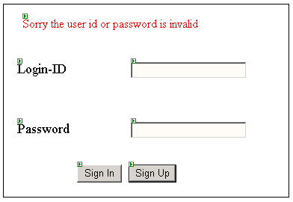

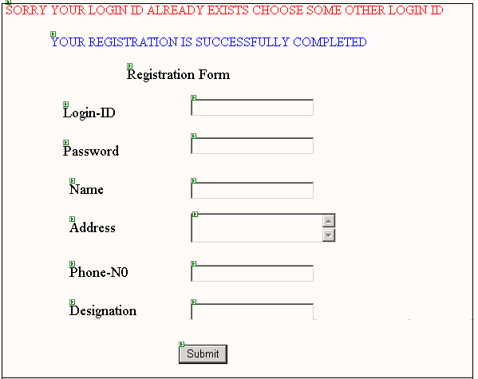
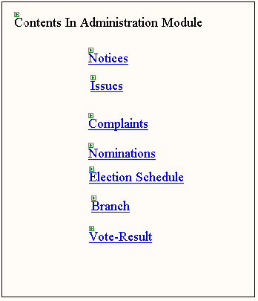

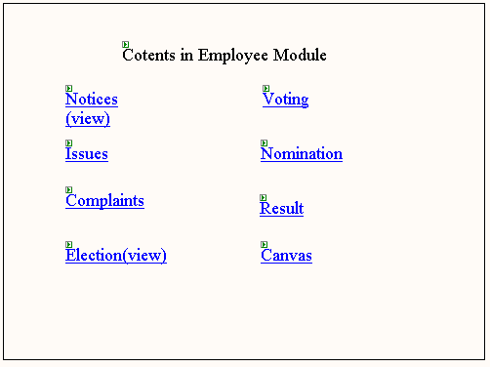

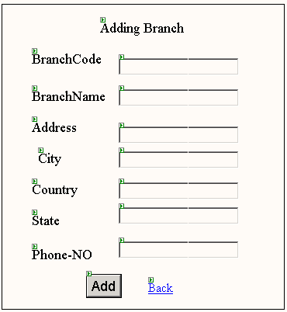

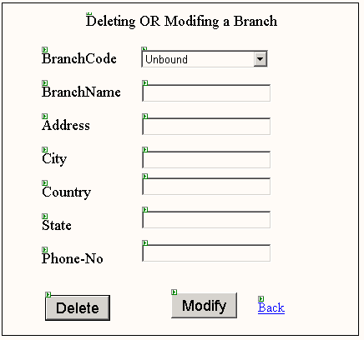

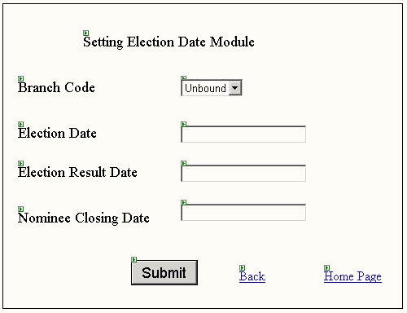

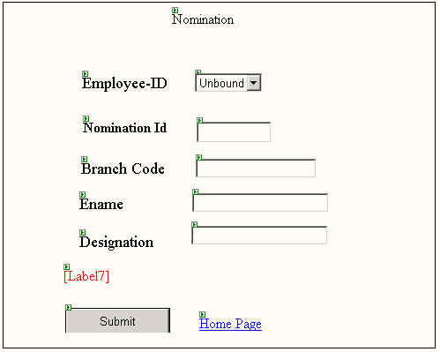
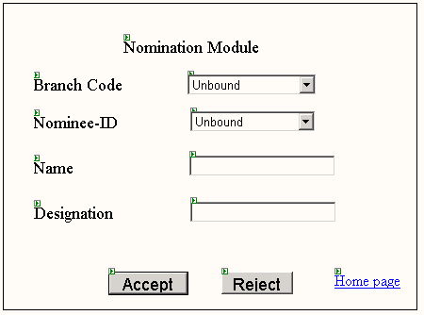

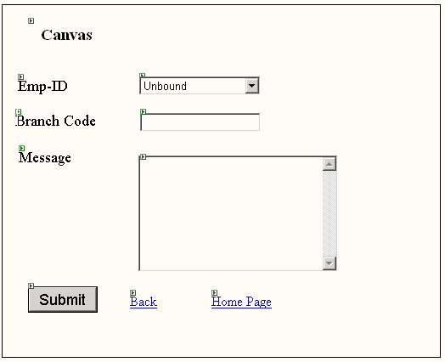

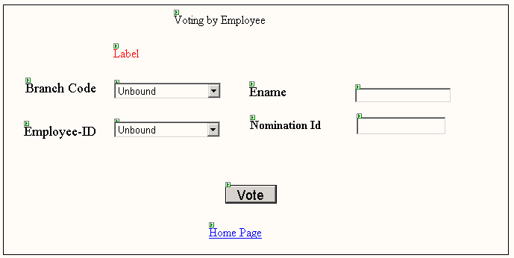

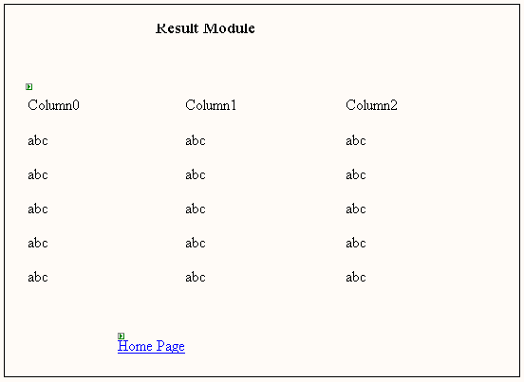

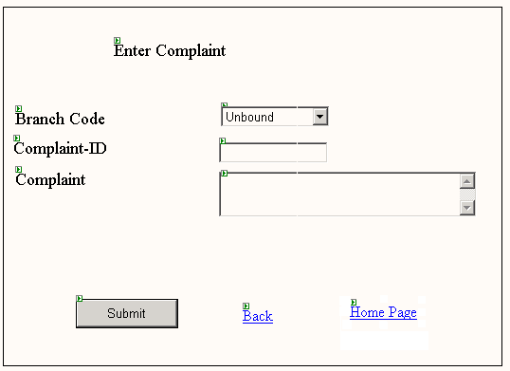

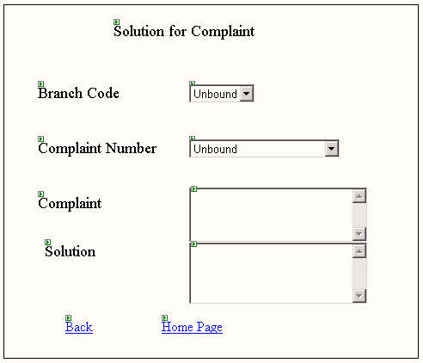
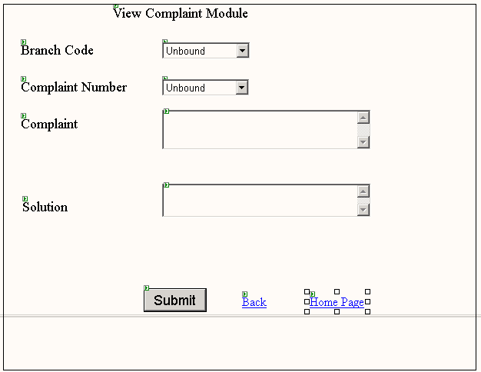

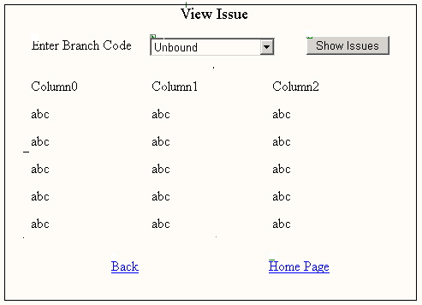

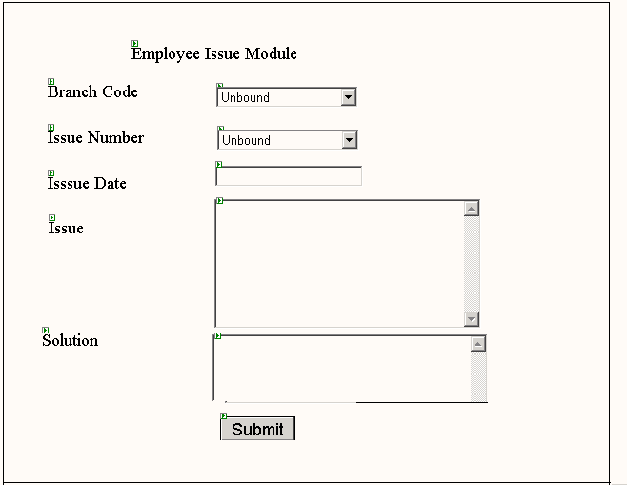

FUTURE ENHANCEMENT

Each and every module in this project is individual and independent from others. All the modules are called in the main form. Any new operation or activity can be added to the project as new module or existing can be enhanced without disturbing the data. Hence the project can be extended according to the requirements.

For linking the database, ADO.NET is used. So, any backend like
MS ACCESS, SQL SERVER can be used as a backend with out modifying the Existing system. Thus the System gives the scope for enhancement.

CONCLUSION

The project title “ONLINE ISSUE MANAGEMENT” is actually a web application.

The project is mainly useful for any company. Generally the company consists of different branches. Generally all branches are communicated through the telephone. So, by using this project we can communicate all branch through online.

After careful verification and validation of procedures, this system was confirmed to satisfy the user requirements in both specification and security aspects. The system can now be tested along with the existing system for a period of time and verified by the user themselves and used after they are satisfied.

BIBLOGRAPHY

1. INTRODUCTION TO SYSTEM HAWARYSZKIEWYCZ
ANALYSIS AND DESIGN

2. AN INTRODUCTION TO PANKAJ JALOTE
SOFTWARE ENGINEERING

3. SOFTWARE ENGINEERING ROGER.S.PRESSMAN

4. AN INTRODUCTION TO C.J.DATE
DATABASE SYSTEM

5. DATABASE SYSTEM H.J.KORTH
CONCEPTS

6. ORACLE 8 SCOTT URMAN

7. ORACLE 8 GEORGE KOCH &
KEVIN LONEY

