Creating 3D Animations of Laboratory Experiments Using Open Source Tools

Sameer Sahasrabudhe and Sridhar Iyer
Department of Computer Science and Engineering,
Indian Institute of Technology Bombay, India

s1000brains@iitb.ac.in
sri@iitb.ac.in

Abstract

The importance of laboratory experiments in engineering education is well accepted. Though such experiments are part of the curriculum, commonly encountered problems in developing countries are: a) availability of infrastructure (which differs from place to place) b) maintenance of the laboratories (which has substantial implications on the results) and c) consistent explanation methodology (which depends primarily on the lab instructors).

Animation is an effective way of augmenting the learning of lab experiments. Two dimensional (2D) animation is widely prevalent, and has been shown to be successful in many areas. Advent of three dimensional (3D) animation has expanded the possibilities and scope of the content in many ways. 3D animation not only continues to have the advantages offered by 2D, like interactivity and reusability, but also adds a whole new dimension of visualization possibilities. These include cross sections (to show the internal construction or assembly of an object), walkthroughs (synthesized video travel within the object) and different viewing angles (views that may not possible in real world).

3D animation has been used in eLearning in different domains but high cost of proprietary tools and scarcity of trained personnel for the content creation has not extended the reach as expected. Cheaper and more user friendly solutions are certainly required for wide accessibility, especially for developing countries. Blender (www.blender.org) is a popular Open source 3D animation package, typically used for entertainment domain. It is free and is available for various platforms viz Windows, Apple, and Linux. However, we did not find any literature on using Blender for eLearning animations.

In this paper we examine the suitability of Blender for content creation in eLearning. We present a methodology as well as a case study, of using Blender to create eLearning content for Chemical Engineering Labs. The experiment selected is a Vapour Liquid Equilibrium process from the curriculum of undergraduate Chemical Engineering. This experiment is suitable for the usage of 3D animation because of two main factors: (i) The complex assembly of different components, and (ii) The size of the actual apparatus, varies from 4-16 feet and it is expensive for replication in smaller institutions.

We found that Blender has most of the desired features to create the eLearning 3D animation. Students who viewed the content found it useful and enjoyed working with it. We were also able to export the 3D models to an open source repository. We believe that the proposed methodology can be: (i) used to scale the 3D animated content creation of lab experiments, and (ii) adopted by other institutions elsewhere.

Keywords: 3D animation, Lab experiments, Blender, Open Source tools

1. Introduction
Laboratory experiments (labs) are an important component of science and engineering education. Hands on sessions in a lab offer an experience of handling the actual components and performing the processes in person contributing significantly to student learning (Hofstein and Lunetta 1982). In developing countries such as India, the most common problems faced in setting up of a lab are: quality of infrastructure, availability of skilled manpower, and maintenance issues.
In such conditions, using multimedia based eLearning to augment the lab experiments is an attractive solution. Additionally, multimedia could also enrich and improve the learning experience (Ellis 2001). Multimedia based eLearning typically comprises of videos shot with cameras (camera videos) or created through animation. These mediums can facilitate visual communication. They are able to show change over time, are portable, and can be interactive. Most researchers agree that these solutions cannot replace the instructors, but they can be certainly used as additional aid for the students to understand the concepts (Ellis 2001, Mackensie and Jansen 1998).
Camera videos are preferred in certain domains where reality of the visuals would be more convincing for the students. For example, in the experiment of a litmus paper changing color, a video would be more convincing rather than an animated clip, since the video establishes that no image manipulation gimmick has been attempted. On the other hand camera video is not adequate in examples like: separating hydrogen from water or melting of metals in a furnace. Such experiments that need to show objects that cannot be captured by cameras, or cannot be perceived by the naked eye, or have extremely inaccessible view points, find a suitable medium in animation. In this paper we restrict our discussion to animation.
Animation provides the ability to add motion to static diagrams (given in books). Two dimensional (2D) animation is widely prevalent, and has been shown to be successful in many areas (Selmer, Kraft, Moros, & Colton 2007). Advent of three dimensional (3D) animation has expanded the possibilities and scope of the content in many ways. 3D animation not only continues to have the advantages offered by 2D, like interactivity and reusability, but also adds a whole new dimension of visualization possibilities. It makes it feasible to go beyond the flat view and see the experiments/models from any angle. For example: Internal organs of human body right up to micro/nano level of DNA strands, walkthrough of a solar system and cross sections of mechanical engine. We focus on 3D animation in this paper.
Content creation with 3D animation is often a costly proposition. The cost of proprietary software, high end hardware to support 3D graphic display in real time, and need for trained personnel, make it a costly medium (Beilla, Luther 2007). Hence the reach of 3D animations in eLearning has not proliferated as expected, especially in developing countries.
Blender is a free open source 3D content creation suite, available for all major operating systems under the GNU General Public License (Blender website, 2009). It supports a variety of geometric primitives including polygon meshes and fast subdivision surface modeling. It has advanced tools for key framed animation, including inverse kinematics and armature (skeletal). It also has a game engine for adding interactivity to the animations. Currently, Blender has been used in different entertainment domains like animated movies, short films, television commercials, and gaming.
To the best of our knowledge, there is no study reported on the use of Blender for creating eLearning animations of lab experiments. In this paper we investigate the suitability of Blender for creating animated eLearning content. We not only propose a methodology but also elaborate it using a case study of Vapour Liquid Equilibrium (VLE) experiment from chemical engineering. We find that Blender has most of the desired features to create the eLearning 3D animation. Students who viewed the content found it useful and enjoyed working with it. We are also able to export the created 3D models to an open source repository. We believe that the proposed methodology can be: (i) used to scale the 3D animated content creation of lab experiments, and (ii) adopted by other institutions elsewhere.
The organization of the paper is as follows: Section 2 presents our design goals for content creation using Blender. Section 3 describes the methodology in detail and Section 4 presents the case study. Section 5 discusses the findings and Section 6 concludes with a mention of ongoing work.

2. DESIGN GOALS

Our main design goals for creating eLearning animations using Blender are:

- Offering multiple 3D visualization angles of the given experiment: The assembly of the experiment apparatus is often complex. The 2D drawings in the lab manuals are usually insufficient to convey the details of the apparatus and the procedure. 3D models can provide options to view the experiment from any angle thereby helping the user's comprehension. Another advantage of 3D models is the ability to view cross-sections of the apparatus. Hence, our first design goal is to use 3D visualization to enable the user to easily understand the experiment.
- Incorporating relevant animation in the 3D models created: The procedure of the experiment often includes motion of various components. A static 3D model is insufficient to capture the moving aspects of the experiment. Hence, our second design goal is to incorporate relevant animation into the 3D models, to allow the user to view the experiment procedure (with motion).

- Adding interactivity to the 3D animation created: Interactivity enables the users to play with various setting of the experiment, thereby increasing their understanding. It also allows them to go through the content at their own pace. Hence, our third design goal is to add interactivity to the 3D animation created, to further enhance the user's learning.
- Our final design goal is to formulate and articulate a methodology that can be replicated to create eLearning 3D animations on a large scale, using open source tools like Blender.

After the animation has been created, we evaluate the extent to which these goals have been met by collecting actual usage data and feedback from students as well as instructors. In the next section we present our methodology for creating eLearning animations using Blender, along with an illustrative example.

3. Methodology

Our content creation methodology (derived from standard 3D content creation process) is divided into three main phases:
- Pre-production phase: This consists of collecting the required data and planning of the animation procedure based on the complexity of modeling, animation and rendering involved.
- Production phase: This is sub-divided into modeling, texturing, lighting and animation steps that are described subsequently.
- Post-production phase: This consists of rendering the animated content and uploading into online repositories.

We explain the methodology details, using an illustrative example of Vapour Liquid Equilibrium (VLE) experiment described below. The animation was created by a five member team, including three trainees, one graphic designer, and a supervising animator. The trainees were final year under graduate computer science students. The graphic designer was a recent fine arts graduate and the supervising animator had many years of experience in animation film making. Some other members contributed by providing domain expertise of the subject (VLE) and technology (Python) used.

3.1 Illustrative Example

The lab experiment of VLE is part of the curriculum for the undergraduate lab in Chemical engineering (UG lab manual, 2008). The main motivations of this experiment are: (1) to check the thermodynamic consistency of the data, and (2) to present the thermodynamic characteristics and constants of Margules equation for the given system. This particular experiment of VLE is suitable to test our design goals since it has a complex assembly of glass apparatus and motion of fluids. As shown in Figure 1a and 1b, the two important parts of the apparatus are: (1) Vapourizer and (2) Flash chamber or the Equilibrium chamber. The assembly of four concentric glass flasks in the equilibrium chamber has a peculiar position, and the printed diagram of the same is difficult to comprehend. The students have difficulty in visualizing the actual assembly and the motion of the fluids by referring to the 2D diagram. The experiment is conducted real time, and it becomes difficult to register the details of the flow.

The lab instructors explain this experiment using the manual mentioned above. It is a PDF document consisting of a detailed description of the procedure, the chemical equations and a labelled diagram of the apparatus as shown in Figure 1a. The faculty for this course wanted a 3D animation as an additional aid to the lab instructor. They were curious to explore the effectiveness of using 3D animated models to explain the lab experiment. They were also interested in the other benefits like anytime access to the content, ease of portability, etc.

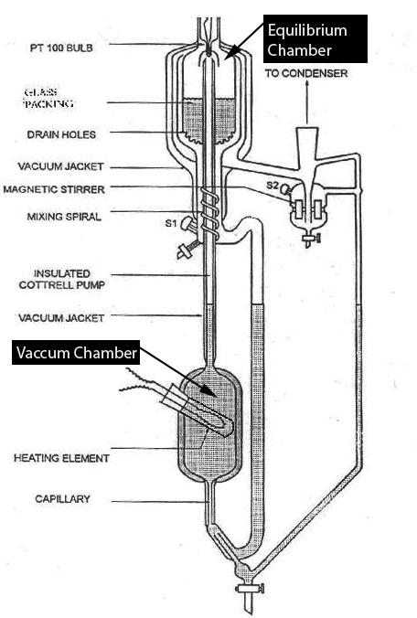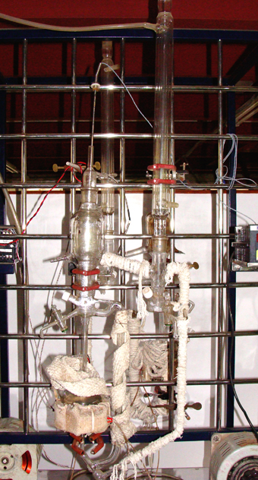
Figure 1a: Diagram of the VLE experiment, Figure 1b: Actual photograph of the experiment.

3.2 Pre-Production Phase
3.2.1 Collection of data
Once the subject area is finalized, the process starts with collecting data (in various forms) about the experiment to be animated. This could be in the form of text, scientific diagrams, actual images, videos (to explain the process), and meeting the faculty/lab instructor in person to understand the process. The various forms of data are useful in subsequent phases for different purposes.
Example: The text, diagrams and the equations in the given manual (UG lab manual, 2008) served as a technically correct input to start the 3D content creation. To get more clarity of the visual aspects, we photographed and videographed of the VLE apparatus from various angles, and captured details of the apparatus.
3.2.2 Planning for the content creation
The planning of the entire animation process is started once data collection is complete. Typically, creating animation using 3D software is a long process with interdependent phases. It is important to plan for the chronology of the phases to avoid duplication, delays or compatibility issues in the finished models. The planning phase also helps the animation artists to model the components of the sections in a way that they can be assembled at the time of animation.
The main steps involved in the planning phase are:
- Create the storyboard: A detailed storyboard is planned for the experiment, based on the given text and the demonstration by the lab instructor. The storyboard includes motivation for the experiment, introduction of the apparatus and the components, the actual procedure for performing the experiment, and a last section for inferences and conclusions. All the sections are drawn in a storyboard with details of the timing, visual contents, and the narrative (script for the voiceover) to be added.
- Record the script for the voiceover: The script decided for the voiceover is then recorded by a voiceover artist, with the duration as indicated in the storyboard.
- Assess the modeling type: Modeling has common units like faces, edges and vertices. The types of modeling in Blender are: (i) Objects: Working with objects as a whole, (ii) Meshes: Working with the mesh that defines the shape of an object, (iii) Curves: Using Curves to model and to control objects, and (iv) Surfaces: Modeling a NURBS surface. For the VLE experiment we have chosen Surface modeling technique (see section 3.3.1).
- Standardize the modeling type: Standardization decides the consistency of various parameters and interoperability of objects. In the assembly phase, the different models have to be joined to create the complete apparatus. At this juncture, it is very important to have uniformity in the thickness of all the objects. Hence, during planning, a generic decision should be taken in this regard.
- Decide the assembly point: The assembly point is a point when the modeling is complete, with the wireframe mesh created for all the objects. Additional modeling, to join components, is done after the assembly.
- Assess and create textures and materials: The necessary textures and materials are taken from the available libraries, or created afresh (in case of non availability).
- Decide the animation style: The animation style can range from fully realistic to just the key details. In case of eLearning animations, clarity of motion is critical. Directional arrows are preferred to explain the flow in the concept. The common types of animation are based on: keyframes, motion curves and paths. In Blender, the first two systems are integrated in a single one, the IPO (InterPOlation) system which is used in our case-study.
- Deciding the level of interactivity: The level of interactivity can range from simple switch on/off buttons to a complex type which can control the parameters of the components. The interactivity planned in this phase, is useful for the subsequent phases like modeling, animation and rendering. Interactivity is planned keeping the end user in mind. It can be the students or the lab instructors. Note that, the pattern of interactivity is different for each user group.
- Select the rendering options: Rendering converts a model into an image either by simulating light transport to get photorealistic images, or by applying some kind of style as in non-photorealistic rendering. Rendering phase has many options: (i) whether it is to be a continuous video, or (ii) it is to be an interactive animation content, or (ii) both. For a continuous video the options are the compression, bitrate and the resolution, and for the interactive content the options are about the operating systems etc.
Once the planning is complete, it is reviewed rigorously before proceeding to the Production phase.

3.3 Production Phase
3.3.1 Modeling
3D modeling is the process of developing a mathematical, wireframe representation of any three-dimensional object. The modeling stage has the following steps:
- Make a list of objects to be modeled.
- For each object, use the available photographs (see section 3.2.1) as reference for images in the respective viewports of Blender (top, front, side, or isometric). Figure 2a shows the ‘front view’ of the modeling screen.
- Start with the available basic shapes (using the photos). For example: flask can be created using a ‘cylinder’ as the basic shape (see Figure 2a).
- Use transformation controls in Blender like extrude, taper, scale, and rotate etc to get the desired shape for the object.
- Use the different viewports in Blender while modeling the object to ensure that all the details are captured.
- Use parameters (faces, edges or vertices) as planned to get the appropriate finish of the object. The smoothness of the object depends on the number of details used. On one hand, when more number of details are used it results in a smoother finish. On the other hand, more number of details makes the 3D file heavy in terms of the calculations.
Example: A cylinder created with 8 faces would show a box type finish (with a small file size), as compared to a 36 or 72 faced cylinder (with a big file size). Hence it is necessary to balance the number of details required and the file size to be handled.
- Test render the portion modeled. This is useful to check the quality and the accuracy of the modeled object.
- Repeat steps from 2 to 5 for each object in the list.
Some points to be kept in mind while modeling are:
- Use ‘Hide objects’ option in Blender. This is useful for simplifying the clutter while working on concentric objects, such as the flasks shown in Figure 2a.
- Use 'color code' option. This is useful for identifying the objects or group of objects easily.
- Use a clear labeling and naming scheme for all the modeled objects. This feature is useful later, at the time of assembly, when the models are to be merged.
- Ensure uniformity of thickness of the objects. This makes it easier in the assembly section, when the objects are joined.
Once the modeling of objects is complete, we proceed to the Assembly phase, described below.

3.3.2 Assembly
Assembly is the process of joining the models created to form the entire apparatus. The important steps in the assembly section are:
- Join the relevant models as suggested in the photographs. This is an important task, as rest of the animation depends on it. The joining should be done in a way, that the joint should not leave any marks on the inner or the outer surfaces.
Example: We start with the innermost objects, and join them with the outer ones. Figure 2b shows two models getting assembled.
- Test the assembly, for the open holes, or leakages by creating some fluid inside it.
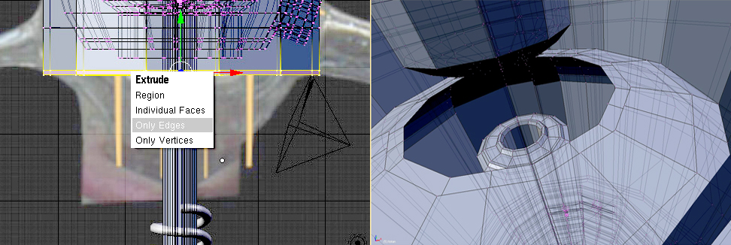
Figure 2a: Modeling process, Figure 2b: Assembly process

3.3.3 Texturing and Lighting
Texturing is the process of applying a bitmap image to the surface of a model. Appropriate textures are created and applied to the models, based on the details of the data collected. Sometimes, the complexity of models is a deterrent factor, especially with textures like glass or shiny metal.
The complete assembled structure of the components of the experiment is the starting point for texturing. The steps involved in texturing phase are:
- Change the default material to the required material for the object. Select from the available list of materials, or create a new one to suit the requirement of the object (see Figure 3).
- Fine tune the parameters of the material applied, to achieve the desired effect. The effects are transparency, viscosity, ray transform, reflectivity index etc.
Example: In VLE, the texture of glass flasks need to have some transparency.
Some points to be kept in mind while texturing are:
- Texture and lighting are interdependent. Some textures may reflect after the lighting, so it is necessary to check whether the selected texture is suitable for the object after lighting also.
- Ensure that the texture used is covering the object fully, in all directions.
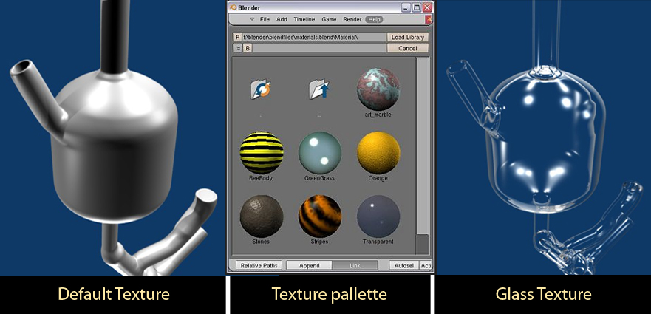
Figure 3: Texture Library of Blender
Lighting is the process of illuminating the entire model by adding various light sources. Lighting has to be applied carefully, in order to have clear visibility of the objects and the motion in the experiment. The different types of lights in Blender are: Lamp, Sun, Spot, Hemi and Area. The steps to create lighting in a Blender scene are:
- Add a light, at a suitable position, so that the emitter is able to light up the required area.
- Set the level of illumination intensity, density and shadow parameters, to enable the viewer to see the action clearly.
- Repeat steps 1 and 2 with different light types and positions till the desired effect is achieved.
- Add multiple lights by repeating steps 1-3 till the entire action area is suitably lit.
Some points to be kept in mind while lighting are:
- Select the correct type of light.
Example: Smaller light may make it dark, and high intensity light may increase brightness, resulting in non visibility of the action.
- Pay attention to the shadow settings, as it may create dark patches in the action area.
3.3.4 Animation

Animation is the process of adding motion to the static models created. Animation follows the sequence of events according to the description in the lab manual. Blender Game Engine supports animation of various objects through the different programming logics like collision detection, fluid dynamics etc. The important steps to be followed in the animation phase are:

- Study the experiment by analyzing the recorded video and by talking to the lab instructors, to understand the motion of the components.
- Use the available animation presets in the Blender Game Engine module, to start the animation.
- Edit the properties to achieve the desired motion effects.
- Use the 'Baking' option in Blender to test the actual flow of the fluids.
- Assign properties of 'obstacles' to the various components to drive the fluid in the desired direction, at the desired speed.
Example: Glass walls of the tubes have to act as obstacles; otherwise the fluid may come out from the tube.
- Test render to check the motion. Repeat steps 2 to 5, till the results are satisfactory.
At the end of the production phase, we have a fully textured model with lighting and animation. Now, we need to add interactivity and export it to various formats, which are done in the next phase.
3.4 Post-Production Phase

3.4.1 Adding interactivity

Interactivity allows the users to choose the sequence of actions and settings of parameters. Blender game engine can be used to create the desired level of interactivity, based on the instructor's requirement. The important steps of adding interactivity are:

- Select the relevant object/solid/fluid to assign the motion.
- Add a new Sensor, Controller and Actuator with the 'Add' buttons in each column.
- Edit the settings of the components in the Game Logic window to achieve the specific requirement.
- Apply the appropriate settings to the other moving entities and check the collisions with the other entities.
- Insert the recorded audio of the narrative, at proper cue points, using the tools provided.
- Render the output of this to get an interactive audio-video self extracting file, which is independent of the operating systems.

3.4.2 Reviewing the animation

Review the output to ensure that (i) The experiment is depicted correctly, and (ii) The design goals have been met. The steps to be followed are:

- Check the 3D animated content with the detailed script of the experiment.
- Check the boundary conditions of the various parameters of the components used to ensure that there is no distortion.
- Check the important viewing angles for the experiment (front, side, top and isometric) to confirm the correctness of the 3D animated content.

For the chosen illustrative example of VLE, the design goals have been met as follows:

- The fully assembled 3D model, complete with texturing and lighting fulfils the first design goal of offering clarity to the user by creating the experiment in 3D (see Figure 4).
- The animation created using fluid dynamics as per the requirement of the script of the experiment fulfils the second design goal.
- The interactive content based on the requirements, suffices the third design goal.

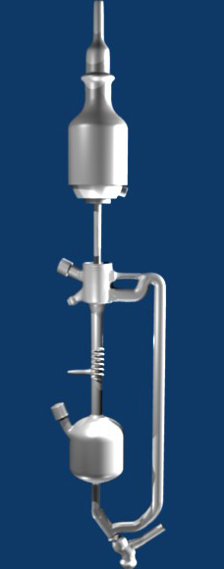
Figure 4: Completed VLE experiment in Blender.

3.4.3 User testing and feedback

The interactive content created is tested by getting feedback from the faculty and students as follows:
- Get faculty and students to use the 3D content and see the virtual experiment.
- Document their experiences and difficulties during the virtual 3D lab experiment.
- Take the necessary corrective actions to further refine the content.

3.4.4 Final rendering and sharing

These involve the following steps:
- Refine the animation based on the feedback from the users.
- Render the refined animation in different formats.
Example: The interactive medium would require a stand alone, real-time interactive animation file which is able to run on any platform. The second and commonly used format is the animated video. Choose the appropriate settings to render the video file.
- List the individual models, textures, materials which are reusable. Render these models in respective file formats. Upload them to open source repositories such as blender.org, for sharing with the community.

In the next section we discuss some salient aspects of the content created for the VLE experiment.

4. Discussion and Conclusion

The chosen experiment of VLE proved to be an appropriate selection for investigating the suitability of Blender for 3D lab animations. The starting point was just a text describing the details of the procedure along with a diagram of the apparatus. Creating a correct and visually appealing animation was a challenge. Our methodology used to create this virtual experiment succeeded in achieving the design goals.

The decision of using 3D for VLE experiment was justified by the faculty instructor, and the students in unison. The instructors were particularly happy for the multiple viewpoints to explain the intricate steps in the process. The students were excited about the new medium, and found it easier to visualize the VLE apparatus using the animation as compared to the diagram. The faculty was satisfied with the quality and correctness of the programming. They were pleased with the interactivity and portability of the solution. We also found that 3D enabled lab sessions have excited students towards lab experiments.

We found that Blender is definitely useful for animation in the eLearning domain. It has all the necessary components to enable an animator to model, apply texture and animate almost any object. It has most of the features comparable to commercial, proprietary, high end and mid range 3D software such as mesh collision detection, LBM fluid dynamics, Bullet rigid body dynamics, particle system etc. Blender's ability to deploy the programming logic to the different ingredients in the experiment like water, glass and other chemicals is an important asset to be explored. We found it useful to have a team of animators with knowledge of two diversified backgrounds like fine arts and computer science. This augmented the visual communication and the programming aspects of the final product. We were pleasantly surprised to find that Blender Game engine could handle water falling; however it requires significant programming effort. Also, the user interface of Blender created a stumbling block in the initial stages and it took us 2-3 months to learn and use the various options.

The Blender game engine allows the creation of stand-alone, real-time applications ranging from architectural visualization to video game construction. Adapting its features to build more advanced experiments for eLearning is of great value. We are studying the use of Blender for more detailed lab experiments in various domains.

Acknowledgments

We would like to acknowledge the help and guidance by faculty at IIT Bombay, Prof. Sanjay Mahajani regarding VLE and Prof. Prabhuramchandran regarding Python scripting. We thank the students working on the project: Priyam Mukhopadhyay, Karan Mulchandani, Gokul Menon, Nitin Aiyar, Chirag Raman, Kaeyur Rudra, and our colleague Bhairavnath Lahotkar for the animation and modelling.

This work is supported by National Mission on Education through ICT, by Ministry of HRD, Government of India.

References
Selmer, A., Kraft M., Moros R. and Colton, C.K., (2007) Weblabs in chemical engineering education, Trans IChemE, Part D, Education for Chemical Engineers,

Daniel B. and Luther W. (2007) Reusability of 2D and 3D course content for replicated experiments in Virtual 3D environments, Proceedings of the 6th Conference on E-learning: ECEL 2007, Copenhagen Business School, Denmark, 2007

Hofstein, A., and Lunetta, V.N. (1982) The role of the laboratory in science teaching: Neglected aspects of research, Review of Educational Research, 52(2), 201–217.

Mackensie, D.S. and Jansen, D.G. (1998) Impact of multimedia computer-based instruction on student comprehension of drafting principles, Journal of Industrial Teacher Education, 35(4), 61-82.

Ellis, T., (2001) Animating to improve learning: a model for studying multimedia effectiveness, 31st ASEE/IEEE Frontiers in Education Conference, 10 - 13, 2001 Reno, NV

UG lab manual, (2009), http://www.che.iitb.ac.in/courses/uglab/manuals/labmanual.pdf

Computer Graphics society website (2009) http://wiki.cgsociety.org/index.php/Comparison_of_3d_tools

Wikipedia website, (2009) http://en.wikipedia.org/wiki/Blender_3D

Blender website, (2009) http://www.blender.org

....

