RTAN: A PROTOCOL FOR RELIABLE DATA TRANSFER OVER ASYMMETRIC NETWORKS
Anupam Goyal, Sridhar Iyer
KR School of Information Technology
IIT Bombay, India - 400 076
anupam@it.iitb.ac.in, sri@it.iitb.ac.in

ABSTRACT
Asymmetric networks are generally characterized by a large bandwidth unreliable communication channel coupled with a low bandwidth reliable communication channel. Such asymmetric networks are used for communication between multiple users spread across a region. The typical applications involve data broadcasting systems such as video conferencing and stock quotes distribution etc. In some situations it might be useful to have reliable data transfer capability over such networks.

We have designed a protocol, RTAN, which can be used to transmit data reliably over asymmetric networks. RTAN also forms the basis of development of protocols such as HTTP and SMTP for asymmetric networks. We have implemented RTAN in developing a file transfer utility for Distance Education Program, IIT Bombay which employs a satellite network for its operation. In this paper, we describe the design of RTAN, its implementation in developing the file transfer utility and the experiments performed to assess the performance of the protocol.

INTRODUCTION
An asymmetric network consists of a high bandwidth unreliable communication channel coupled with a low bandwidth reliable communication channel. When the need for sending data reliably to multiple users spread across a large region arises, using such networks becomes an interesting possibility. Satellite networks are one such architecture.

The Distance Education Program (DEP) at IIT Bombay uses a satellite based asymmetric network. It has a high bandwidth half duplex broadcast channel and a low bandwidth point-to-point full duplex control channel. Such a network does not fit the commonly understood definition of asymmetric networks due to the half duplex nature of the broadcast channel. Hence, we have designed and deployed a novel protocol for reliable data transfer (RTAN) over such asymmetric networks. RTAN also forms the basis of development of protocols such as HTTP and SMTP for asymmetric networks.

THE PROBLEM
We focus on one instance of asymmetric networks, viz. the satellite network employed by DEP at IIT Bombay, for illustrating RTAN operation.
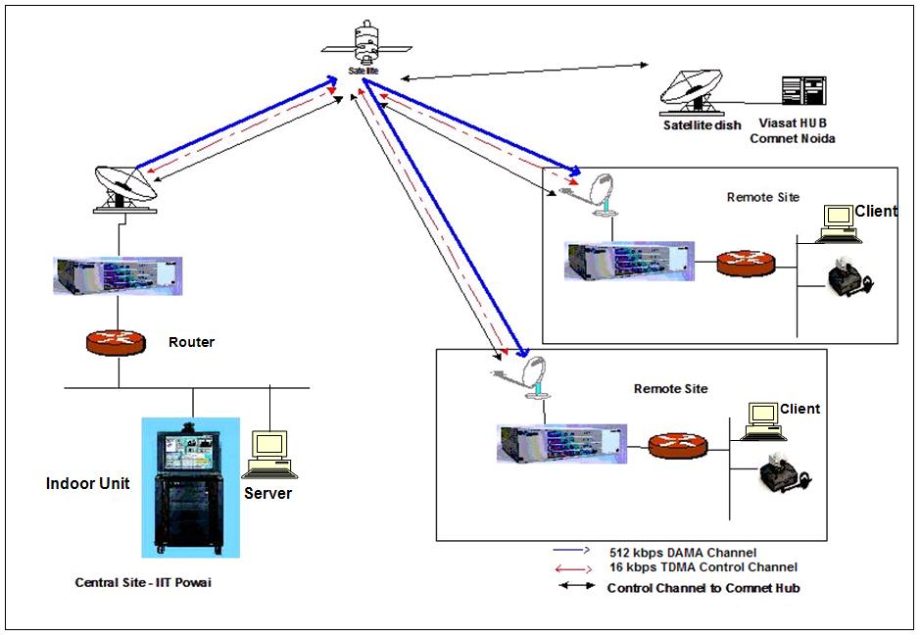
Figure 1. The DEP Network

The DEP Setup
The network topology comprises of nodes at IIT Bombay as well as various Remote Centers (RC). The network consists of a 512 kbps half duplex multicast channel and a 16 kbps full duplex point-to-point control channel on a satellite link. The 512 kbps multicast channel is a Demand Assigned Multiple Access (DAMA) channel and only one center can use it for data transfer at a time. Other centers remain in receive mode when the station having control of the 512 kbps channel transmits. The 16 kbps full duplex channel is a Time Division Multiple Access (TDMA) channel and is available for data transfer at all times to all the centers in the network. Figure 1 gives an overview of the DEP satellite network.

The Requirement
The growing use of dedicated asymmetric networks, such as the one employed by DEP, stimulated the design of the protocol. These networks could also be used for reliable communication between the centers comprising the network apart from the services based on unreliable transfer protocols. The services such as file transfer, web service, mail service etc. need to be provided across the network. In the case of DEP, it is required to send lecture videos and other tutorial material to the remote centers for later reference of the students. Hence, a reliable data transfer utility was required to be developed. The need to design a customized protocol arose because of the following reasons:
- Small files of the order of some KBs to large files of the order of some GBs need to be sent reliably across the network.
- The 16 kbps channel provides TCP and hence, reliable transfer option but is too inadequate to transfer files of the order of 1 GB in reasonable amount of time.
- The 512 kbps channel is a multicast half duplex channel over UDP and hence inherently unreliable. So, it is rendered inadequate despite its larger bandwidth due to the need for TCP like reliability.
Hence, we designed a generic protocol, RTAN, which enables reliable transfer of files across asymmetric network.

OVERVIEW OF RTAN
RTAN uses the 512 kbps multicast channel to send data across to the receivers and the 16 kbps reliable channel to exchange information about the data lost in transmission in order to recover the lost data. Figure 2 gives an overview of RTAN operation. On a file transfer request, RTAN sends information about the file to be transferred to all the intended receivers. The file to be transferred is divided into M segments. Each segment is in turn divided into N fixed sized packets. RTAN follows a sender-initiated approach. The server maintains an index for all the packets sent and also keeps track of all the receivers. RTAN operates by sending all N packets belonging to a segment to all the receivers. It doesn't send any new packets until all packets are successfully transferred to all the clients. The receivers create N bit index for all the packets of the segment being transferred and update it according to the receipt of the data packets. After the server finishes multicasting a segment, it queries the receivers for their respective indices. Receivers indicate packet loss by the way of both ACKs and NACKs through the packet index entries. The server performs a boolean AND on the indices received which yields all the packets that were dropped by at least one receiver. It re-multicasts all the dropped packets and queries the receivers again for indices. The server repeats the process until the whole segment and eventually the whole file has been successfully transferred to all the clients.

DESIGN AND IMPLEMENTATION OF RTAN
All messages to and from the client are exchanged on the 16 kbps channel. Only the data to be sent is multicast on the 512 kbps channel. Every other communication occurs on the 16 kbps reliable channel. The complete data transfer consists of many transfer cycles. Successful completion of a transfer cycle corresponds to the complete transfer of a selected segment of the file to all the clients. Each transfer cycle, in turn, consists of a data multicast and several recovery cycles. A data multicast consists of transmission of all the packets of the current file segment on the 512 kbps multicast channel. A recovery cycle, on the other hand, consists of obtaining the packet receipt information from all the clients and re-multicasting packets that were not received by any of the clients. The index exchanged by the server and the client is a bit index. Each bit corresponds to one packet. If the bit for a packet is set then it indicates that the client has successfully received the packet. Otherwise, it is reset. The index entries correspond to the sequence numbers of the packets. RTAN has been implemented using a client-server paradigm. The basic designs of the server and the client are as follows.

Server Implementation
The servers main thread creates a session object for each file transfer operation that contains file information, temporary buffers, indices etc. required for transfer. Apart from the main thread, the server consists of the following three threads:
- ConnectionAcceptor thread: This thread keeps listening for clients and opens a TCP connection with them and adds the new client information to a global connection object list, ConnectionList. Each connection object contains information such as the state of the TCP connection with the client etc.
- ControlProcessor thread: This thread actually

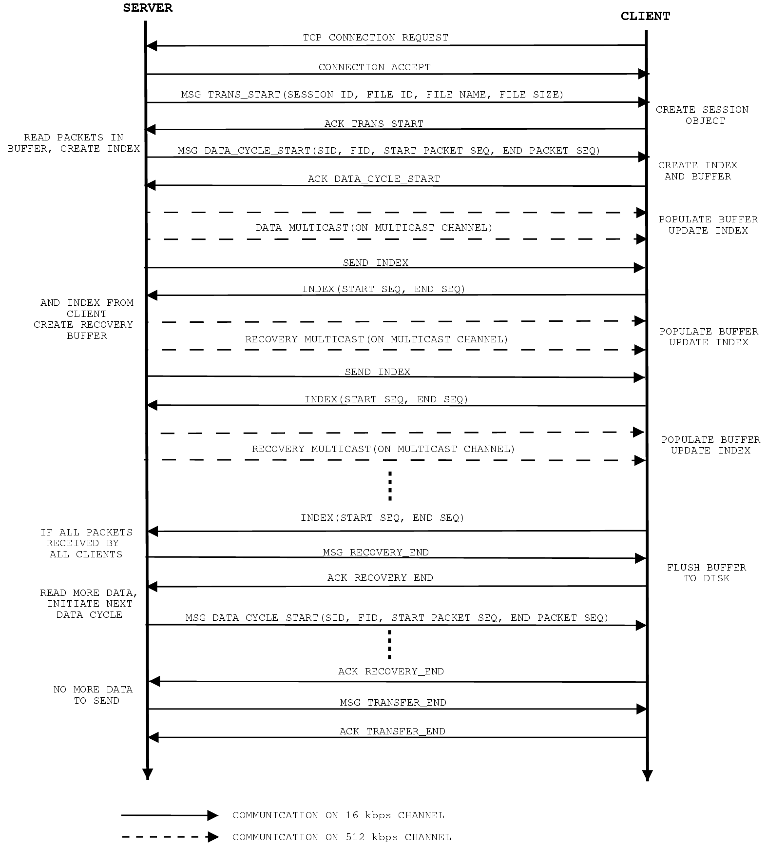
Figure 2. RTAN Protocol Graph

implements the protocol. It sends various messages to the client as per the protocol and receives acknowledgments and indices from the client. The messages are sent to all the clients individually. All messages are sent to all the clients.
- Keep-Alive thread: This thread is used to keep the link alive and keeps multicasting keep alive packets to the group every 2 seconds.
All clients connected at the time of transfer request are marked in session. The file is transferred to only these clients and not to any other clients, which connect after the server has started the transfer.

Client Implementation
Analogous to server main thread, the client main thread also creates a session object for each file transfer request. Session object contains file information, temporary buffers, indices etc. required for the transfer. The client consists of the following two basic threads:
- DataProcessor thread: This thread receives multicast data from the server and stores them in buffer.
- ControlProcessor thread: This thread exchanges control information with the server control thread and maintains the protocol. It establishes a TCP connection on the 16 kbps channel with the server ControlProcessor thread. The client is terminated if the connection open fails.

Multicast Data Packet Format
As shown in figure 3, multicast data packet consists of two parts - the header and the payload. The header contains information about the data in the multicast packet and the payload contains the actual data that has to be transferred. The header size is 17 bytes. It consists of the following fields:
- Session Id (4 bytes): Session identifier distinguishes between sessions. One session consists of transfer of a file to only one set of predetermined clients. Currently, only one session can be handled at a time.
- File Id (4 bytes): Identifies the unique identifier assigned to each file by RTAN before the transmission begins.
- Sequence Number (4 bytes): The sequence number of the packet being transmitted.
- Payload Size (4 bytes): The number of data bytes contained in this packet.
- Flags (1 byte): Indicates whether the received packet is a data packet or a keep-alive packet. One bit is being used for indication of packet type. The rest of the bits are reserved for future use.

4 | 4 | 4 | 4 | 1 | 1423
Session ID | File ID | Sequence  Number | Payload Size | Flag  Byte | Data
Figure 3. Multicast Data Packet Format (field width in bytes)

FIELD EXPERIMENTS
We carried out a number of field experiments to get a fair view of the performance of the protocol and the various parameters affecting the performance. The Maximum Transmission Unit (MTU) of the DEP satellite network is 1500 bytes. Since, maximum application data that can be put into one MTU is 1440 bytes, we conservatively used 1400 bytes of data per MTU in all experiments. Also, we experimented with the data rates of 49.5 KBps and 75 KBps, the closest lower and higher achievable data rates respectively to the link data rate of 64 KBps.

Experiment 1: Transfer Time Vs File Size
The experiment consisted of sending files of various sizes ranging from small files of size 4 MB to large files of size 122 MB and noting the time taken for the transfer. The intent was to measure the effect of control information exchange that occurs during each transfer cycle on the total transfer time with the increase in file size. The value of packets per transfer cycle was kept constant at 10,000 for the experiment. As can be seen from figure 4, the transfer time increases linearly with the file size indicating the protocol to be reasonably good.
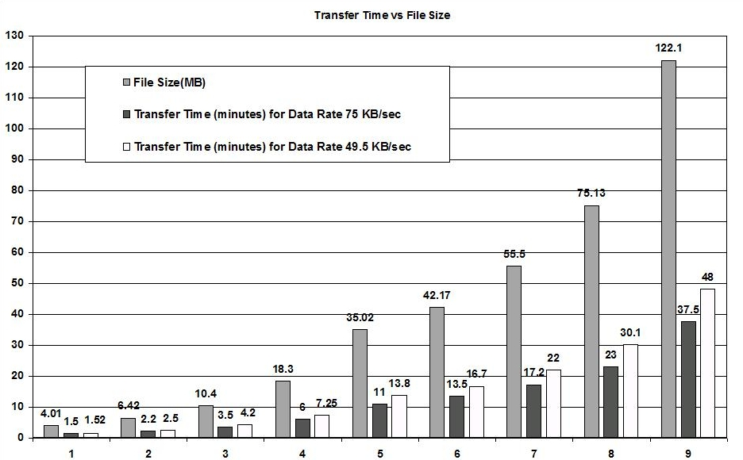
Figure 4. Experiment 1 – Transfer Time Vs File Size

Experiment 2: Transfer Time Vs Packets Per Transfer
The intent of this experiment was to find out the effect of time spent in exchanging control information per transfer cycle on the total transfer time of the data on varying the packets per transfer. The data rate for the experiment had been set to 75 kilobytes per second. The experiment was performed for three different file sizes. The initial value of packets per transfer was set to 2000 and was changed in increments of 2000. As can be seen from figure 5, transfer time can be reduced by 16%-19% by increasing the packets per transfer irrespective of the file size for smaller values of packets per transfer. Increasing the value of packets per transfer after a certain optimum doesn’t lead to a decrease in transfer time. The transfer time remains more or less constant after that.
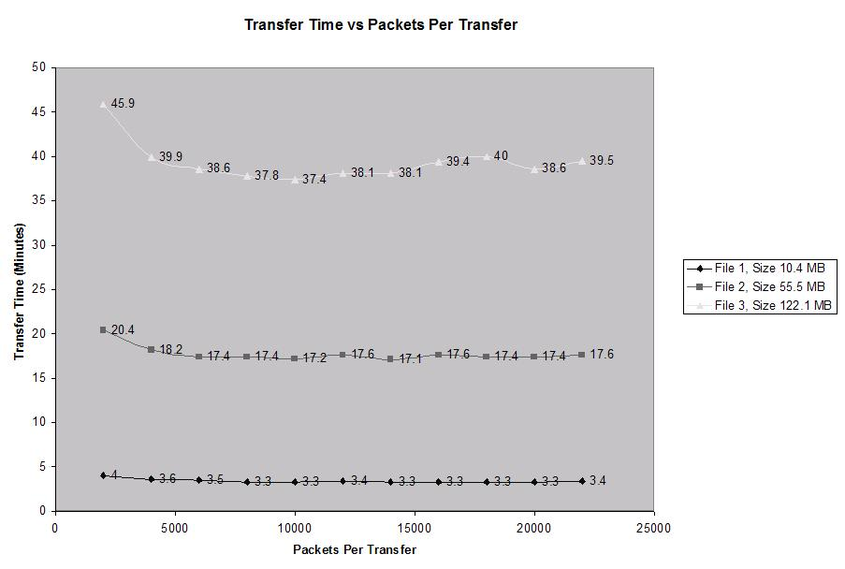
Figure 5. Experiment 2 – Transfer Time Vs Packets Per Transfer

Observations
The following conclusions can be drawn from the experiments. First, there is a linear increase in transfer time with the increase in file size. Second, the data rate is the main contributing factor in determining the overall transfer time. We found that any value of packets per transfer greater than 6000 does not make a significant difference to the overall transfer time for any file size. And third, data rates closest to the multicast link capacity result in maximum throughput.

Deployment Issues
A few deployment issues that had an effect on the efficiency of the protocol are as follows.
- The satellite network required the multicast link to have continuous traffic. If there was a latency of more than 2 seconds in the use of the link, the link was disabled by the network for the next 20 seconds. Hence, keep-alive packets were sent to the multicast port every 2 seconds along with the data packets.
- The router at the server end required 3 to 5 seconds for multicast route discovery and dropped all packets during this interval.
- It was not possible to accurately synchronize the data rate of the RTAN server with the data rate of the satellite network. Hence, the available bandwidth could not be used to its exact capacity.

CONCLUSIONS AND FUTURE WORK
RTAN is a protocol for reliable transfer of data over asymmetric multicast networks. The central idea is to use high bandwidth multicast channel for data transfer and use low bandwidth unicast channel for control information exchange in order to perform loss recovery. Specifically, the protocol was implemented in developing a file transfer utility for the Distance Education Program (DEP), IIT Bombay. The file transfer utility was successfully developed and deployed over the satellite network to transfer the required files. Field experiments on the DEP satellite network have shown that the basic protocol works quite well for the DEP satellite network. We have also proposed some extensions to RTAN to counter high error rates and scalability problems. As part of the future work, we are also developing higher-level protocols such as HTTP and SMTP, which will use RTAN as the basic protocol for data transfer over asymmetric networks.

7.REFERENCES
- S. Pingali, D. Towsley, and J. F. Kurose, "A comparison of sender-initiated and receiver-initiated reliable multicast protocols," in Performance Evaluation Review, vol. 22, pp. 221-- 230, May 1994.
- S. Floyd, V. Jacobson, C. Liu, S. McCanne, L Zhang, “A Reliable Multicast Framework for Light-weight Sessions and Application Level Framing,” Proc. SIGCOMM 95, pp. 342-356, August 1995.
- J. C. Lin and S. Paul, "RMTP: A reliable multicast transport protocol," in Proc. IEEE Infocom, pp. 1414--1425, March 1996.
- B. N. Levine and JJ Garcia-Luna-Aceves, “A Comparison of Known Classes of Reliable Multicast Protocols,” Proc. Int’l. Conf. Network Protocols ’96, Oct. 1996.
- Allman M., Kruse H., Osterman S., “An Application-Level Solution to TCP's Satellite Inefficiencies,” in Proceedings of the 1st WOSBIS, November 1996.
- H. Balakrishnan, V.N. Padmanabhan, and R.H. Katz, “The Effects of Asymmetry on TCP Performance,'' Proc. of ACM/IEEE Int'l. Conf. on Mobile Computing and Networking, Sep. 1997.
- K. Obraczka, “Multicast transport protocols: a survey and taxonomy,” IEEE Communications Magazine 36(1): 94-102, Jan 1998.
- M.W. Koyabe and G. Fairhurst, "Reliable Multicast via Satellite: a comparison survey and taxonomy," International Journal of Satellite Communication, vol. 19, pp. 3 - 28, 2001.

