Performance Analysis of WiFiRe
Venkat Reddy M, Sridhar Iyer

KReSIT,IITBombay
Powai,Bombay,
E-mail: venkata@it.iitb.ac.in, sri@it.iitb.ac.in

Abstract
The goal of WiFiRe is to provide broadband Internet services in the rural areas. The key idea in WiFiRe is to replace the 802.11b MAC mechanisms, with something more suitable for long-range communication, while using 802.11b PHY. WiFiRe network topology is a star topology, a System (S) with set of Base Statons (BS) with sectorized antennas at the fiber Point of Presence (PoP) and Subscriber Terminals in the surrounding villages with directional antennas. WiFiRe Cell is divided into sectors and a BS will cover each sector. WiFiRe has one common medium access (MAC) controller for all the sectors, to co-ordinate the medium access among them. The multiple access mechanism is time division duplexed, multi-sector TDM (TDD-MSTDM) scheduling of slots.
This protocol is modeled in OPNET. We have simulated this protocol in different scenarios with different MAC configurations. We have simulated UGS, rtPS, nrtPS and BE service classes with different configurations, like changing polling time, changing slot length, etc. We have compared throughput and service delays of different service classes in different scenarios. By simulation results, we have determined the best slot length for different type of service classes.

WiFiRe Introduction
WiFiRe[1] stands for WiFi – Rural extension. It takes advantage from the license free nature of the WiFi[4] spectrum (IEEE 802.11b, 2.4 GHz Band) in order to provide long-range communications (15-20 Kms) for rural areas. The key idea in WiFiRe is to replace the 802.11b MAC mechanisms (DCF/PCF), with something more suitable for long-range communication, because DCF/PCF will not work in long-range communications. WiFiRe network topology is a star topology, a System (S) with set of Base Statons (BS) with sectorized antennas at the fiber Point of Presence (PoP) and Subscriber Terminals in the surrounding villages with directional antennas. Cell is divided into sectors, for each sector there is one base station (BSs), with a sectorized antenna, mounted on a transmission tower at a height of 40 m for enabling line-of-sight communication, as shown in Figure 1.
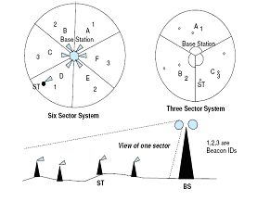
Figure 1: WiFiRe Network Configuration
WiFiRe has one common medium access (MAC) controller for all the sectors, to co-ordinate the medium access among them. There are multiple STs in each sector. The multiple access mechanism is time division duplexed, multi-sector TDM (TDD-MSTDM) scheduling of slots. Time is divided into frames. Each frame is further partitioned into a downlink (DL) and an uplink (UL) segments which need not be of equal durations. Within each segment there are multiple slots of equal duration each. Beacons are transmitted at the start of each DL segment. The beacon for each sector contains information regarding the DL and UL slot allocations (DL-MAP, UL-MAP) for that frame. All DL transmissions follow the DL-MAP in the Beacon. In each DL slot, one or zero transmissions can take place for each sector. The DL-MAP may allow multiple non-interfering BS to simultaneously transmit a packet to the ST(s) in their respective sectors. In each UL slot, one or zero transmissions can take place for each sector, as governed by the UL-MAP. The UL-MAP is constructed in such a way that multiple ST(s) from different sectors, may transmit in the same UL slot, provided these transmissions are non-interfering at the BS.

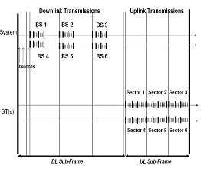
Figure 2: Parallel transmissions in a six sector system

In WiFiRe MAC layer there are three sub layers, Service Specific Sub-Layer (SSS), Link control sub layer and security sub layer.
The Service Specific Sub-layer (SSS) resides on top of the MAC Link Control Sub-layer (LCS). It provides the following services to upper layer. 1) Connection management and 2) packet classification
Link Control Sub-Layer (LCS)
The MAC-LCS services are used by Service Specific Sub-layer (SSS) to access the connection-oriented wireless link for data packet transport. The LCS layer provides the following categories of services:
1. Connection provision services, including creation, termination and change.
2. Data delivery services, from/to the higher layer SSS to/from the peer LCS entity
The association between a ST and a System S is static. This is determined by configuration at the ST during deployment. The association of a ST with a BS in a system S is dynamic and can change during each ‘power-on’ scenario of the ST. Ranging and registration are required for the synchronization between ST and BS and to ensure that a ST communicates with one and only one BS of system S. This association is fixed as long as the ST remains in ‘power on' mode.

WiFiRe MAC Services:
WiFiRe MAC is connection oriented like 802.16. A connection defines the mapping between peer data link processes that utilize both MAC and service flow category. The service flow category defines the QoS parameter for PDU(s) that are exchanged on the connection. Each connection has unique identifier to identify connections. A service flow is a MAC transport service that provides unidirectional transport of packets either to uplink packets transmitted by the SS or to downlink packets transmitted by the BS. A service flow is characterized by a set of QoS Parameters such as latency, jitter etc. Each service flow is associated with some service classes and each service class is associated with one of four scheduling types. S may grant bandwidth to an ST in one or more of the following ways.
Unsolicited bandwidth grants, polling (real-time and non-real time) and contention based. WiFiRe MAC supports four services, Unsolicited Grant Service (UGS), Real-time Polling Service (rtPS), non Real-time Polling Service (nrtPS) and Best Effort.

Unsolicited Grant Service (UGS) is designed to support real-time flows that generate fixed size data packets on a periodic basis, such as T1/E1 and Voice over IP Without silence suppression. When a data CID is associated with UGS service flow type, the ST does not have to send periodic bandwidth request to the BS for that connection (data CID). The UGS service offers fixed size grants on a real-time periodic basis, which eliminate the overhead and latency of ST requests and assure that grants are available to meet the flow’s real-time needs. The BS shall provide fixed size data grant slots at periodic intervals to the service flow.

Real-time Polling Service: The Real-Time Polling Service (rtPS) is designed to support real-time flows that generate variable size data packets on a periodic basis, such as MPEG video. The service offers real-time, periodic, unicast request opportunities, which meet the flow’s real-time needs and allow the ST to specify the size of the desired grant. This service requires more request overhead than UGS, but supports variable grant sizes for optimum data transport efficiency. The BS shall provide periodic unicast request opportunities, by assigning appropriate polling slots in the uplink.

Non real time Polling Service: The Non-Real-Time Polling Service (nrtPS) is designed to support non real-time flows that require variable size data grant slots on a regular basis, such as high bandwidth FTP. The service offers unicast polls on a regular basis, which assures that the flow receives request opportunities even during network congestion. The BS typically polls nrtPS CIDs on an interval (periodic or non-periodic). The BS shall provide timely unicast request opportunities by assigning appropriate polling slots in the uplink.

Best Effort Service: The intent of the Best Effort (BE) service is to provide efficient service to best effort traffic. These flows served by contention slots.

MAC PDU Formats:
Each PDU shall begin with fixed length Generic Mac header. Header may be flowed by payload. Payload shall consists of zero of more sub headers and zero or more MAC SDU(s)
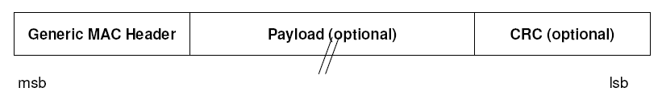
Figure 3: WiFiRe MAC PDU

There are two MAC header formats, Generic MAC header and Beacon MAC header. Generic MAC header is used for management messages and Data PDU(s). Beacon header is used to transmit beacons.
Figure 4: Generic MAC header

HT field distinguishes the Generic and Beacon header formats. Len is 7 bits to indicate length of MAC PDU. Type is 1 byte to indicate MAC management message type, i.e DSA Request, DSA Response etc. CID is 2 bytes.
Figure 5: Beacon header

Figure 6: Beacon Message:

Header is 2 bytes; Rng Slots is 1 bit indicating if there are any ranging slots allocated in UL-MAP. DL-MAP is 50 bytes. It is 50 element vector of <CID>. UL-MAP is also 50 element vector of <CID>.

WiFiRe MAC Operation Details:
Network Entry and Initialization: On ST ‘Power On’ it determines operator ID and system ID from the configuration file and starts listening for beacons. The ST then constructs a Ranging Request and sends it in the ranging block of the UL sub frame for each BS that it hears. Ranging requests includes signal strength. After that ST waits for a Ranging Response. If no response is received within a timeout period, ST sends ranging request again after random back-off period. S receives the ranging request message and selects an appropriate BS, then S constructs the ranging response and puts it in the transmit queue of the corresponding BS and it invokes the scheduler to construct DL-MAP & UL-MAP. S transmits DL-MAP and UL-MAP in next beacon. Ranging response gets scheduled in next frame or some other subsequent frames. After successful Ranging, ST will register with its BS by sending Registration Request.
Connection Management and Data Transport: When higher layer at ST has data to send, then it sends Dynamic Service Addition (DSA) message to BS in polling slots or contention slots. If no response is received within time out period it transmits again after waiting random back-off time. This DSA message is processed by admission control module in S. If resources are available then S assigns data CID to this connection and sends response through DSA-Response. QoS parameters associated with connection are known at both end. If it is UGS service flow then Scheduler at S will assign periodic grants in each frame. If it is rtPS or nrtPS then ST will request bandwidth whenever needed by sending Bandwidth Request in respected UL slot, Then S will grant requested slots in next frame. To terminate connection ST sends Dynamic Service Deletion message to BS.

WiFiRe Model in OPNET
We used OPNET [5] [6] to develop a simulation model for the WiFiRe protocol for evaluating performance. We are using WiMAX 03-Oct-2005 release Patch to build WiFiRe OPNET model. Main components in WiFiRe OPNET model are Base Station node model, ST node model, common MAC process model, BS child control process model and ST Child control process model. Base Station node consists of 4 Ethernet interfaces and 6 WiFiRe interfaces. Each WiFiRe interface represents a sector shown in Figure 8. WiFiRe ST node model is fixed node model with workstation functionality shown in Figure 9.
Figure 7 shows the Design block diagram of WiFiRe model in OPNET. Some modules shown in this block diagram are common to both BS and ST, for example, Classifier is required at both nodes. Beacon processing, traffic scheduling and lower layer data processing modules are also common for both ST and BS. Admission control module runs only on Base Station node. Admission control, slot scheduler and MAP generator are BS specific tasks. DSA Req, BW Req generator tasks are specific to ST. The Figure 7 shows how all these modules work together to build the WiFiRe simulator.

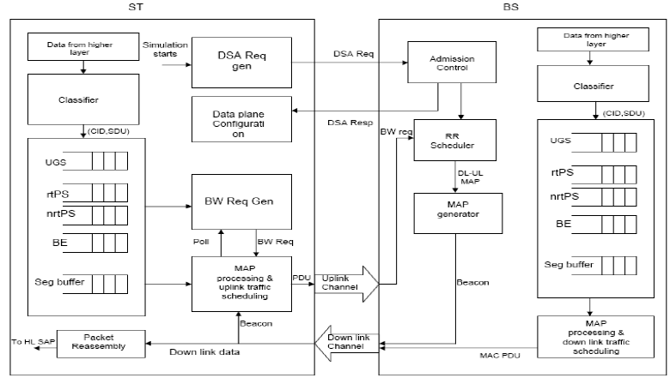

Figure 7: WiFiRe Model design block diagram

When the simulation starts, STs will send the DSA Req to BS, for each service flow (uplink or downlink) defined on it. DSA Req contains the service flow parameters for requesting connection and source MAC address. When BS receives DSA Req message, it calls the Admission control module to process it. Admission control module will process it and send DSA Resp to the requested ST. DSA Resp contains acceptance status and accepted service flow parameters. Admission control process is different for different types of service classes. If ST receives DSA Resp with an accepted state of connection, then it will configure the data plane data structures, containing Shaper, Classifier, data queue and segmentation buffer for the accepted connection. After data plane configured, connection is ready for data transmission.
Periodically, The scheduler processes the list of all accepted flows and allocates bandwidth for the active service flows. It allocates polling slots to rtPS and nrtPS flows, if the last
Polled time exceeds the polling interval. Round Robin Scheduler is used for slot scheduling in both uplink and downlink.
When MAC receives a packet from higher layer, it gives this packet to the classifier module. The Classifier classifies this packet into the connection it belongs to and gives connection ID (CID). After classification, the higher layer SDU is enqueued into the queue corresponding to that CID. The BS sends beacons, which contain slot-scheduling information for downlink and uplink. When an ST receives a beacon, it extracts the Uplink MAP and schedules its traffic in corresponding slots. The ST sends a BW request with request size equal to queue size, if it is polled.
For each connection, there is one segmentation buffer shown in Figure 7. While scheduling packets from packet buffer, if the next packet size in the queue is greater than allocated size of that connection, then scheduler calls the segmentation module which segments the packet and inserts resultant segments into corresponding segmentation buffer for that connection. After segmentation is completed, scheduler takes one segment from segmentation buffer and schedules it for transmission. Scheduler checks for pending segments of previous packet in segmentation buffer, before scheduling new packets from packet buffer. If segmentation buffer is empty, then it takes one packet from packet buffer and segmentation is applied if packet size is more than allocated size. The scheduler schedules packets in FCFS order. At the receiving end, reassembly module reconstructs the segmented packets and sends them to the upper layer SAP.

Admission Control in WiFiRe
Admission control decision is different for different types of service classes. If scheduling type is UGS, then BS will admit it with maximum sustained traffic rate. If scheduling type is rtPS or nrtPS BS will admit it with minimum reserved traffic rate. By default BS will accept all Best effort flows. The requested rate from STs is free of MAC and PHY overhead. So BS adds the MAC and PHY overhead to the requested rate. Now if the available bandwidth is greater than requested rate, then BS will admit the flow. For uplink rtPS and nrtPS flows there is additional polling overhead. After adding overhead, if the remaining bandwidth is greater than or equal to requested bandwidth then BS will admit the flow otherwise it will simply reject them.

Round Robin Slot Scheduling
Round Robin scheduler is a simple slot-scheduling algorithm. The frame is divided into downlink and uplink sub-frames. Downlink and uplink sub-frames are further dived into three contiguous parts, if opposite sectors transmit in parallel. For example, in six sector system, sectors 1 and 4 serve in first part, sectors 2 and 5 serve in second part and sectors 3 and 6 serve in the third part. If alternate base stations transmit in parallel, then downlink and uplink frames further divided into two contiguous parts only. Sectors 1,3,5 are served in first part and sectors 2,4,6 served in second part. With Round Robin algorithm, maximum number of simultaneous transmissions, n0 = 3 are allowed in each slot in six sector system [1]. But with greedy slot scheduling algorithm we can have a maximum of 4 simultaneous transmissions in one slot [1].
Round Robin scheduler first allocates polling slots to rtPS and nrtPS flows, if last polled time exceeds polling interval. Then it scans the list of all admitted flows and allocates admitted number of slots for UGS flows. It allocates requested number of slots for rtPS and nrtPS flows, if the requested numbers of slots are less than the admitted number of slots. Otherwise, it allocates admitted number of slots, and it will allocate remaining slots in next set of frames. Scheduler will allocate remaining slots to Best Effort flows. If there are any slots free after allocating BE flows, scheduler will mark all those slots as contention slots.

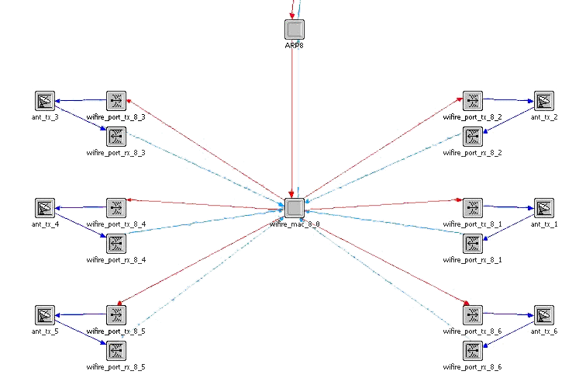
Figure 8: WiFiRe BS node model

WiFiRe ST node model is fixed node model with workstation functionality. ST node mode is shown in figure 9.

WiFiRe Common MAC Process model: This is the main process model, shown in Figure 10. This process runs at both BS and ST nodes. Packet classification, constructing MAC frames, Bandwidth request generation and Beacon processing etc. are functionalities of this process. It is called whenever packets come to the WiFiRe MAC layer.
Init_1 state: In this state, MAC parameters will be parsed, and data plane structures: mux, demux, classifier set are created and initialized. Classifiers defined at both ST and BS are parsed and inserted into the data plane.
Init_3 state: BS and ST Control child processes are spawned depending on MAC role.

Idle state: This state will check whether the incoming packet is higher layer data packet or lower layer data packet or control packet. If the packet is coming from higher layer then it goes to ‘hl_pk’ state. If packet is coming from lower layer then it goes to ‘ll_pk’ state if it is data packet and it goes to control_pk state if it is control packet.
hl_pk state: The incoming packet first classified into CID. After classification it gets queued into corresponding queue for that CID. If there is no connection associated to this packet then packet will be dropped.

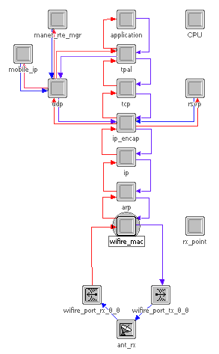

Figure 9: WiFiRe SS node model

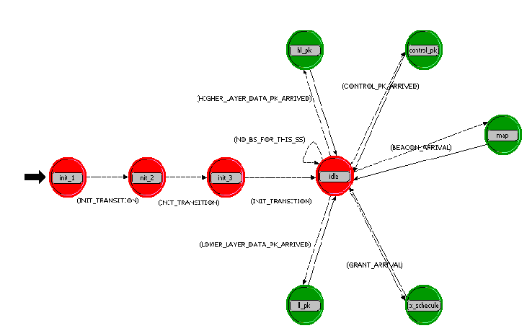
Figure 10: Common MAC process model

ll_pk state: It extracts the CID from the incoming MAC PDU and checks whether packet is destined to this ST or not by checking CID. If it is destined to this ST, then it simply extracts the MAC SDU from the incoming packet and inserted into the reassembly buffer.

control_pk state: Root MAC process spawns one of the control child process to process the control messages. If MAC role is BS and incoming control packet is DSA request or bandwidth request then BS control child process is invoked. ST control child process is invoked if MAC role is ST and incoming control packet is DSA response.
Beacon process state: Every station process beacon independently and schedules its traffic according to slot numbers in MAP. BS sends downlink traffic first after that ST(s) sends their traffic. Sending packet is implemented using direct delivery method. So communication between BS and ST is MAC to MAC communication.

ST control child process model: This is invoked when parent process received control packet or wants to send a control packet i.e. DSA Request, DSA Response. Initially when simulation starts this process is invoked by parent process to deliver DSA request for each service flow defined on this ST. ST process is shown in Figure 11.
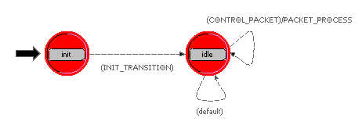
Figure 11: ST control child process model

BS control child process model: Functionalities of this process are admission control, MAP generation, bandwidth grant scheduler and activation of admitted service flows. This process is invoked when parent Process received control packet or when parent process wants to send bandwidth request. It also process DSA request messages coming from ST’s. These DSA Request messages are processed by admission control module. MAP generation function will be called periodically to generate DL-MAP and UL-MAP. BS process is shown in Figure 12.

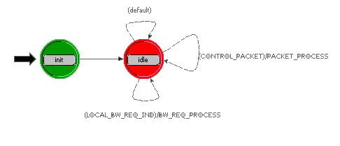
Figure 12: BS control child process model

Sectorized Antenna: Sectorized antenna is also one type of Directional antenna, which will cover particular sector area that is specified by antenna radiation pattern. Antennas exhibit directivity by radiating most of their power in one direction-the direction of major lobe. They radiate small amount in side lobes. Another important directivity attribute of antenna is Antenna beamwidth. If we want 60 Degrees sector antenna, then horizontal antenna beamwidth will be around 45 degrees. Choose sector antenna with a horizontal beamwidth equal to 75 percent of sector width. Because antenna with 60-degree horizontal beamwidth still radiates a substantial amount of power beyond a 60-degree angle. So for six sector system we need six sector antennas with horizontal beamwidth equal to 45 degrees or more. OPNET provides antenna pattern Editor to design directional antenna pattern. The OPNET Antenna pattern Editor uses the spherical angles phi and theta to graphically create a 3-dimensional antenna pattern.

Evaluation: For evaluating performance of the protocol we are simulating this protocol in different scenarios such as allowing only voice users, mixing up voice and video users, etc. with different MAC configurations. We will be comparing throughput of different service classes in different scenarios, and also compare service delays of different classes. All the results we are going to show are MAC-to-MAC based results. PHY layer effects are not added to the model.

1 | Frequency Channel | 2.4 GHz
2 | Bandwidth | 22 MHz
3 | Data rate | 11 Mbps
4 | Frame duration | 10 ms
5 | Symbols per frame | 220000
6 | Symbol duration | .045 µs
7 | Scheduling algorithm | Round Robin
8 | Number of sectors | 6

Table 1: Common parameters for all experiments

The Table 1 shows common WiFiRe setup parameters for all simulations we have conducted. We are assuming modulation technique is BPSK and coding rate is 1/2 according to 802.11b. With 11 Mbps data rate, BPSK modulation scheme and with 1/2 coding rate, number of symbols per 10 ms frame is equal to 2, 20,000.
The setup consists of six sectors. Each sector has one workstation. Base station is connected with Ethernet server using 100BaseT cable. Each workstation has configured with 4 uplink and 4 downlink service flows, i.e UGS, rtPS, nrtPS and Best Effort service flows.

Figure 13: Simulation setup with one ST, and one BS

VoIP user Scenario: The aim of this scenario is to find the minimum slot size required to support voice applications, and the maximum number of users the system can support with this slot size. We can also compare end-to-end MAC delay with different slot sizes.

S.No | Parameter | value
1 | Service class | UGS
2 | Max traffic rate | 24 Kbps
3 | Min reserved rate | 24 Kbps
4 | Max latency | 4 sec
5 | Polling interval | NA
S.No | Parameter | Value
1 | Slot duration | 32 µs
2 | Contention slots | 10
3 | DL-UL | 2:1
4 | Voice codec | G729
5 | Number of STs | 1
Table 2: UGS Setup parameters; Table 3: UGS service flow parameters.

ST is configured with one VoIP call having G729 codec with 20ms sampling rate, 8kbps coding rate and one downlink and one uplink service flow with parameters shown in Table 3. System is configured with 32 µs slot and 10 ms frame. Other setup parameters are shown in Table 2. Simulation setup is shown in Figure 13.

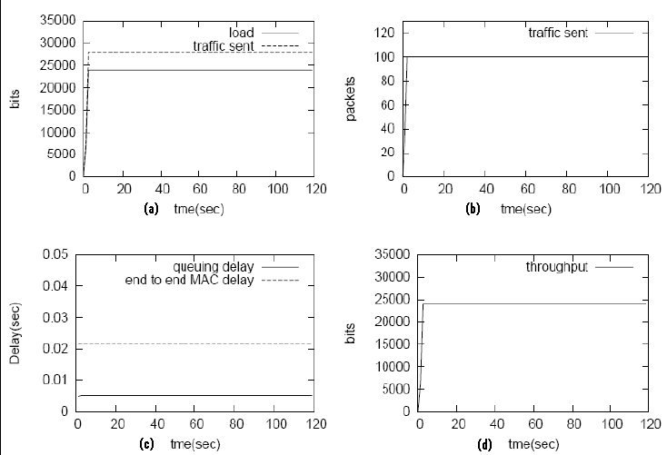

Figure 14: UGS statistics with slot size 32 µs (a) load and traffic sent vs time. (b) Packets sent vs time. (c) Queuing delay and end-to-end MAC delay vs time. (d) Throughput vs time.

Figure 14 shows the simulation results with configuration shown in Tables 2 and 3. Figure 14(a) shows the load is 24 kbps and traffic sent is 28 kbps. Using G729 codec with 20 ms sampling rate and 8 kbps coding rate, voice payload will be 20 bytes. Total packet size at MAC layer is 20+40(IP+UDP+RTPS) bytes. This VoIP packet will be served in two 10 ms frames, because with one 32 micro sec slot, ST can send only 44 bytes. So 60 bytes VoIP packet is segmented into two and sends in two frames. Queuing delay and end-to-end MAC delay is constant shown in Figure 14(c), because arrival rate is equal to service rate that is one VoIP packet per 20 ms.
With this experiment it has been observed that 32 µs slot is enough to provide VoIP services with G729 codec, 20 ms sampling rate and 8 kbps coding rate.
Figure 15: UGS statistics with slot size 40 µs (a) load and traffic sent vs time. (b) Packets sent vs time. (c) Queuing delay, end-to-end MAC delay (d) Throughput vs time

The Figure 15 shows the simulation results with configuration shown in Tables 2 and 3 except slot size and requested bandwidth. This experiment is configured with slot size 40 µs and requested bandwidth is 40 kbps. In this setup we used G729 codec with 10ms sampling rate and 8 kbps coding rate. Figure 15(a) shows that load at MAC layer is 40 kbps and traffic sent is around 44 kbps, this includes WiFiRe overhead. With one 40 micro sec slot, ST can sent data at 44 kbps, So queuing delay and end to end MAC delay are constant shown in Figure 15(c).
From this experiment, it has been observed that 40 µs slot size is suitable for VoIP service with G729, 10 ms sampling rate and 8 kbps coding rate.

Video Conference user Scenario
The aim of this experiment is to find the minimum slot size required to support video applications. The experimental results will also show the effect of slot size on queuing delay and end-to-end MAC delay. Results will also show the effect of polling interval on queuing delay and end-to-end MAC delay.

S.No | Parameter | Value
1 | Slot duration | 32 micro sec
2 | Contention slots | 10
3 | DL-UL ratio | 2:1
4 | Frame duration | 10 ms
5 | Number of STs | 1
S.No | Parameter | Value
1 | Service class | rtPS
2 | Max traffic rate | 100Kbps
3 | Min reserved rate | 90 Kbps
4 | Max latency | 8 sec
5 | Polling Interval | 80 ms
Table 4: rtPS Setup parameters; Table 5: rtPS service flow parameters.

This experiment is configured with parameters shown in Tables 4 and 5. The common setup parameters are shown in Table 1. ST is configured with one Videoconference application. This application is configured with .2 sec frame interval time, which is exponentially distributed, and frame size is 2028 bytes. One uplink and one downlink rtPS service flow is configured at ST, with parameters shown in Table 5.

Figure 16: rtPS statistics with slot size 32 µs (a) load and traffic sent vs time. (b) Packets sent. (c) Queuing delay and end-to-end MAC delay vs time. (d) Throughput vs time.

With 90Kbps requested rate, it needs three 32µs slots. With three 32µs slots STs can send traffic at 105 Kbps. Figure 16(c) shows that queuing delay and end to end MAC delay are increasing upto 15th second, because if you observe the load, it is increasing up to 15th second and it is more than service rate 105 Kbps. Queuing delay started to increase, thus increasing the end to end MAC delay. Maximum end to end MAC delay is 2.2 seconds, so packets are not exceeding maximum latency 8 seconds. So no packets are dropped by destination MAC, hence throughput is same as load shown in Figure 16(d).
Above simulation results showing that, three 32 µs slots are required to provide Video service with configuration shown in Tables 4 and 5.

FTP Scenario
This experiment discusses the effect of slot size on queuing delay and end-to-end MAC delay. This experiment also discusses the effect of polling interval on queuing delay and end-to-end MAC delay.

S.No | Parameter | Value
1 | Slot duration | 32 micro sec
2 | Contention slots | 10
3 | DL-UL ratio | 2:1
4 | Frame duration | 10 ms
S.No | Parameter | Value
1 | Service class name | nrtPS
2 | Max traffic rate | 20 Kbps
3 | Min reserved rate | 10 Kbps
4 | Max latency | 10 sec
5 | Polling Interval | 2 sec
Table 6: nrtPS Setup parameters; Table 7: nrtPS service flow parameters.

The simulation parameters for this experiment are shown in the Tables 6 and 7. In this setup, polling interval is two seconds, which means that the BS will poll nrtPS flows in every two seconds. Then ST will send a bandwidth request equal to the queue size, if queue is not empty. In this experiment, FTP packet inter request time is exponentially distributed with a mean of 15 seconds and packet size is 5000 bytes.

Figure 17: nrtPS statistics with slot size 32 µs (a) load and traffic sent vs time. (b) Throughput vs time. (c) Queuing and end-to-end MAC delay vs time.

Figure 17 shows the simulation results of FTP user scenario with setup parameters shown in Tables 6 and 7. In the Figure 17(c) queuing delay is more than two second for most of the time, because polling interval is two second. But end-to-end MAC delay is always more than 2 seconds because STs can send their traffic only after BS polled their connections. With one 32µs slot STs can send their traffic at the rate of 44 Kbps, So one 32µs is enough to support FTP applications.

Conclusion: Extensive simulation results shown that 32 µs slot is suitable to provide voice service. However rtPS flows need more than one slot, which will increase WiFiRe over-head. If slot size is small, then MAC overhead will be increased due to segmentation. If slot size is large, then the packet will be delivered quickly to the destination MAC.

References: [1] S. Iyer et al., “Broadband Wireless for Rural Areas — WiFiRe: Medium Access Control (MAC) and Physical Layer (PHY) Specifications — Draft Release 2006,” Tech. rep., Centre for Excellence in Wireless Technologies, IIT Madras, Chennai, India, 2006.
[2] Krishna Paul, Anitha Varghese, Sridhar Iyer, Bhaskar Ramamurthi, Anurag Kumar, “WiFiRe: Rural Area Broadband Access Using the WiFi PHY and a Multisector TDD MAC”, IEEE Communications Magazine January 2007.
[3] LAN/MAN standards Committee, and IEEE Microwave Theory and Techniques Society, Part 16: Air Interface for Fixed Broadband Wireless Access Systems, IEEE-SA Standards Board, June 2004.
[4] LAN/MAN standards Committee, Part 11: Wireless LAN Medium Access Control (MAC) and Physical Layer (PHY) Specifications, IEEE-SA Standards Board, June 2003.
[5] OPNET Documentation. http://www.opnet.com
[6] Xinjie Chang. “Network simulations with OPNET”, Winter Simulation Conference, pages 307{314, 1999.

