MADE PROJECT:
Mobile agents (MA) based implementation of a distance evaluation (DE) system was a project sponsored by the Ministry of Information Technology. It is a proof-of-concept prototype that can be implemented by further development. The research work for this project was carried out at the School of Information Technology, Indian Institute of Technology Bombay.

The growth of the Internet has led to new avenues for distance education. A crucial factor for the success of distance education is effective mechanisms for evaluation of remote students.

DISTANCE examination SYSTEms
Some existing approaches are:
•Computer Based Testing (CBT):
• This may be dynamic, i.e., different questions may be given to diferent examinees.
•Also Adaptive: different weights to different questions
•Drawback: Entire database has to be present at the exam site, leading to security issues
•Internet Based Testing Schemes:
•Front End: HTML forms/Applets based
•Back End: CGI scripts/Servlets based
•Drawback: Vulnerable to network latencies
Difficult to push information to participant
Difficult to handle dynamic contents
DESIRABLE FEATURES IN DISTANCE EVALUATION:
•Ability to cater to all stages of the examination process, viz.,
•Exam setting
–examiners set the question papers
•Distribution and testing
–question papers are presented to the students
•Evaluation and result compilation
–answers are collected, evaluated and results compiled

•Delivery of dynamic content
•Support synchronous, off-line examination of remote students
•Support for push communication
•Ability to incorporate subjective questions

We believe that extending client-server based implementations would be cumbersome and ineffective.
MOBILE AGENTS:
Programs that can autonomously migrate amongst nodes of a network and perform computations on behalf of a user.
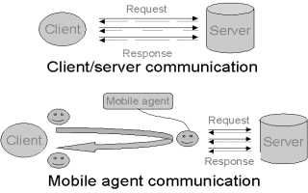
MADE OVERVIEW:

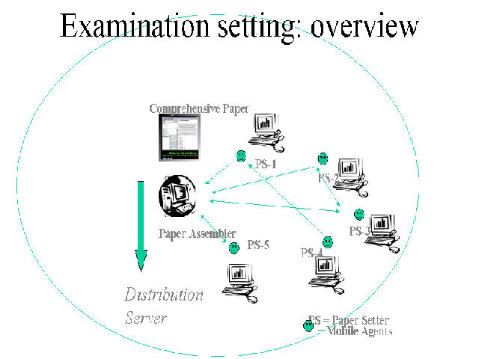

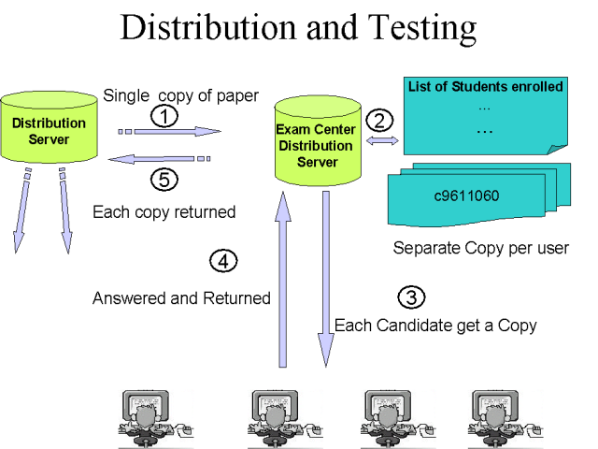

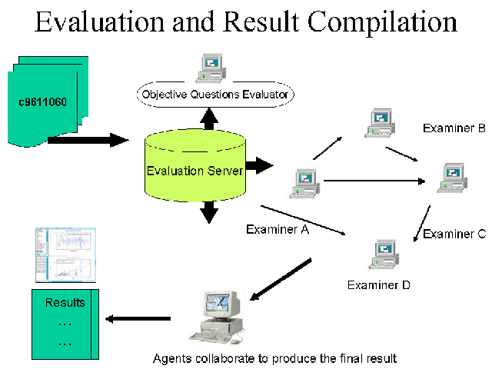

MADE IMPLEMENTATION:
MADE has been implemented using Java as the development language and Voyager ORB as the MA Framework. Voyager is a generalized platform for distributed object computing and allows easy integration of MAs with the rest of the application components.
The prototyping was carried out on Pentium III, 450 MHz workstations (running either on Windows2000 or Linux operating systems) on a campus network. Voyager ORB was installed on all of these machines.
The set-up for the examination process was simulated by using different ports on each machine for the different services.
Observations:
Mobile agents enable
- Local interactions
- Handling dynamic contents
- Application level multicasting
- Dynamic up-gradation of application components
- Centralized control and management of logistics
Mobile agents provide effective and flexible mechanisms for structuring distributed applications like student examination systems.

Contact Information:
Sridhar Iyer
Associate Professor

Kanwal Rekhi School of Information Technology
IIT Bombay, Powai
Mumbai 400 076

Ph: (022)-2576-7905
Email: sri@it.iitb.ac.in

Website:
http://www.it.iitb.ac.in/~sri/made

MADE

MOBILE AGENTS BASED DISTANCE EVALUATION SYSTEM

Kanwal Rekhi School of Information Technology
Indian Institute of Technology Bombay

SPONSORED BY:
Ministry of Information Technology,
Govt. of India

